UNITED STATES
SECURITIES AND EXCHANGE COMMISSION
Washington, D.C. 20549

FORM 8-K

CURRENT REPORT
Pursuant to Section 13 or 15(d)
of the Securities Exchange Act of 1934
Date of Report (Date of earliest event reported): July 27, 2026

MapLight Therapeutics, Inc.
(Exact name of registrant as specified in its charter)

Delaware |  | 001-42914 |  | 83-2163243
(State or other jurisdiction  of incorporation) |  | (Commission  File Number) |  | (IRS Employer  Identification No.)

800 Chesapeake Drive
Redwood City, California 94063
(Address of principal executive offices)
Registrant’s telephone number, including area code: (617) 984-6300
N/A
(Former name or former address, if changed since last report.)

Check the appropriate box below if the Form 8-K filing is intended to simultaneously satisfy the filing obligation of the registrant under any of the following provisions:

☐ | Written communications pursuant to Rule 425 under the Securities Act (17 CFR 230.425)

☐ | Soliciting material pursuant to Rule 14a-12 under the Exchange Act (17 CFR 240.14a-12)

☐ | Pre-commencement communications pursuant to Rule 14d-2(b) under the Exchange Act (17 CFR 240.14d-2(b))

☐ | Pre-commencement communications pursuant to Rule 13e-4(c) under the Exchange Act (17 CFR 240.13e-4(c))
Securities registered pursuant to Section 12(b) of the Act:

Title of each class |  | Trading  symbol(s) |  | Name of each exchange  on which registered
Voting Common Stock, $0.0001 par value per share |  | MPLT |  | Nasdaq Global Select Market
Indicate by check mark whether the registrant is an emerging growth company as defined in as defined in Rule 405 of the Securities Act of 1933 (§230.405 of this chapter) or Rule 12b-2 of the Securities Exchange Act of 1934 (§240.12b-2 of this chapter).
Emerging growth company ☒
If an emerging growth company, indicate by check mark if the registrant has elected not to use the extended transition period for complying with any new or revised financial accounting standards provided pursuant to Section 13(a) of the Exchange Act. ☐

Item 7.01 Regulation FD Disclosure.
On July 27, 2026, MapLight Therapeutics, Inc. (the “Company”) will hold a conference call to discuss the topline results from ZEPHYR, a Phase 2 trial of ML-007C-MA in inpatient adult participants with schizophrenia experiencing an acute exacerbation of psychosis (the “ZEPHYR Trial Results”). A copy of the presentation that will accompany the conference call is furnished herewith as Exhibit 99.1 to this Current Report on Form 8-K.
In accordance with General Instruction B.2. of Form 8-K, the information in this Item 7.01 and Exhibit 99.1 hereto shall not be deemed “filed” for purposes of Section 18 of the Securities Exchange Act of 1934, as amended (the “Exchange Act”), or otherwise subject to the liability of that section, nor shall it be deemed incorporated by reference in any of the Company’s filings under the Securities Act of 1933, as amended, or under the Exchange Act, whether made before or after the date hereof, regardless of any incorporation language in such a filing, except as expressly set forth by specific reference in such a filing.
Item 8.01 Other Events.
On July 27, 2026, the Company issued a press release announcing the ZEPHYR Trial Results. A copy of this press release is filed as Exhibit 99.2 to this Current Report on Form 8-K and is incorporated herein by reference.

Item 9.01 | Financial Statements and Exhibits.
(d) Exhibits

Exhibit  Number |  | Exhibit Description
99.1 |  | Company Presentation, dated July 27, 2026.
99.2 |  | Press Release, dated July 27, 2026.
104 |  | Cover Page Interactive Data File (formatted as inline XBRL).

SIGNATURES
Pursuant to the requirements of the Securities Exchange Act of 1934, the registrant has duly caused this report to be signed on its behalf by the undersigned hereunto duly authorized.

 |  |  |  | MapLight Therapeutics, Inc.
Dated: July 27, 2026 |  |  |  | By: |  | /s/ Christopher A. Kroeger
 |  |  |  |  |  | Christopher A. Kroeger, M.D.
 |  |  |  |  |  | Chief Executive Officer
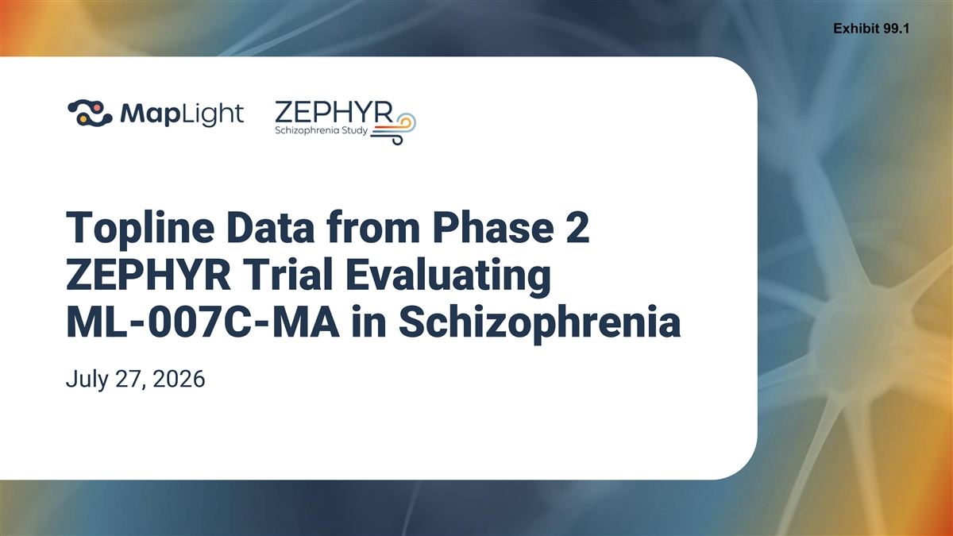
Exhibit 99.1 Topline Data from Phase 2 ZEPHYR Trial Evaluating ML-007C-MA in Schizophrenia July 27, 2026

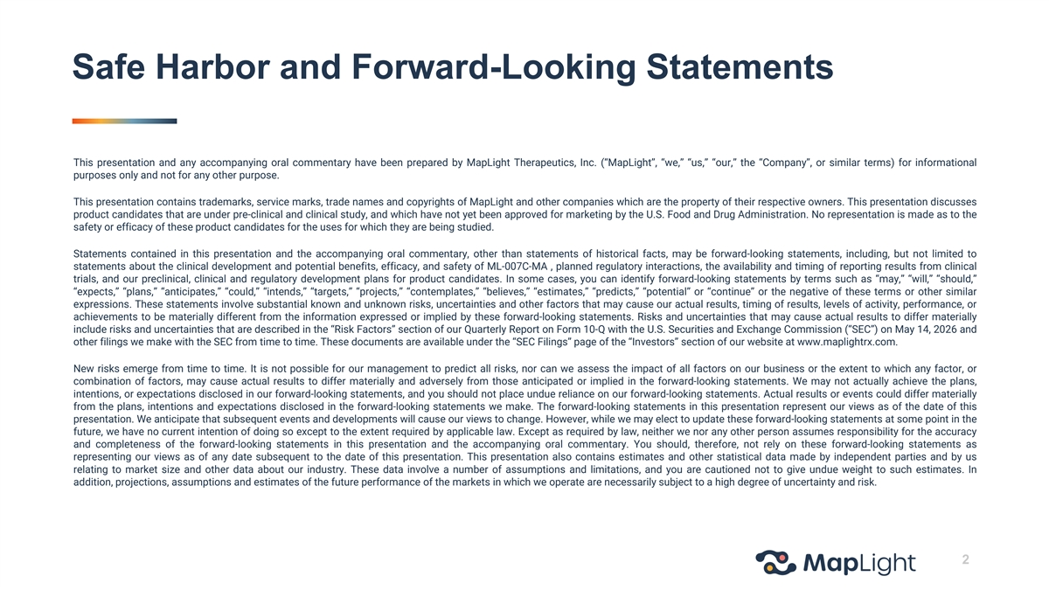
Safe Harbor and Forward-Looking Statements This presentation and any accompanying oral commentary have been prepared by MapLight Therapeutics, Inc. (“MapLight”, “we,” “us,” “our,” the “Company”, or similar terms) for informational purposes only and not for any other purpose. This presentation contains trademarks, service marks, trade names and copyrights of MapLight and other companies which are the property of their respective owners. This presentation discusses product candidates that are under pre-clinical and clinical study, and which have not yet been approved for marketing by the U.S. Food and Drug Administration. No representation is made as to the safety or efficacy of these product candidates for the uses for which they are being studied. Statements contained in this presentation and the accompanying oral commentary, other than statements of historical facts, may be forward-looking statements, including, but not limited to statements about the clinical development and potential benefits, efficacy, and safety of ML-007C-MA , planned regulatory interactions, the availability and timing of reporting results from clinical trials, and our preclinical, clinical and regulatory development plans for product candidates. In some cases, you can identify forward-looking statements by terms such as “may,” “will,” “should,” “expects,” “plans,” “anticipates,” “could,” “intends,” “targets,” “projects,” “contemplates,” “believes,” “estimates,” “predicts,” “potential” or “continue” or the negative of these terms or other similar expressions. These statements involve substantial known and unknown risks, uncertainties and other factors that may cause our actual results, timing of results, levels of activity, performance, or achievements to be materially different from the information expressed or implied by these forward-looking statements. Risks and uncertainties that may cause actual results to differ materially include risks and uncertainties that are described in the “Risk Factors” section of our Quarterly Report on Form 10-Q with the U.S. Securities and Exchange Commission (“SEC”) on May 14, 2026 and other filings we make with the SEC from time to time. These documents are available under the “SEC Filings” page of the “Investors” section of our website at www.maplightrx.com. New risks emerge from time to time. It is not possible for our management to predict all risks, nor can we assess the impact of all factors on our business or the extent to which any factor, or combination of factors, may cause actual results to differ materially and adversely from those anticipated or implied in the forward-looking statements. We may not actually achieve the plans, intentions, or expectations disclosed in our forward-looking statements, and you should not place undue reliance on our forward-looking statements. Actual results or events could differ materially from the plans, intentions and expectations disclosed in the forward-looking statements we make. The forward-looking statements in this presentation represent our views as of the date of this presentation. We anticipate that subsequent events and developments will cause our views to change. However, while we may elect to update these forward-looking statements at some point in the future, we have no current intention of doing so except to the extent required by applicable law. Except as required by law, neither we nor any other person assumes responsibility for the accuracy and completeness of the forward-looking statements in this presentation and the accompanying oral commentary. You should, therefore, not rely on these forward-looking statements as representing our views as of any date subsequent to the date of this presentation. This presentation also contains estimates and other statistical data made by independent parties and by us relating to market size and other data about our industry. These data involve a number of assumptions and limitations, and you are cautioned not to give undue weight to such estimates. In addition, projections, assumptions and estimates of the future performance of the markets in which we operate are necessarily subject to a high degree of uncertainty and risk. 2

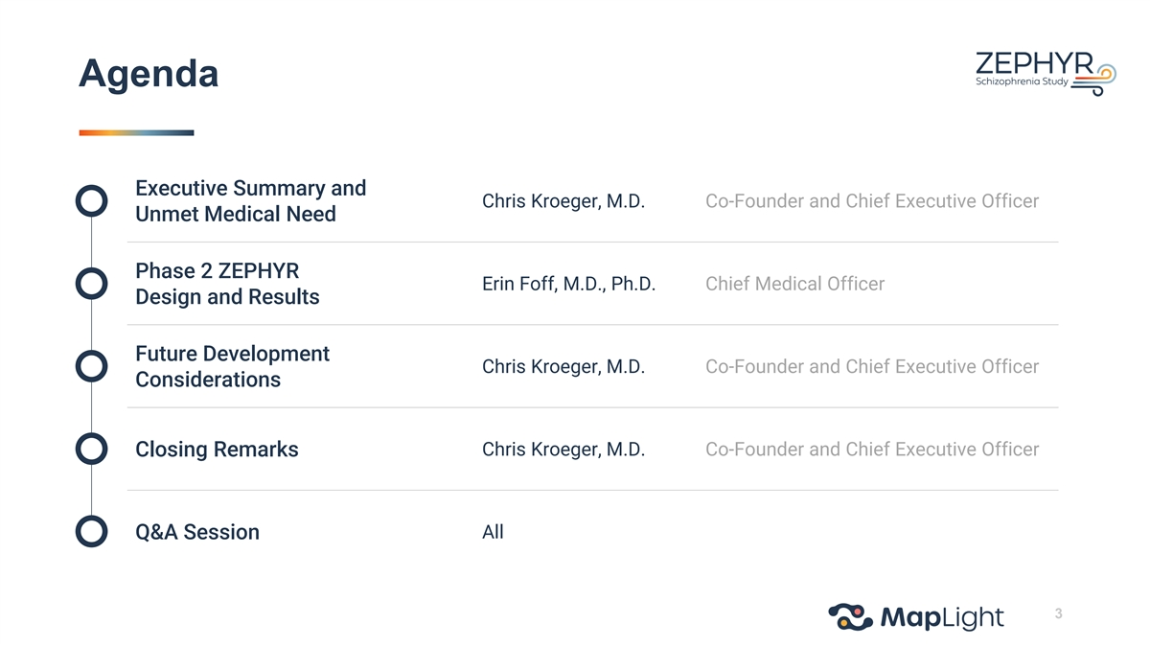
Agenda Executive Summary and Chris Kroeger, M.D. Co-Founder and Chief Executive Officer Unmet Medical Need Phase 2 ZEPHYR Erin Foff, M.D., Ph.D. Chief Medical Officer Design and Results Future Development Chris Kroeger, M.D. Co-Founder and Chief Executive Officer Considerations Closing Remarks Chris Kroeger, M.D. Co-Founder and Chief Executive Officer Q&A Session All 3

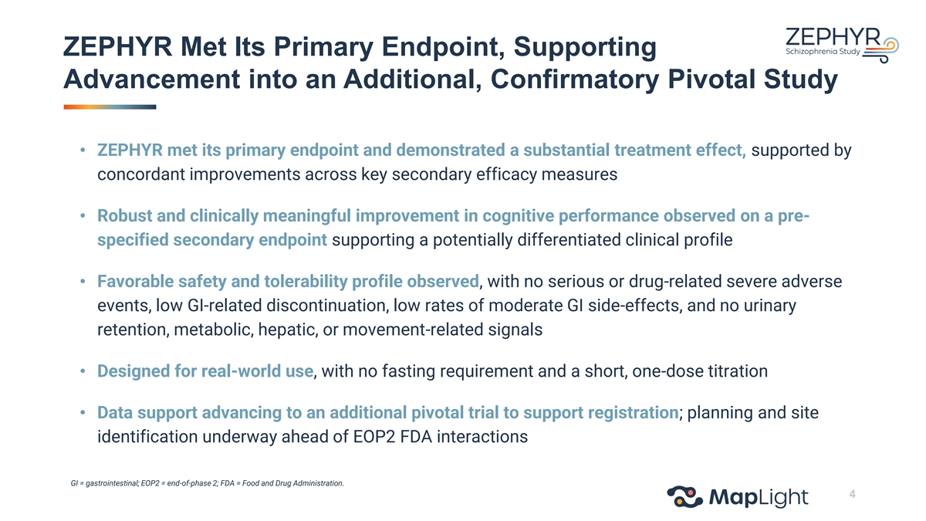
ZEPHYR Met Its Primary Endpoint, Supporting Advancement into an Additional, Confirmatory Pivotal Study • ZEPHYR met its primary endpoint and demonstrated a substantial treatment effect, supported by concordant improvements across key secondary efficacy measures • Robust and clinically meaningful improvement in cognitive performance observed on a pre- specified secondary endpoint supporting a potentially differentiated clinical profile • Favorable safety and tolerability profile observed, with no serious or drug-related severe adverse events, low GI-related discontinuation, low rates of moderate GI side-effects, and no urinary retention, metabolic, hepatic, or movement-related signals • Designed for real-world use, with no fasting requirement and a short, one-dose titration • Data support advancing to an additional pivotal trial to support registration; planning and site identification underway ahead of EOP2 FDA interactions GI = gastrointestinal; EOP2 = end-of-phase 2; FDA = Food and Drug Administration. 4

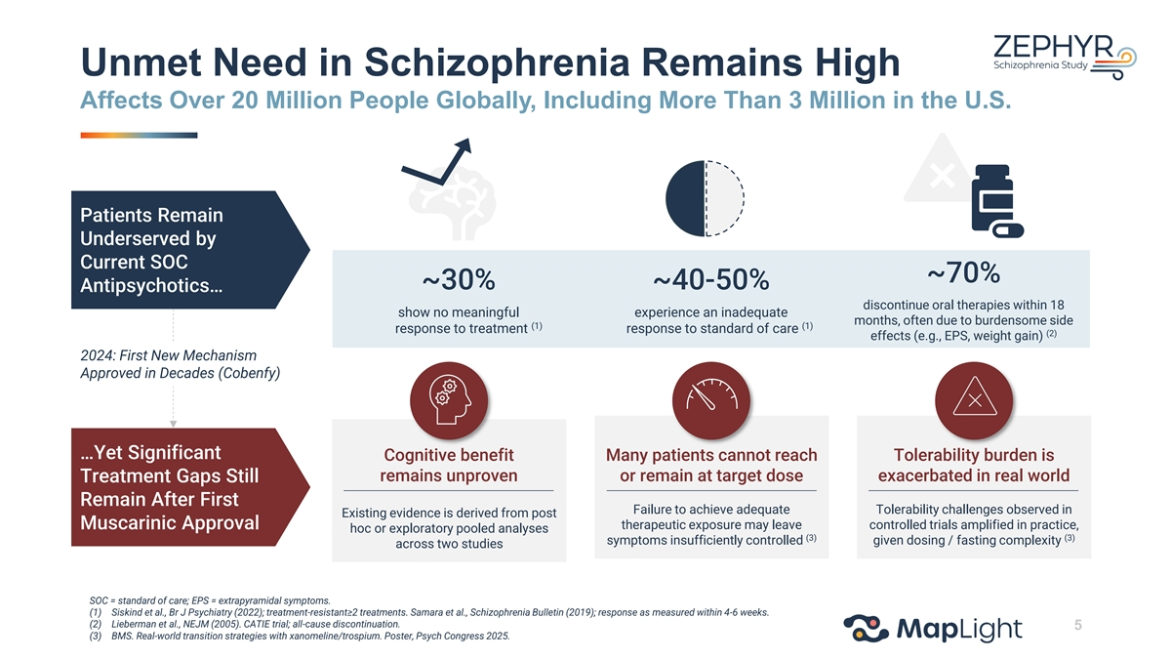
Unmet Need in Schizophrenia Remains High Affects Over 20 Million People Globally, Including More Than 3 Million in the U.S. Patients Remain Underserved by Current SOC ~70% ~30% ~40-50% Antipsychotics… discontinue oral therapies within 18 show no meaningful experience an inadequate months, often due to burdensome side (1) (1) response to treatment response to standard of care (2) effects (e.g., EPS, weight gain) 2024: First New Mechanism Approved in Decades (Cobenfy) …Yet Significant Cognitive benefit Many patients cannot reach Tolerability burden is remains unproven or remain at target dose exacerbated in real world Treatment Gaps Still Remain After First Failure to achieve adequate Tolerability challenges observed in Existing evidence is derived from post Muscarinic Approval therapeutic exposure may leave controlled trials amplified in practice, hoc or exploratory pooled analyses (3) (3) symptoms insufficiently controlled given dosing / fasting complexity across two studies SOC = standard of care; EPS = extrapyramidal symptoms. (1) Siskind et al., Br J Psychiatry (2022); treatment-resistant≥2 treatments. Samara et al., Schizophrenia Bulletin (2019); response as measured within 4-6 weeks. (2) Lieberman et al., NEJM (2005). CATIE trial; all-cause discontinuation. 5 (3) BMS. Real-world transition strategies with xanomeline/trospium. Poster, Psych Congress 2025.

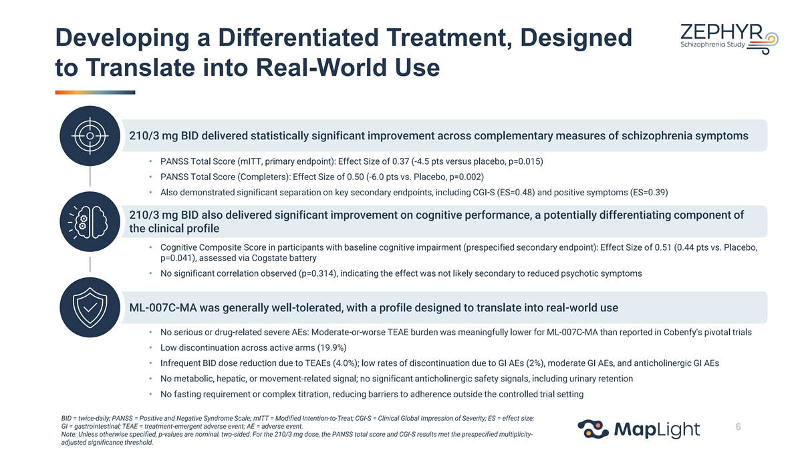
Developing a Differentiated Treatment, Designed to Translate into Real-World Use 210/3 mg BID delivered statistically significant improvement across complementary measures of schizophrenia symptoms • PANSS Total Score (mITT, primary endpoint): Effect Size of 0.37 (-4.5 pts versus placebo, p=0.015) • PANSS Total Score (Completers): Effect Size of 0.50 (-6.0 pts vs. Placebo, p=0.002) • Also demonstrated significant separation on key secondary endpoints, including CGI-S (ES=0.48) and positive symptoms (ES=0.39) 210/3 mg BID also delivered significant improvement on cognitive performance, a potentially differentiating component of the clinical profile • Cognitive Composite Score in participants with baseline cognitive impairment (prespecified secondary endpoint): Effect Size of 0.51 (0.44 pts vs. Placebo, p=0.041), assessed via Cogstate battery • No significant correlation observed (p=0.314), indicating the effect was not likely secondary to reduced psychotic symptoms ML-007C-MA was generally well-tolerated, with a profile designed to translate into real-world use • No serious or drug-related severe AEs: Moderate-or-worse TEAE burden was meaningfully lower for ML-007C-MA than reported in Cobenfy's pivotal trials • Low discontinuation across active arms (19.9%) • Infrequent BID dose reduction due to TEAEs (4.0%); low rates of discontinuation due to GI AEs (2%), moderate GI AEs, and anticholinergic GI AEs • No metabolic, hepatic, or movement-related signal; no significant anticholinergic safety signals, including urinary retention • No fasting requirement or complex titration, reducing barriers to adherence outside the controlled trial setting BID = twice-daily; PANSS = Positive and Negative Syndrome Scale; mITT = Modified Intention-to-Treat; CGI-S = Clinical Global Impression of Severity; ES = effect size; GI = gastrointestinal; TEAE = treatment-emergent adverse event; AE = adverse event. 6 Note: Unless otherwise specified, p-values are nominal, two-sided. For the 210/3 mg dose, the PANSS total score and CGI-S results met the prespecified multiplicity- adjusted significance threshold.


Phase 2 Design and Results Erin Foff, M.D., Ph.D. | Chief Medical Officer

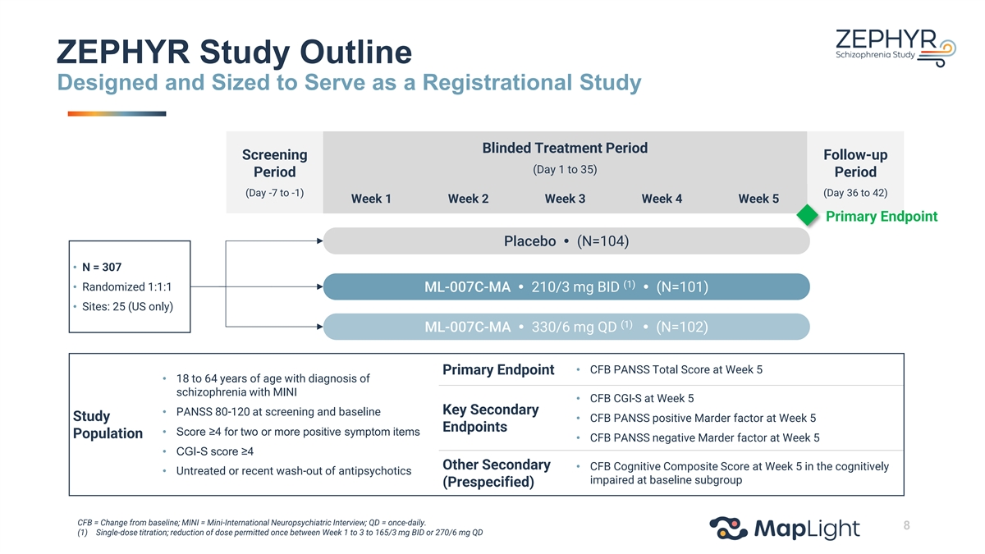
ZEPHYR Study Outline Designed and Sized to Serve as a Registrational Study Blinded Treatment Period Screening Follow-up (Day 1 to 35) Period Period (Day -7 to -1) (Day 36 to 42) Week 1 Week 2 Week 3 Week 4 Week 5 Primary Endpoint Placebo  (N=104) • N = 307 (1) • Randomized 1:1:1 ML-007C-MA  210/3 mg BID  (N=101) • Sites: 25 (US only) (1) ML-007C-MA  330/6 mg QD  (N=102) • CFB PANSS Total Score at Week 5 Primary Endpoint • 18 to 64 years of age with diagnosis of schizophrenia with MINI • CFB CGI-S at Week 5 Key Secondary • PANSS 80-120 at screening and baseline Study • CFB PANSS positive Marder factor at Week 5 Endpoints • Score ≥4 for two or more positive symptom items Population • CFB PANSS negative Marder factor at Week 5 • CGI-S score ≥4 Other Secondary • CFB Cognitive Composite Score at Week 5 in the cognitively • Untreated or recent wash-out of antipsychotics impaired at baseline subgroup (Prespecified) CFB = Change from baseline; MINI = Mini-International Neuropsychiatric Interview; QD = once-daily. 8 (1) Single-dose titration; reduction of dose permitted once between Week 1 to 3 to 165/3 mg BID or 270/6 mg QD

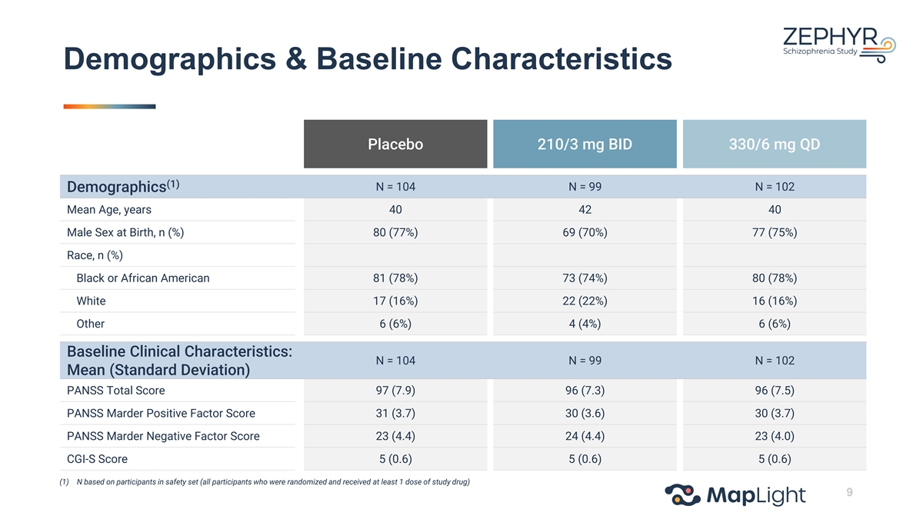
Demographics & Baseline Characteristics Placebo 210/3 mg BID 330/6 mg QD (1) N = 104 N = 99 N = 102 Demographics Mean Age, years 40 42 40 Male Sex at Birth, n (%) 80 (77%) 69 (70%) 77 (75%) Race, n (%) Black or African American 81 (78%) 73 (74%) 80 (78%) White 17 (16%) 22 (22%) 16 (16%) Other 6 (6%) 4 (4%) 6 (6%) Baseline Clinical Characteristics: N = 104 N = 99 N = 102 Mean (Standard Deviation) PANSS Total Score 97 (7.9) 96 (7.3) 96 (7.5) PANSS Marder Positive Factor Score 31 (3.7) 30 (3.6) 30 (3.7) PANSS Marder Negative Factor Score 23 (4.4) 24 (4.4) 23 (4.0) CGI-S Score 5 (0.6) 5 (0.6) 5 (0.6) (1) N based on participants in safety set (all participants who were randomized and received at least 1 dose of study drug) 9

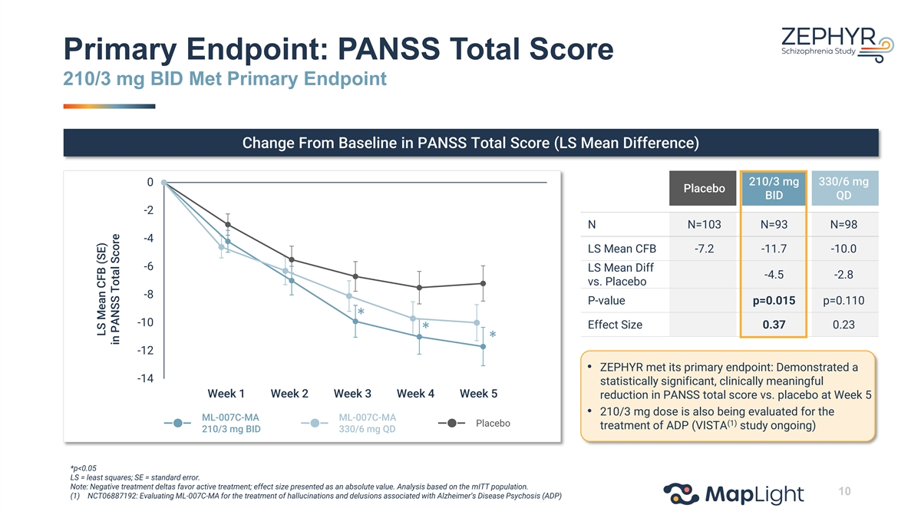
Primary Endpoint: PANSS Total Score 210/3 mg BID Met Primary Endpoint Change From Baseline in PANSS Total Score (LS Mean Difference) 210/3 mg 330/6 mg 0 Placebo BID QD -2 N N=103 N=93 N=98 -4 LS Mean CFB -7.2 -11.7 -10.0 -6 LS Mean Diff -4.5 -2.8 vs. Placebo -8 P-value p=0.015 p=0.110 * -10 Effect Size 0.37 0.23 * * -12 • ZEPHYR met its primary endpoint: Demonstrated a -14 statistically significant, clinically meaningful 0 1 2 3 4 5 6 Week 1 Week 2 Week 3 Week 4 Week 5 reduction in PANSS total score vs. placebo at Week 5 • 210/3 mg dose is also being evaluated for the ML-007C-MA ML-007C-MA (1) Placebo treatment of ADP (VISTA study ongoing) 210/3 mg BID 330/6 mg QD *p<0.05 LS = least squares; SE = standard error. Note: Negative treatment deltas favor active treatment; effect size presented as an absolute value. Analysis based on the mITT population. 10 (1) NCT06887192: Evaluating ML-007C-MA for the treatment of hallucinations and delusions associated with Alzheimer’s Disease Psychosis (ADP) LS Mean CFB (SE) in PANSS Total Score

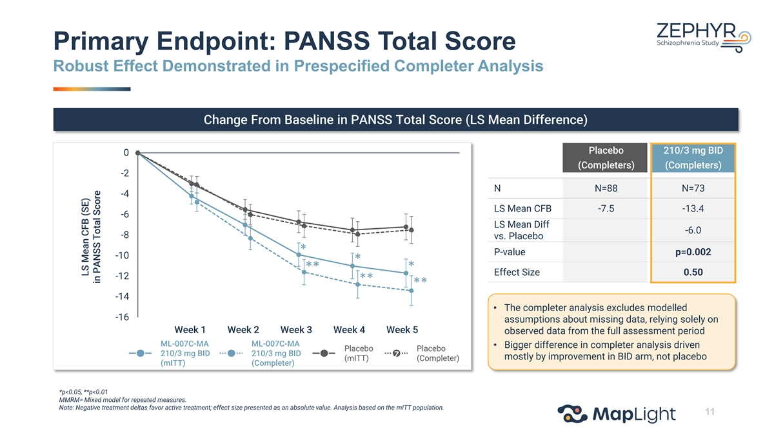
Primary Endpoint: PANSS Total Score Robust Effect Demonstrated in Prespecified Completer Analysis Change From Baseline in PANSS Total Score (LS Mean Difference) Placebo 210/3 mg BID 0 (Completers) (Completers) -2 N N=88 N=73 -4 LS Mean CFB -7.5 -13.4 -6 LS Mean Diff -6.0 -8 vs. Placebo * P-value p=0.002 -10 * * ** Effect Size 0.50 -12 ** ** -14 • The completer analysis excludes modelled -16 assumptions about missing data, relying solely on 0 1 2 3 4 5 6 Week 1 Week 2 Week 3 Week 4 Week 5 observed data from the full assessment period ML-007C-MA ML-007C-MA • Bigger difference in completer analysis driven Placebo Placebo 210/3 mg BID 210/3 mg BID z mostly by improvement in BID arm, not placebo (mITT) (Completer) (mITT) (Completer) *p<0.05, **p<0.01 MMRM= Mixed model for repeated measures. Note: Negative treatment deltas favor active treatment; effect size presented as an absolute value. Analysis based on the mITT population. 11 LS Mean CFB (SE) in PANSS Total Score

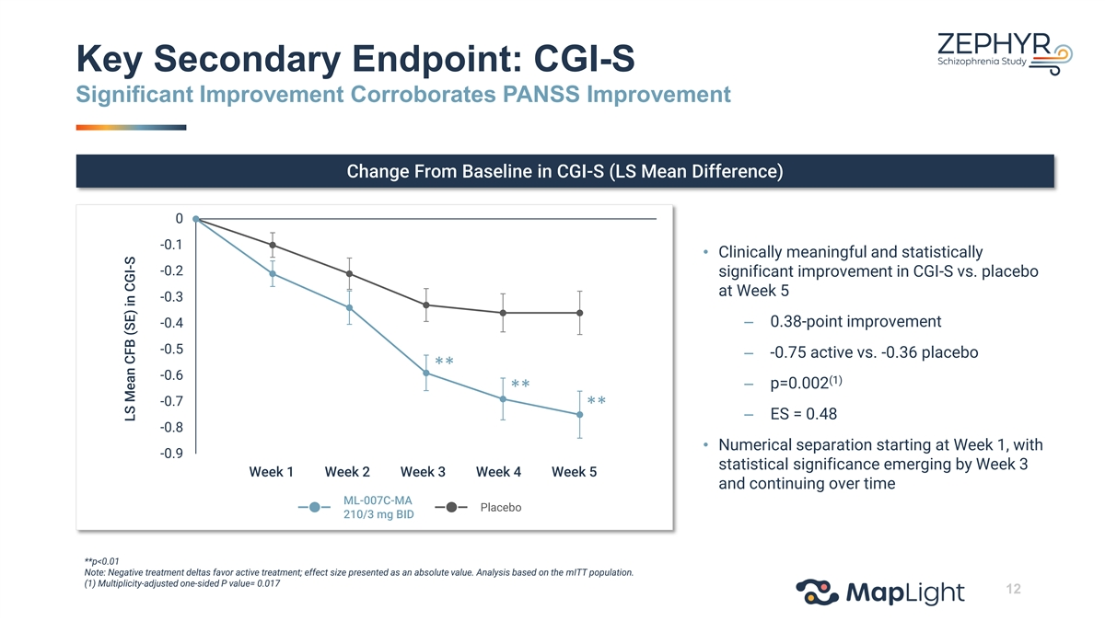
Key Secondary Endpoint: CGI-S Significant Improvement Corroborates PANSS Improvement Change From Baseline in CGI-S (LS Mean Difference) 0 -0.1 • Clinically meaningful and statistically -0.2 significant improvement in CGI-S vs. placebo at Week 5 -0.3 – 0.38-point improvement -0.4 -0.5 – -0.75 active vs. -0.36 placebo ** -0.6 (1) – p=0.002 ** -0.7 ** – ES = 0.48 -0.8 • Numerical separation starting at Week 1, with -0.9 statistical significance emerging by Week 3 0 1 2 3 4 5 6 Week 1 Week 2 Week 3 Week 4 Week 5 and continuing over time ML-007C-MA Placebo 210/3 mg BID **p<0.01 Note: Negative treatment deltas favor active treatment; effect size presented as an absolute value. Analysis based on the mITT population. (1) Multiplicity-adjusted one-sided P value= 0.017 12 LS Mean CFB (SE) in CGI-S

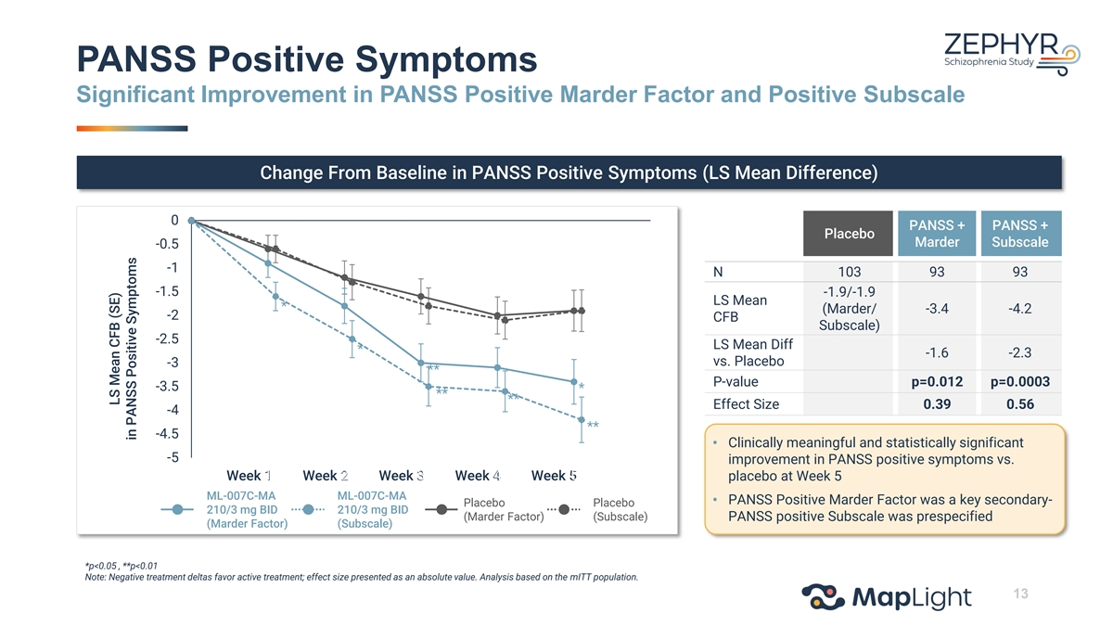
PANSS Positive Symptoms Significant Improvement in PANSS Positive Marder Factor and Positive Subscale Change From Baseline in PANSS Positive Symptoms (LS Mean Difference) 0 PANSS + PANSS + Placebo Marder Subscale -0.5 -1 N 103 93 93 -1.5 -1.9/-1.9 LS Mean * (Marder/ -3.4 -4.2 -2 CFB Subscale) -2.5 LS Mean Diff * -1.6 -2.3 vs. Placebo -3 ** P-value p=0.012 p=0.0003 -3.5 * ** ** Effect Size 0.39 0.56 -4 ** -4.5 • Clinically meaningful and statistically significant -5 improvement in PANSS positive symptoms vs. 0 1 2 3 4 5 6 Week 1 Week 2 Week 3 Week 4 Week 5 placebo at Week 5 ML-007C-MA ML-007C-MA • PANSS Positive Marder Factor was a key secondary- Placebo Placebo 210/3 mg BID 210/3 mg BID (Marder Factor) (Subscale) PANSS positive Subscale was prespecified (Marder Factor) (Subscale) *p<0.05 , **p<0.01 Note: Negative treatment deltas favor active treatment; effect size presented as an absolute value. Analysis based on the mITT population. 13 LS Mean CFB (SE) in PANSS Positive Symptoms

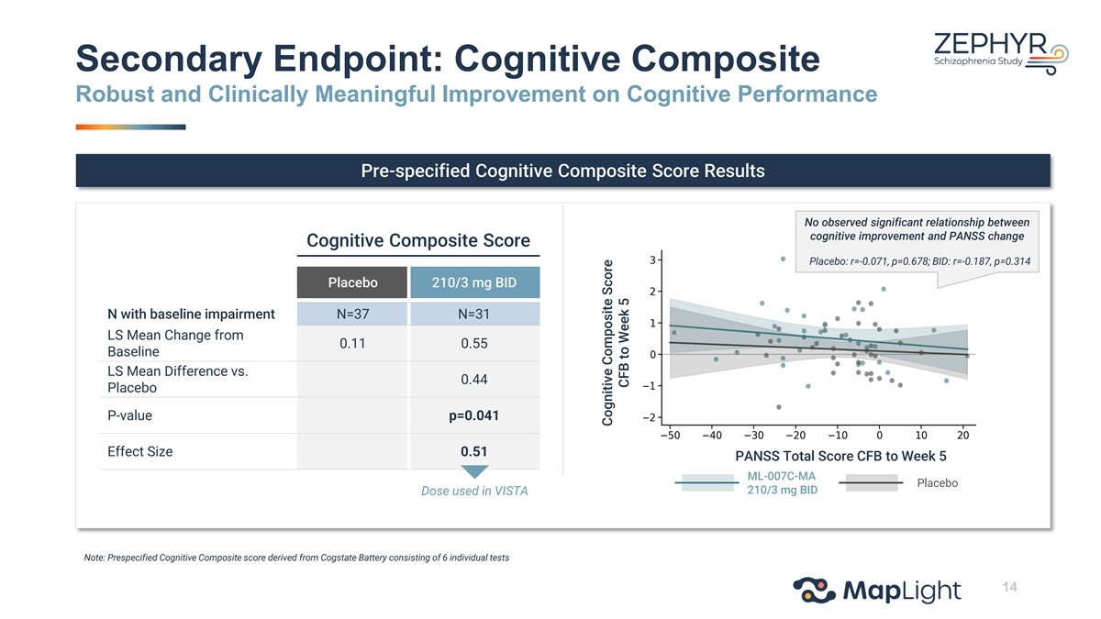
Secondary Endpoint: Cognitive Composite Robust and Clinically Meaningful Improvement on Cognitive Performance Pre-specified Cognitive Composite Score Results No observed significant relationship between cognitive improvement and PANSS change Cognitive Composite Score Placebo: r=-0.071, p=0.678; BID: r=-0.187, p=0.314 Placebo 210/3 mg BID N with baseline impairment N=37 N=31 LS Mean Change from 0.11 0.55 Baseline LS Mean Difference vs. 0.44 Placebo P-value p=0.041 Effect Size 0.51 PANSS Total Score CFB to Week 5 ML-007C-MA Placebo 210/3 mg BID Dose used in VISTA Note: Prespecified Cognitive Composite score derived from Cogstate Battery consisting of 6 individual tests 14 Cognitive Composite Score CFB to Week 5

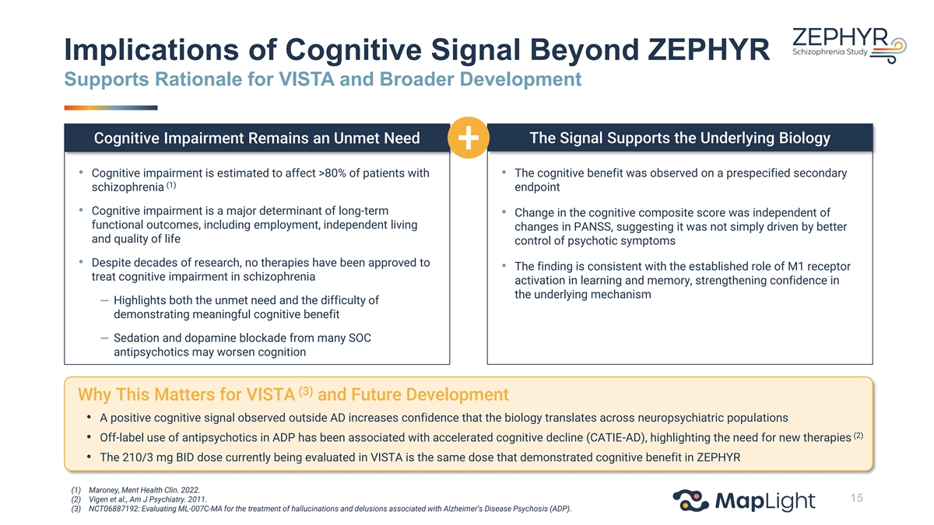
Implications of Cognitive Signal Beyond ZEPHYR Supports Rationale for VISTA and Broader Development The Signal Supports the Underlying Biology Cognitive Impairment Remains an Unmet Need • Cognitive impairment is estimated to affect >80% of patients with • The cognitive benefit was observed on a prespecified secondary (1) schizophrenia endpoint • Cognitive impairment is a major determinant of long-term • Change in the cognitive composite score was independent of functional outcomes, including employment, independent living changes in PANSS, suggesting it was not simply driven by better and quality of life control of psychotic symptoms • Despite decades of research, no therapies have been approved to • The finding is consistent with the established role of M1 receptor treat cognitive impairment in schizophrenia activation in learning and memory, strengthening confidence in the underlying mechanism – Highlights both the unmet need and the difficulty of demonstrating meaningful cognitive benefit – Sedation and dopamine blockade from many SOC antipsychotics may worsen cognition (3) Why This Matters for VISTA and Future Development • A positive cognitive signal observed outside AD increases confidence that the biology translates across neuropsychiatric populations (2) • Off-label use of antipsychotics in ADP has been associated with accelerated cognitive decline (CATIE-AD), highlighting the need for new therapies • The 210/3 mg BID dose currently being evaluated in VISTA is the same dose that demonstrated cognitive benefit in ZEPHYR (1) Maroney, Ment Health Clin. 2022. (2) Vigen et al., Am J Psychiatry. 2011. 15 (3) NCT06887192: Evaluating ML-007C-MA for the treatment of hallucinations and delusions associated with Alzheimer’s Disease Psychosis (ADP).

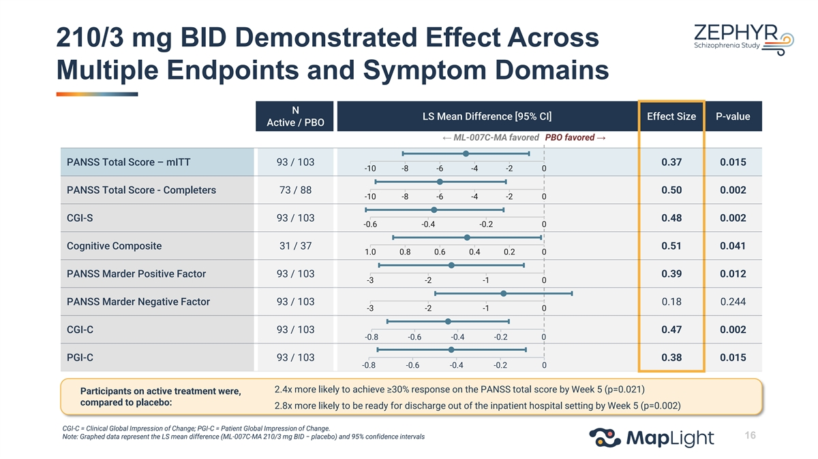
210/3 mg BID Demonstrated Effect Across Multiple Endpoints and Symptom Domains N LS Mean Difference [95% CI] Effect Size P-value Active / PBO ← ML-007C-MA favored PBO favored → PANSS Total Score – mITT 93 / 103 0.37 0.015 -10 -8 -6 -4 -2 0 PANSS Total Score - Completers 73 / 88 0.50 0.002 -10 -8 -6 -4 -2 0 CGI-S 93 / 103 0.48 0.002 -0.6 -0.4 -0.2 0 Cognitive Composite 31 / 37 0.51 0.041 1.0 0.8 0.6 0.4 0.2 0 PANSS Marder Positive Factor 93 / 103 0.39 0.012 -3 -2 -1 0 PANSS Marder Negative Factor 93 / 103 0.18 0.244 -3 -2 -1 0 CGI-C 93 / 103 0.47 0.002 -0.8 -0.6 -0.4 -0.2 0 PGI-C 93 / 103 0.38 0.015 -0.8 -0.6 -0.4 -0.2 0 2.4x more likely to achieve ≥30% response on the PANSS total score by Week 5 (p=0.021) Participants on active treatment were, compared to placebo: 2.8x more likely to be ready for discharge out of the inpatient hospital setting by Week 5 (p=0.002) CGI-C = Clinical Global Impression of Change; PGI-C = Patient Global Impression of Change. 16 Note: Graphed data represent the LS mean difference (ML-007C-MA 210/3 mg BID − placebo) and 95% confidence intervals

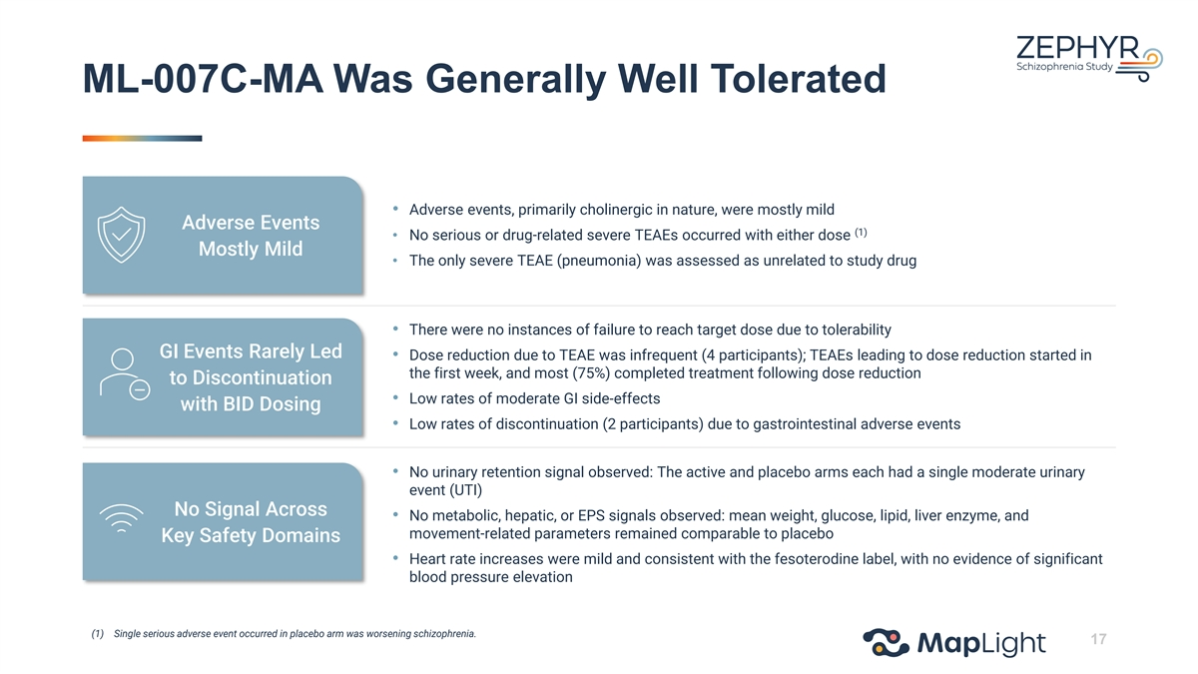
ML-007C-MA Was Generally Well Tolerated • Adverse events, primarily cholinergic in nature, were mostly mild Adverse Events (1) • No serious or drug-related severe TEAEs occurred with either dose Mostly Mild • The only severe TEAE (pneumonia) was assessed as unrelated to study drug • There were no instances of failure to reach target dose due to tolerability GI Events Rarely Led • Dose reduction due to TEAE was infrequent (4 participants); TEAEs leading to dose reduction started in the first week, and most (75%) completed treatment following dose reduction to Discontinuation • Low rates of moderate GI side-effects with BID Dosing • Low rates of discontinuation (2 participants) due to gastrointestinal adverse events • No urinary retention signal observed: The active and placebo arms each had a single moderate urinary event (UTI) No Signal Across • No metabolic, hepatic, or EPS signals observed: mean weight, glucose, lipid, liver enzyme, and movement-related parameters remained comparable to placebo Key Safety Domains • Heart rate increases were mild and consistent with the fesoterodine label, with no evidence of significant blood pressure elevation (1) Single serious adverse event occurred in placebo arm was worsening schizophrenia. 17

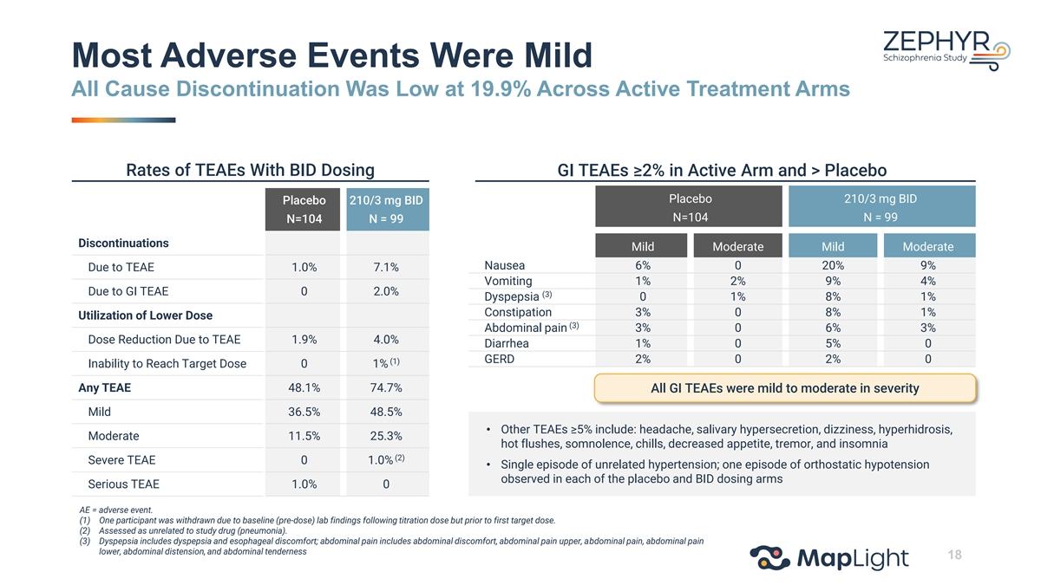
Most Adverse Events Were Mild All Cause Discontinuation Was Low at 19.9% Across Active Treatment Arms Rates of TEAEs With BID Dosing GI TEAEs ≥2% in Active Arm and > Placebo Placebo 210/3 mg BID Placebo 210/3 mg BID N=104 N = 99 N=104 N = 99 Discontinuations Mild Moderate Mild Moderate Nausea 6% 0 20% 9% Due to TEAE 1.0% 7.1% Vomiting 1% 2% 9% 4% Due to GI TEAE 0 2.0% (3) Dyspepsia 0 1% 8% 1% Constipation 3% 0 8% 1% Utilization of Lower Dose (3) Abdominal pain 3% 0 6% 3% Dose Reduction Due to TEAE 1.9% 4.0% Diarrhea 1% 0 5% 0 GERD 2% 0 2% 0 (1) Inability to Reach Target Dose 0 1% Any TEAE 48.1% 74.7% All GI TEAEs were mild to moderate in severity Mild 36.5% 48.5% • Other TEAEs ≥5% include: headache, salivary hypersecretion, dizziness, hyperhidrosis, Moderate 11.5% 25.3% hot flushes, somnolence, chills, decreased appetite, tremor, and insomnia (2) Severe TEAE 0 1.0% • Single episode of unrelated hypertension; one episode of orthostatic hypotension observed in each of the placebo and BID dosing arms Serious TEAE 1.0% 0 AE = adverse event. (1) One participant was withdrawn due to baseline (pre-dose) lab findings following titration dose but prior to first target dose. (2) Assessed as unrelated to study drug (pneumonia). (3) Dyspepsia includes dyspepsia and esophageal discomfort; abdominal pain includes abdominal discomfort, abdominal pain upper, abdominal pain, abdominal pain lower, abdominal distension, and abdominal tenderness 18

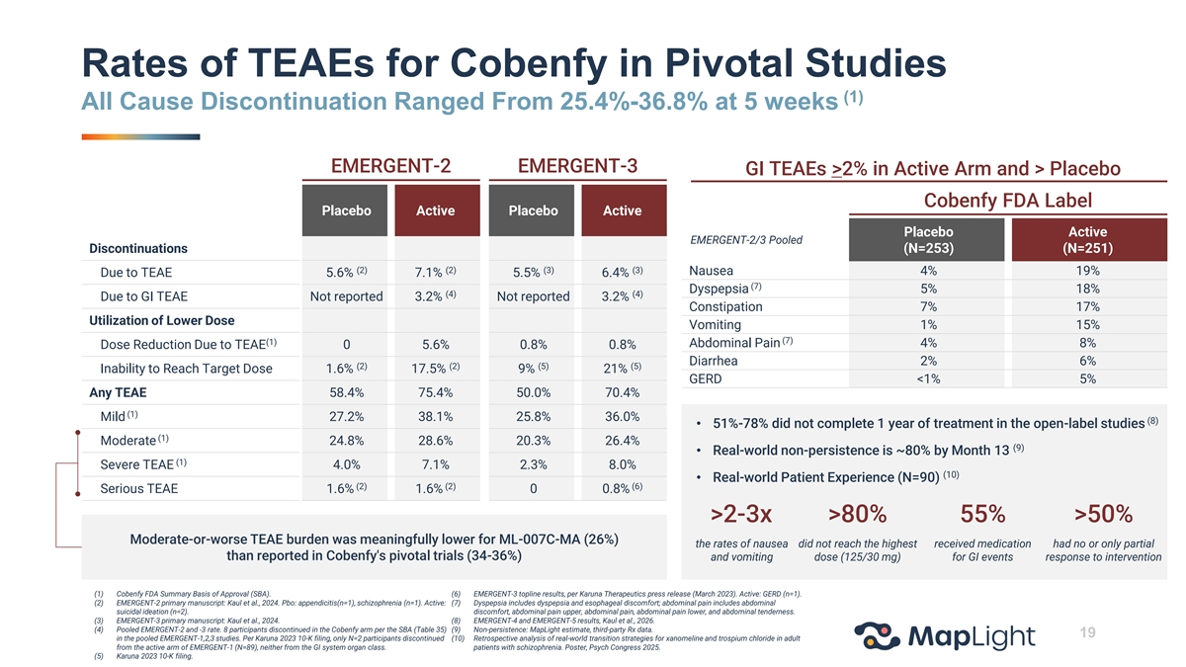
Rates of TEAEs for Cobenfy in Pivotal Studies (1) All Cause Discontinuation Ranged From 25.4%-36.8% at 5 weeks EMERGENT-2 EMERGENT-3 GI TEAEs >2% in Active Arm and > Placebo Cobenfy FDA Label Placebo Active Placebo Active Placebo Active EMERGENT-2/3 Pooled Discontinuations (N=253) (N=251) (2) (2) (3) (3) Nausea 4% 19% Due to TEAE 5.6% 7.1% 5.5% 6.4% (7) Dyspepsia 5% 18% (4) (4) Due to GI TEAE Not reported 3.2% Not reported 3.2% Constipation 7% 17% Utilization of Lower Dose Vomiting 1% 15% (7) (1) Abdominal Pain 4% 8% Dose Reduction Due to TEAE 0 5.6% 0.8% 0.8% Diarrhea 2% 6% (2) (2) (5) (5) Inability to Reach Target Dose 1.6% 17.5% 9% 21% GERD <1% 5% Any TEAE 58.4% 75.4% 50.0% 70.4% (1) Mild 27.2% 38.1% 25.8% 36.0% (8) • 51%-78% did not complete 1 year of treatment in the open-label studies (1) Moderate 24.8% 28.6% 20.3% 26.4% (9) • Real-world non-persistence is ~80% by Month 13 (1) Severe TEAE 4.0% 7.1% 2.3% 8.0% (10) • Real-world Patient Experience (N=90) (2) (2) (6) Serious TEAE 1.6% 1.6% 0 0.8% >2-3x >80% 55% >50% Moderate-or-worse TEAE burden was meaningfully lower for ML-007C-MA (26%) the rates of nausea did not reach the highest received medication had no or only partial than reported in Cobenfy's pivotal trials (34-36%) and vomiting dose (125/30 mg) for GI events response to intervention (1) Cobenfy FDA Summary Basis of Approval (SBA). (6) EMERGENT-3 topline results, per Karuna Therapeutics press release (March 2023). Active: GERD (n=1). (2) EMERGENT-2 primary manuscript: Kaul et al., 2024. Pbo: appendicitis(n=1), schizophrenia (n=1). Active: (7) Dyspepsia includes dyspepsia and esophageal discomfort; abdominal pain includes abdominal suicidal ideation (n=2). discomfort, abdominal pain upper, abdominal pain, abdominal pain lower, and abdominal tenderness. (3) EMERGENT-3 primary manuscript: Kaul et al., 2024. (8) EMERGENT-4 and EMERGENT-5 results, Kaul et al., 2026. (4) Pooled EMERGENT-2 and -3 rate. 8 participants discontinued in the Cobenfy arm per the SBA (Table 35) (9) Non-persistence: MapLight estimate, third-party Rx data. 19 in the pooled EMERGENT-1,2,3 studies. Per Karuna 2023 10-K filing, only N=2 participants discontinued (10) Retrospective analysis of real-world transition strategies for xanomeline and trospium chloride in adult from the active arm of EMERGENT-1 (N=89), neither from the GI system organ class. patients with schizophrenia. Poster, Psych Congress 2025. (5) Karuna 2023 10-K filing.


Future Development Considerations Chris Kroeger, M.D. | Co-Founder and Chief Executive Officer

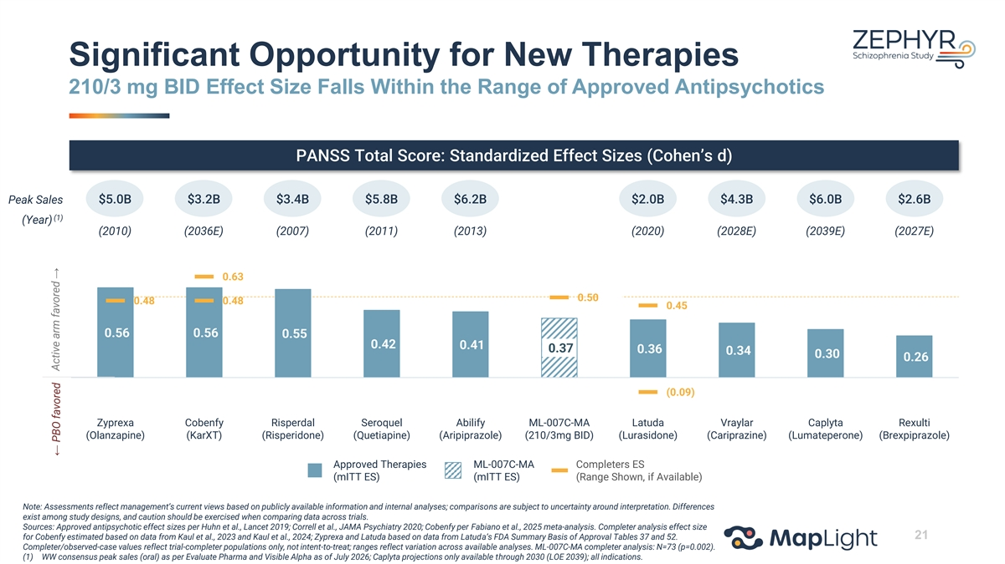
Significant Opportunity for New Therapies 210/3 mg BID Effect Size Falls Within the Range of Approved Antipsychotics PANSS Total Score: Standardized Effect Sizes (Cohen’s d) Peak Sales $5.0B $3.2B $3.4B $5.8B $6.2B $2.0B $4.3B $6.0B $2.6B (1) (Year) (2010) (2036E) (2007) (2011) (2013) (2020) (2028E) (2039E) (2027E) 0.63 0.50 0.48 0.48 0.45 0.56 0.56 0.55 0.42 0.41 0.37 0.36 0.34 0.30 0.26 (0.09) Zyprexa Cobenfy Risperdal Seroquel Abilify ML-007C-MA Latuda Vraylar Caplyta Rexulti (Olanzapine) (KarXT) (Risperidone) (Quetiapine) (Aripiprazole) (210/3mg BID) (Lurasidone) (Cariprazine) (Lumateperone) (Brexpiprazole) Approved Therapies ML-007C-MA Completers ES (mITT ES) (mITT ES) (Range Shown, if Available) Note: Assessments reflect management’s current views based on publicly available information and internal analyses; comparisons are subject to uncertainty around interpretation. Differences exist among study designs, and caution should be exercised when comparing data across trials. Sources: Approved antipsychotic effect sizes per Huhn et al., Lancet 2019; Correll et al., JAMA Psychiatry 2020; Cobenfy per Fabiano et al., 2025 meta-analysis. Completer analysis effect size 21 for Cobenfy estimated based on data from Kaul et al., 2023 and Kaul et al., 2024; Zyprexa and Latuda based on data from Latuda’s FDA Summary Basis of Approval Tables 37 and 52. Completer/observed-case values reflect trial-completer populations only, not intent-to-treat; ranges reflect variation across available analyses. ML-007C-MA completer analysis: N=73 (p=0.002). (1) WW consensus peak sales (oral) as per Evaluate Pharma and Visible Alpha as of July 2026; Caplyta projections only available through 2030 (LOE 2039); all indications. Active arm favored → ← PBO favored

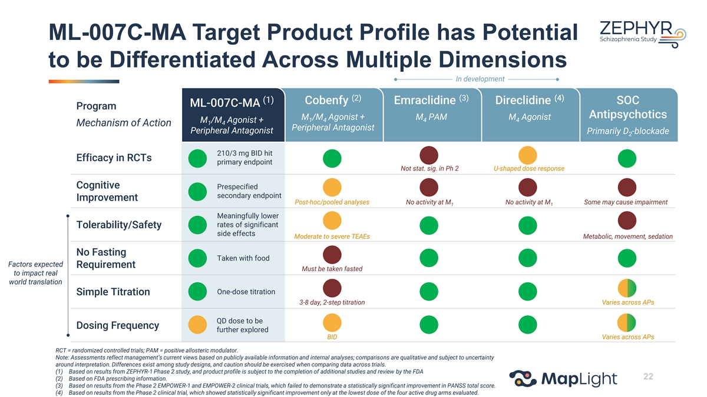
ML-007C-MA Target Product Profile has Potential to be Differentiated Across Multiple Dimensions In development (2) (3) (4) (1) Cobenfy Emraclidine Direclidine SOC ML-007C-MA Program Antipsychotics M /M Agonist + M PAM M Agonist 1 4 4 4 M /M Agonist + 1 4 Mechanism of Action Peripheral Antagonist Peripheral Antagonist Primarily D -blockade 2 210/3 mg BID hit Efficacy in RCTs primary endpoint Not stat. sig. in Ph 2 U-shaped dose response Cognitive Prespecified secondary endpoint Improvement Post-hoc/pooled analyses No activity at M No activity at M Some may cause impairment 1 1 Meaningfully lower rates of significant Tolerability/Safety side effects Moderate to severe TEAEs Metabolic, movement, sedation No Fasting Taken with food Factors expected Requirement Must be taken fasted to impact real world translation One-dose titration Simple Titration 3-8 day, 2-step titration Varies across APs QD dose to be Dosing Frequency further explored BID Varies across APs RCT = randomized controlled trials; PAM = positive allosteric modulator. Note: Assessments reflect management’s current views based on publicly available information and internal analyses; comparisons are qualitative and subject to uncertainty around interpretation. Differences exist among study designs, and caution should be exercised when comparing data across trials. (1) Based on results from ZEPHYR-1 Phase 2 study, and product profile is subject to the completion of additional studies and review by the FDA 22 (2) Based on FDA prescribing information. (3) Based on results from the Phase 2 EMPOWER-1 and EMPOWER-2 clinical trials, which failed to demonstrate a statistically significant improvement in PANSS total score. (4) Based on results from the Phase 2 clinical trial, which showed statistically significant improvement only at the lowest dose of the four active drug arms evaluated.

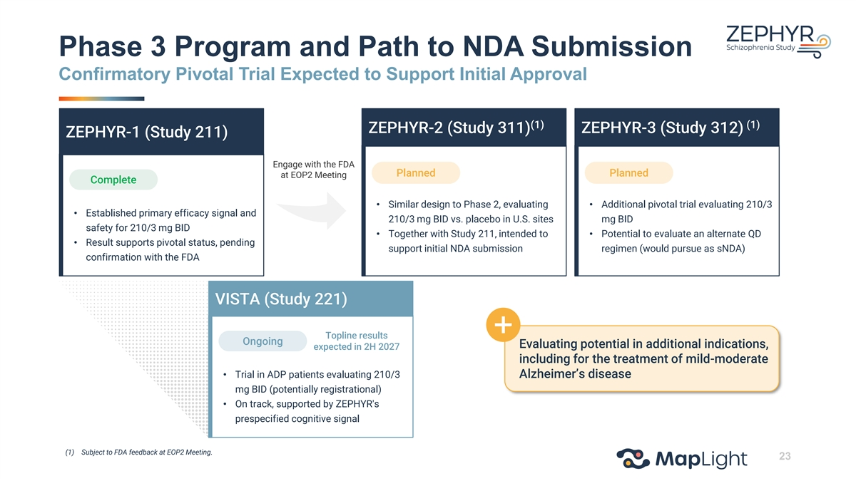
Phase 3 Program and Path to NDA Submission Confirmatory Pivotal Trial Expected to Support Initial Approval (1) (1) ZEPHYR-2 (Study 311) ZEPHYR-3 (Study 312) ZEPHYR-1 (Study 211) Engage with the FDA Planned Planned at EOP2 Meeting Complete • Similar design to Phase 2, evaluating • Additional pivotal trial evaluating 210/3 • Established primary efficacy signal and 210/3 mg BID vs. placebo in U.S. sites mg BID safety for 210/3 mg BID • Together with Study 211, intended to • Potential to evaluate an alternate QD • Result supports pivotal status, pending support initial NDA submission regimen (would pursue as sNDA) confirmation with the FDA VISTA (Study 221) Topline results Ongoing Evaluating potential in additional indications, expected in 2H 2027 including for the treatment of mild-moderate • Trial in ADP patients evaluating 210/3 Alzheimer’s disease mg BID (potentially registrational) • On track, supported by ZEPHYR's prespecified cognitive signal (1) Subject to FDA feedback at EOP2 Meeting. 23


Closing Remarks Chris Kroeger, M.D. | Co-Founder and Chief Executive Officer

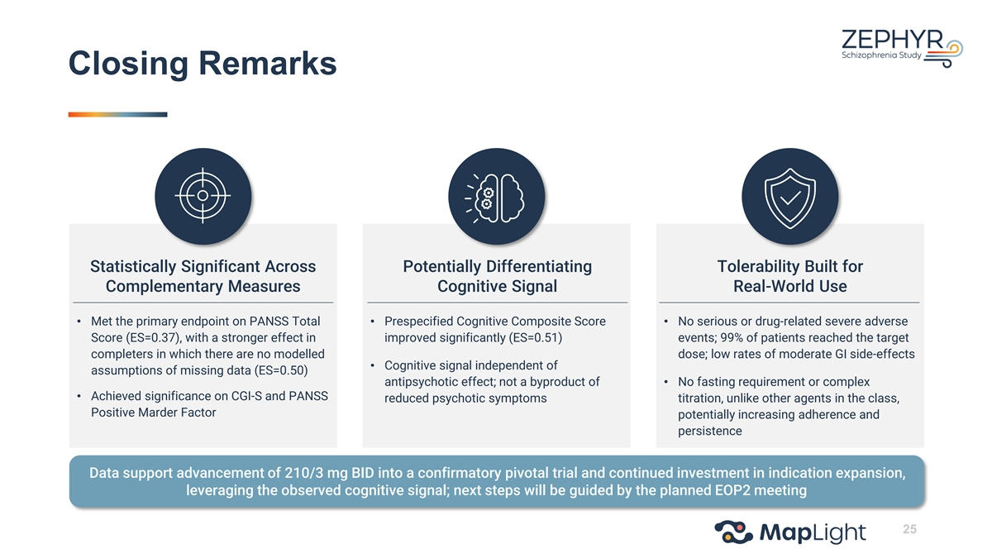
Closing Remarks Statistically Significant Across Potentially Differentiating Tolerability Built for Complementary Measures Cognitive Signal Real-World Use • Met the primary endpoint on PANSS Total • Prespecified Cognitive Composite Score • No serious or drug-related severe adverse Score (ES=0.37), with a stronger effect in improved significantly (ES=0.51) events; 99% of patients reached the target completers in which there are no modelled dose; low rates of moderate GI side-effects • Cognitive signal independent of assumptions of missing data (ES=0.50) antipsychotic effect; not a byproduct of • No fasting requirement or complex • Achieved significance on CGI-S and PANSS reduced psychotic symptoms titration, unlike other agents in the class, Positive Marder Factor potentially increasing adherence and persistence Data support advancement of 210/3 mg BID into a confirmatory pivotal trial and continued investment in indication expansion, leveraging the observed cognitive signal; next steps will be guided by the planned EOP2 meeting 25

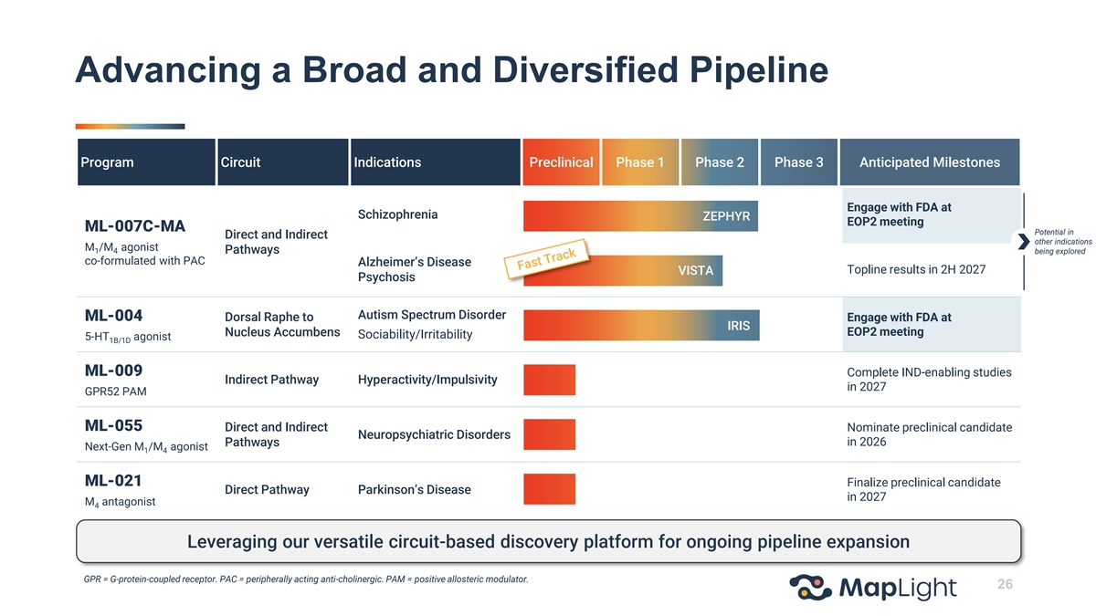
Advancing a Broad and Diversified Pipeline Program Circuit Indications Preclinical Phase 1 Phase 2 Phase 3 Anticipated Milestones Engage with FDA at Schizophrenia ZEPHYR EOP2 meeting ML-007C-MA Potential in Direct and Indirect other indications M /M agonist 1 4 Pathways being explored co-formulated with PAC Alzheimer’s Disease Topline results in 2H 2027 VISTA Psychosis Autism Spectrum Disorder ML-004 Dorsal Raphe to Engage with FDA at IRIS EOP2 meeting Nucleus Accumbens Sociability/Irritability 5-HT agonist 1B/1D ML-009 Complete IND-enabling studies Indirect Pathway Hyperactivity/Impulsivity in 2027 GPR52 PAM ML-055 Direct and Indirect Nominate preclinical candidate Neuropsychiatric Disorders Pathways in 2026 Next-Gen M /M agonist 1 4 ML-021 Finalize preclinical candidate Direct Pathway Parkinson’s Disease in 2027 M antagonist 4 Leveraging our versatile circuit-based discovery platform for ongoing pipeline expansion GPR = G-protein-coupled receptor. PAC = peripherally acting anti-cholinergic. PAM = positive allosteric modulator. 26


Q&A
Exhibit 99.2
MapLight Therapeutics Announces Positive Topline Results from Phase 2 ZEPHYR Trial of ML-007C-MA in Schizophrenia

The trial, designed and sized to support registration, met its primary endpoint, with the 210/3 mg BID dose demonstrating a statistically significant improvement in PANSS total score compared to placebo at Week 5 with an effect size of 0.37 (LS mean difference vs PBO -4.5, p=0.015)
Cognitive performance was improved (ES=0.51, p=0.041) in those with baseline cognitive impairment on a prespecified secondary endpoint
210/3 mg BID dose also achieved significant separation on key secondary endpoints, including CGI-S (ES=0.48, p=0.002) and PANSS Positive Marder Factor (ES=0.39, p=0.012)
ML-007C-MA was generally well tolerated at both doses studied, with no serious or drug-related severe adverse events and low rates of GI-related discontinuations
No fasting requirement and a one-dose titration support a tolerability profile expected to translate into real-world adherence
Data support proceeding with an additional trial, also designed to be registrational, to replicate this result; Company to engage with FDA at End-of-Phase 2 Meeting
Company to host live webcast today at 8:00 AM ET
SAN FRANCISCO and BOSTON, July 27, 2026 (GLOBE NEWSWIRE) — MapLight Therapeutics, Inc. (Nasdaq: MPLT), a clinical-stage biopharmaceutical company focused on improving the lives of patients suffering from debilitating central nervous system disorders, today announced positive topline results from its Phase 2 ZEPHYR trial evaluating ML-007C-MA, an oral M1/M4 muscarinic agonist (betovumeline) co-formulated with a peripherally acting anticholinergic (fesoterodine), in adults with an acute exacerbation of schizophrenia. The trial met its primary endpoint, with the 210/3 mg twice-daily (BID) dose demonstrating a statistically significant and clinically meaningful reduction in Positive and Negative Syndrome Scale (PANSS) total score compared to placebo at Week 5.
In the modified intent-to-treat (mITT) population, the BID arm achieved an effect size of 0.37 (Cohen’s d) and these participants experienced a mean 4.5-point improvement in PANSS total score versus placebo (p=0.015). In a prespecified analysis of participants who completed five weeks of treatment, in which there are no modelled assumptions for missing data, the effect size was 0.50 (LS mean difference from placebo -6.0, p=0.002), driven by greater improvement in the treatment arm rather than the placebo arm. ML-007C-MA also achieved significance on key secondary endpoints in the BID arm, including Clinical Global Impression of Severity (CGI-S) (effect size=0.48; p=0.002), PANSS positive Marder factor (effect size=0.39; p=0.012), and multiple other secondary and exploratory outcomes.

Notably, ML-007C-MA demonstrated a robust and clinically meaningful improvement in cognitive performance in the BID arm, based on the pre-specified secondary endpoint assessed via the Cogstate battery in participants with baseline cognitive impairment (effect size=0.51; 0.44 points versus placebo; p=0.041). This cognitive benefit did not demonstrate correlation with the change in PANSS score, suggesting the effect was independent of, and not secondary to, improvement in psychotic symptoms.
“We are very encouraged by these results, which show that ML-007C-MA delivered clinically meaningful antipsychotic efficacy alongside a favorable tolerability profile designed to translate into real-world use,” said Chris Kroeger, M.D., Co-Founder and Chief Executive Officer of MapLight. “Just as importantly, we observed a robust signal on a pre-specified secondary cognition endpoint that appears independent of antipsychotic effect. Cognitive impairment affects the majority of people living with schizophrenia and remains an area where no therapy has yet been approved. We believe the combination of a significant effect on PANSS and other concordant endpoints, along with a meaningful effect on cognitive performance, represents a powerful, comprehensive overall efficacy profile in schizophrenia, and strengthens the rationale for our ongoing VISTA trial in Alzheimer’s disease psychosis and the broader indication expansion for ML-007C-MA.”
The 330/6 mg once-daily (QD) dose, which results in lower daily exposure than BID dosing, demonstrated numerical improvement over placebo, but did not achieve statistical significance on the primary endpoint. However, it did demonstrate separation on CGI-S (p=0.036), PANSS positive Marder factor (p=0.045), and Readiness for Discharge Questionnaire (p=0.027) and numerical separation on several other endpoints. The Company is conducting further analyses to inform the potential path forward for a once-daily regimen.
Safety and Tolerability
ML-007C-MA was generally well tolerated across all doses studied. Treatment-emergent adverse events (TEAEs) were mostly mild and primarily cholinergic in nature, and there were no serious adverse events or drug-related severe TEAEs with either dose. The only severe TEAE in an active arm was a case of pneumonia, which was assessed as unrelated to study treatment. One serious TEAE of worsening schizophrenia occurred in the placebo arm. All-cause discontinuation across both active arms was low, at 19.9%.
At the 210/3 mg BID dose, TEAEs were reported in 74.7% of participants compared with 48.1% receiving placebo, with most events mild in severity. Gastrointestinal events were mostly mild and rarely associated with discontinuation (two participants, 2.0%), and there were low rates of moderate GI events. No participant failed to reach target dose due to tolerability, and dose reductions due to TEAEs were infrequent (four participants, or 4.0%, three of whom completed treatment).

The rates of anticholinergic events were low, and no clinically meaningful signals were observed with ML-007C-MA for urinary retention, metabolic or hepatic parameters, extrapyramidal symptoms, or blood pressure. Small increases in heart rate were observed, consistent with the known profile of fesoterodine. With no fasting requirement and a short, one-dose titration, these clinical trial results are expected to translate into real-world use, supporting patient adherence and compliance. “Despite recent advances in schizophrenia treatment, patients and clinicians continue to need therapies that pair meaningful symptom control with a tolerability profile patients can sustain over time,” said John M. Kane, M.D., Professor of Psychiatry and Molecular Medicine at the Donald and Barbara Zucker School of Medicine at Hofstra/Northwell, Co-Director of the Institute for Behavioral Science at the Feinstein Institutes for Medical Research, and member of MapLight Therapeutics’ Clinical Advisory Board. “The ZEPHYR results are notable on both fronts: a statistically significant improvement on the primary endpoint and cognitive performance, alongside a meaningfully differentiated safety profile that matters most for the management of patients over time. If confirmed in a further study and approved, ML-007C-MA could offer physicians a valuable additional tool in the treatment arsenal for people living with schizophrenia.”
Future Development
The Company plans to engage with the FDA at an End-of-Phase 2 (EOP2) meeting to discuss the path forward for ML-007C-MA in schizophrenia, including the design of a Phase 3 trial which, together with ZEPHYR, would support an initial New Drug Application (NDA) submission. Planning and site identification for this additional, confirmatory trial are already underway ahead of the MapLight’s EOP2 FDA interactions. The Company is also planning a separate confirmatory trial to evaluate the BID dose used in ZEPHYR along with other dosing regimens, including a possible QD option. VISTA, MapLight’s ongoing trial designed to support registration for the treatment of hallucinations and delusions associated with Alzheimer’s disease psychosis, is also evaluating ML-007C-MA 210/3 mg BID (the same dose associated with the cognitive effect in ZEPHYR), with topline results expected in the second half of 2027.
Additionally, the Company recently reported results for IRIS, a Phase 2 trial evaluating ML-004, an 5-HT1B/1D agonist in autism spectrum disorder (ASD), where a prespecified subgroup analysis in adolescents with significant baseline irritability demonstrated meaningful improvement over placebo on both caregiver- and clinician-rated scales alongside a favorable safety and tolerability profile. Based on these results, the Company intends to engage with the FDA in an EOP2 meeting to determine the next steps for development of ML-004 in irritability associated with ASD.

Live Webcast
The Company will host a live webcast to discuss the Phase 2 ZEPHYR trial results today, Monday, July 27, 2026, at 8:00 a.m. ET. Those who would like to participate may access the live webcast here, or register in advance for the teleconference here.
The event will also be accessible through the “Events and Presentations” page within the Investors section of the Maplight website at https://ir.maplightrx.com/news-events/events-presentations. An archived replay will also be available on the website for at least 90 days following the event.
About ZEPHYR
ZEPHYR is a randomized, double-blind, placebo-controlled trial at 25 US sites that evaluated the efficacy, safety, and tolerability of ML-007C-MA in inpatient adult participants with schizophrenia experiencing an acute exacerbation of psychosis. A total of 307 participants were randomized 1:1:1 to receive either placebo, ML-007C-MA 210/3 mg twice daily, or ML-007C-MA 330/6 mg once daily. The primary endpoint for the trial was the change in PANSS total score from baseline to Week 5. Key secondary endpoints included change in CGI-S score and PANSS-Marder positive and negative factor scores from baseline to Week 5. Change in cognitive function in participants with baseline cognitive impairment from baseline to Week 5 was assessed as a prespecified secondary endpoint.
About ML-007C-MA
ML-007C-MA is an oral, extended-release, fixed-dose combination of the investigational M1/M4 muscarinic agonist ML-007 (betovumeline), co-formulated with a peripherally acting anticholinergic (fesoterodine). ML-007C-MA is designed to activate both M1 and M4 muscarinic receptors in the central nervous system to drive efficacy, while synchronizing the pharmacokinetics of the agonist and antagonist components to mitigate peripheral cholinergic side effects.
About MapLight Therapeutics
MapLight Therapeutics is a clinical-stage biopharmaceutical company focused on improving the lives of patients suffering from debilitating central nervous system disorders. The Company was founded by globally recognized leaders in psychiatry and neuroscience research to address the lack of circuit-specific pharmacotherapies available for patients. The Company’s discovery platform holds the potential to fill this void by identifying neural circuits causally linked to disease and targeting those circuits for therapeutic modulation.
For more information, please visit www.maplightrx.com.

Forward-Looking Statements
Certain statements in this press release may constitute “forward-looking statements” within the meaning of the federal securities laws, including, but not limited to, the clinical development and potential benefits of ML-007C-MA and ML-004, the design, timing and conducting of future clinical trials, the registrational pathway for the Company’s product candidates, including holding EOP2 meetings with the FDA for ML-007C-MA and ML-004 and planned regulatory submissions, the availability and timing of results from the Company’s Phase 2 VISTA trial, and the potential benefits of the Company’s discovery platform. Words such as “may,” “might,” “will,” “objective,” “intend,” “should,” “could,” “can,” “would,” “expect,” “believe,” “design,” “estimate,” “predict,” “potential,” “develop,” “plan” or the negative of these terms, and similar expressions, are intended to identify forward-looking statements. While the Company believes these forward-looking statements are reasonable, undue reliance should not be placed on any such forward-looking statements, which are based on information available to the Company on the date of this release. These forward-looking statements are based upon current estimates and assumptions and are subject to various risks and uncertainties (including, without limitation, those set forth in the Company’s filings with the U.S. Securities and Exchange Commission (SEC)), many of which are beyond the Company’s control and subject to change. Actual results could be materially different. Risks and uncertainties include: the unpredictable relationship between preclinical study results and clinical study results; the risk that results obtained in any clinical trials to date may not be indicative of results obtained in ongoing or future trials; the timing or likelihood of regulatory filings and approvals; expectations regarding the Company’s ability to fund its current operations; and other risks and uncertainties identified in the Company’s Quarterly Report on Form 10-Q for the quarter ended March 31, 2026, and subsequent disclosure documents the Company may file with the SEC. The Company claims the protection of the safe harbor contained in the Private Securities Litigation Reform Act of 1995 for forward-looking statements. The Company expressly disclaims any obligation to update or alter any statements whether as a result of new information, future events or otherwise, except as required by law.
For investor inquiries: investors@maplightrx.com
For media inquiries: media@maplightrx.com

