UNITED STATES
SECURITIES AND EXCHANGE COMMISSION
Washington, D.C. 20549

FORM 8-K

CURRENT REPORT
Pursuant to Section 13 or 15(d)
of the Securities Exchange Act of 1934
Date of Report (Date of earliest event reported): August 13, 2026

MapLight Therapeutics, Inc.
(Exact name of registrant as specified in its charter)

Delaware |  | 001-42914 |  | 83-2163243
(State or other jurisdiction  of incorporation) |  | (Commission  File Number) |  | (IRS Employer  Identification No.)
800 Chesapeake Drive
Redwood City, California 94063
(Address of principal executive offices)
Registrant’s telephone number, including area code: (617) 984-6300
N/A
(Former name or former address, if changed since last report.)

Check the appropriate box below if the Form 8-K filing is intended to simultaneously satisfy the filing obligation of the registrant under any of the following provisions:

☐ | Written communications pursuant to Rule 425 under the Securities Act (17 CFR 230.425)

☐ | Soliciting material pursuant to Rule 14a-12 under the Exchange Act (17 CFR 240.14a-12)

☐ | Pre-commencement communications pursuant to Rule 14d-2(b) under the Exchange Act (17 CFR 240.14d-2(b))

☐ | Pre-commencement communications pursuant to Rule 13e-4(c) under the Exchange Act (17 CFR 240.13e-4(c))
Securities registered pursuant to Section 12(b) of the Act:

Title of each class |  | Trading  symbol(s) |  | Name of each exchange  on which registered
Voting Common Stock, $0.0001 par value per share |  | MPLT |  | Nasdaq Global Select Market
Indicate by check mark whether the registrant is an emerging growth company as defined in as defined in Rule 405 of the Securities Act of 1933 (§230.405 of this chapter) or Rule 12b-2 of the Securities Exchange Act of 1934 (§240.12b-2 of this chapter).
Emerging growth company ☒
If an emerging growth company, indicate by check mark if the registrant has elected not to use the extended transition period for complying with any new or revised financial accounting standards provided pursuant to Section 13(a) of the Exchange Act. ☐

Item 1.01 | Entry Into A Material Definitive Agreement.
On August 13, 2026, MapLight Therapeutics, Inc. (the “Company”) entered into a Securities Purchase Agreement (the “Purchase Agreement”) with certain institutional investors (the “Purchasers”), pursuant to which the Company agreed to sell and issue to the Purchasers in a private placement transaction (the “Private Placement”) (i) 9,197,887 shares (the “Shares”) of the Company’s voting common stock, par value $0.0001 (“Common Stock”) per share, and (ii) with respect to certain Purchasers, pre-funded warrants to purchase 3,983,168 shares of Common Stock (the “Pre-Funded Warrants”) in lieu of Shares. The purchase price per share of Common Stock is $11.38 per share (the “Purchase Price”) and the purchase price for the Pre-Funded Warrants is the Purchase Price minus $0.0001 per share underlying the Pre-Funded Warrants. The Company anticipates receiving gross proceeds of approximately $150.0 million from the Private Placement, before deducting placement agent fees and estimated offering expenses payable by the Company.
The Pre-Funded Warrants have a per share exercise price of $0.0001, subject to proportional adjustments in the event of stock splits or combinations or similar events. The Pre-Funded Warrants will not expire until exercised in full. The Pre-Funded Warrants may not be exercised if the aggregate number of shares of Common Stock beneficially owned by the holder thereof immediately following such exercise would exceed a specified beneficial ownership limitation; provided, however, that a holder that holds less than 20% of the Common Stock prior to such exercise may increase or decrease the beneficial ownership limitation by giving 61 days’ notice to the Company, but not to any percentage in excess of 19.99%.
Also on August 13, 2026, the Company entered into a Registration Rights Agreement (the “Registration Rights Agreement”) with the Purchasers. Under the terms of the Registration Rights Agreement, the Company has agreed to prepare and file, within 30 days after the Closing (the “Filing Deadline”), one or more registration statements with the Securities and Exchange Commission (the “SEC”) to register for resale the Common Stock issued under the Purchase Agreement and the shares of Common Stock issuable upon exercise of the Pre-Funded Warrants (the “Warrant Shares”) issued pursuant to the Purchase Agreement (together, the “Registrable Securities”), and to cause the applicable registration statements to become effective within a specified period set forth in the Registration Rights Agreement (the “Effectiveness Deadline”).
In the event the registration statement has not been filed by the Filing Deadline or has not been declared effective by the SEC by the Effectiveness Deadline, subject to certain limited exceptions, the Company has agreed to make pro rata payments to each Purchaser as liquidated damages in an amount equal to 1.0% of the aggregate amount paid pursuant to the Purchase Agreement by such Purchaser for the Purchaser’s Registrable Securities then held, per 30-day period or pro rata for any portion thereof for each such 30-day period during which such event continues, subject to certain caps set forth in the Registration Rights Agreement.
The Purchase Agreement contains customary representations, warranties and covenants that were made solely for the benefit of the parties to the Purchase Agreement. Such representations, warranties and covenants (i) are intended as a way of allocating risk between the parties to the Purchase Agreement and not as statements of fact, and (ii) may apply standards of materiality in a way that is different from what may be viewed as material by stockholders of, or other investors in, the Company. Accordingly, the Purchase Agreement is included with this filing only to provide investors with information regarding the terms of transaction and not to provide investors with any other factual information regarding the Company.
The Company has engaged Morgan Stanley & Co. LLC, Jefferies LLC, Leerink Partners LLC and Stifel, Nicolaus & Company, Incorporated as placement agents for the Private Placement. The Company has agreed to pay customary placement fees and reimburse certain expenses of the placement agents.
The Company has granted the Purchasers customary indemnification rights in connection with the registration statement. The Purchasers have also granted the Company customary indemnification rights in connection with the registration statement.
The foregoing is only a summary of the terms of the Purchase Agreement, the Registration Rights Agreement and the Pre-Funded Warrants issued under the Purchase Agreement, does not purport to be complete and is qualified in its entirety by reference to the full text of (i) the form of the Purchase Agreement, a copy of which is attached to this

Current Report on Form 8-K as Exhibit 10.1, (ii) the form of the Registration Rights Agreement, a copy of which is attached to this Current Report on Form 8-K as Exhibit 10.2, and (iii) the form of Pre-Funded Warrant issued under the Purchase Agreement, a copy of which is attached to this Current Report on Form 8-K as Exhibit 4.1.

Item 2.02 | Results of Operations and Financial Condition.
On August 13, 2026, the Company issued a press release announcing its financial results for the second quarter ended June 30, 2026. A copy of this press release is furnished as Exhibit 99.1 to this Current Report on Form 8-K.
On August 13, 2026, the Company issued a press release entitled “MapLight Therapeutics Announces $150 Million Private Placement Financing” which includes the following selected preliminary financial information: MapLight’s cash, cash equivalents and investments were $351.3 million as of June 30, 2026. A copy of this press release is furnished as Exhibit 99.2 to this Current Report on Form 8-K.
In accordance with General Instruction B.2. of Form 8-K, the information in this Item 2.02, including Exhibits 99.1 and 99.2 hereto, shall not be deemed “filed” for purposes of Section 18 of the Securities Exchange Act of 1934, as amended (the “Exchange Act”), or otherwise subject to the liability of that section, nor shall it be deemed incorporated by reference in any of the Company’s filings under the Securities Act of 1933, as amended (the “Securities Act”), or the Exchange Act, whether made before or after the date hereof, regardless of any incorporation language in such a filing, except as expressly set forth by specific reference in such a filing.

Item 3.02 | Unregistered Sales of Equity Securities.
The disclosure regarding the securities to be sold and issued under the Purchase Agreement as set forth under Item 1.01 of this report is incorporated by reference under this Item 3.02.
The securities described above under Item 1.01 have not been registered under the Securities Act. Based in part upon the representations of the Purchasers in the Purchase Agreement, the offering and sale of the securities described above are being offered and sold in a private placement under section 4(a)(2) of the Securities Act, and corresponding provisions of state securities or “blue sky” laws. Accordingly, such securities may not be offered or sold in the United States except pursuant to an effective registration statement or an applicable exemption from the registration requirements of the Securities Act and such applicable state securities laws. The sale of the securities did not involve a public offering and was made without general solicitation or general advertising.
Neither this Current Report on Form 8-K nor any exhibit attached hereto is an offer to sell or the solicitation of an offer to buy any securities of the Company.

Item 7.01 | Regulation FD Disclosure.
On August 13, 2026, the Company updated its corporate presentation for use in meetings with investors, analysts and others. The presentation is available on the Company’s website and a copy is furnished as Exhibit 99.3 to this Current Report on Form 8-K.
In accordance with General Instruction B.2. of Form 8-K, the information in this Item 7.01, and Exhibit 99.3 hereto, shall not be deemed “filed” for purposes of Section 18 of the Exchange Act or otherwise subject to the liability of that section, nor shall it be deemed incorporated by reference in any of the Company’s filings under the Securities Act or the Exchange Act, whether made before or after the date hereof, regardless of any incorporation language in such a filing, except as expressly set forth by specific reference in such a filing.

Item 9.01 | Financial Statement and Exhibits.
(d) Exhibits

Exhibit  Number |  | Exhibit Description
4.1 |  | Form of Pre-Funded Warrant.
10.1 |  | Form of Securities Purchase Agreement, dated August 13, 2026, by and among MapLight Therapeutics, Inc. and the Purchasers.
10.2 |  | Form of Registration Rights Agreement, dated August 13, 2026, by and among MapLight Therapeutics, Inc. and the Purchasers.
99.1 |  | Press Release, dated August 13, 2026.
99.2 |  | Press Release, dated August 13, 2026.
99.3 |  | Corporate Presentation, dated August 13, 2026.
104 |  | Cover Page Interactive Data File (embedded within the Inline XBRL document).

SIGNATURES
Pursuant to the requirements of the Securities Exchange Act of 1934, the registrant has duly caused this report to be signed on its behalf by the undersigned hereunto duly authorized.

 |  |  |  | MapLight Therapeutics, Inc.
Dated: August 13, 2026 |  |  |  | By: |  | /s/ Christopher A. Kroeger
 |  |  |  |  |  | Christopher A. Kroeger, M.D.
 |  |  |  |  |  | Chief Executive Officer
Exhibit 4.1
THIS WARRANT AND THE SHARES OF COMMON STOCK ISSUABLE UPON THE EXERCISE OF THIS WARRANT (THE “SECURITIES”) HAVE NOT BEEN REGISTERED UNDER THE SECURITIES ACT OF 1933, AS AMENDED (THE “SECURITIES ACT”), OR THE SECURITIES LAWS OF ANY STATE OF THE UNITED STATES. THE SECURITIES HAVE BEEN ACQUIRED FOR INVESTMENT AND MAY NOT BE SOLD, TRANSFERRED OR ASSIGNED UNLESS (I) SUCH SECURITIES HAVE BEEN REGISTERED FOR SALE PURSUANT TO THE SECURITIES ACT, (II) SUCH SECURITIES MAY BE SOLD PURSUANT TO RULE 144 UNDER THE SECURITIES ACT, (III) THE COMPANY HAS RECEIVED AN OPINION OF COUNSEL REASONABLY SATISFACTORY TO IT THAT SUCH TRANSFER MAY LAWFULLY BE MADE WITHOUT REGISTRATION UNDER THE SECURITIES ACT, OR (IV) THE SECURITIES ARE TRANSFERRED WITHOUT CONSIDERATION TO AN AFFILIATE OF SUCH HOLDER OR A CUSTODIAL NOMINEE (WHICH FOR THE AVOIDANCE OF DOUBT SHALL REQUIRE NEITHER CONSENT NOR THE DELIVERY OF AN OPINION).
FORM OF PRE-FUNDED WARRANT TO PURCHASE COMMON STOCK
Number of Shares: []
(subject to adjustment)

Warrant No. [] |  |  |  | Original Issue Date: [], 2026
MapLight Therapeutics, Inc., a Delaware corporation (the “Company”), hereby certifies that, for good and valuable consideration, the receipt and sufficiency of which are hereby acknowledged, [] or its registered assigns (the “Holder”), is entitled, subject to the terms set forth below, to purchase from the Company up to a total of [] shares of Voting Common Stock, $0.0001 par value per share (the “Common Stock”), of the Company (each such share, a “Warrant Share” and all such shares, the “Warrant Shares”) at an exercise price per share equal to $0.0001 (the “Exercise Price”), in each case as adjusted from time to time as provided in Section 9, upon surrender of this Pre-Funded Warrant to Purchase Common Stock (including any Warrants to Purchase Common Stock issued in exchange, transfer or replacement hereof, the “Warrant”) at any time and from time to time on or after the date hereof (the “Original Issue Date”), subject to the following terms and conditions:
This Warrant is one of a series of similar warrants issued pursuant to that certain Securities Purchase Agreement, dated August 13, 2026 by and among the Company and the Investors identified therein (the “Purchase Agreement”).
1. Definitions. For purposes of this Warrant, the following terms shall have the
following meanings:
“Affiliate” means, with respect to any Person, any other Person that, directly or indirectly through one or more intermediates, controls, is controlled by or is under common control with such Person.
“Attribution Parties” means, collectively, the following Persons and entities: (i) any direct or indirect Affiliates of the Holder, (ii) any investment vehicle, including, any funds, feeder funds or managed accounts, currently, or from time to time after the date hereof, directly or indirectly managed or advised by the Holder’s investment manager, (iii) any Person acting or who could be deemed to be acting as a Group together with the Holder or any Attribution Parties and (iv) any other Persons whose beneficial ownership of the Company’s Common Stock would or could be aggregated with the Holder’s and/or any other Attribution Parties for purposes of Section 13(d) or Section 16 of the Exchange Act. For clarity, the purpose of the foregoing is to subject collectively the Holder and all other Attribution Parties to the Maximum Percentage.

“Closing Sale Price” means, for any security as of any date, the last trade price for such security on the Principal Trading Market for such security, as reported by Bloomberg Financial Markets, or, if such Principal Trading Market begins to operate on an extended hours basis and does not designate the last trade price, then the last trade price of such security prior to 4:00 P.M., New York City time, as reported by Bloomberg Financial Markets, or if the foregoing do not apply, the last trade price of such security in the over-the-counter market on the electronic bulletin board for such security as reported by Bloomberg Financial Markets. If the Closing Sale Price cannot be calculated for a security on a particular date on any of the foregoing bases, the Closing Sale Price of such security on such date shall be the fair market value as mutually determined by the Company and the Holder. If the Company and the Holder are unable to agree upon the fair market value of such security, then the Board of Directors of the Company shall use its good faith judgment to determine the fair market value. The Board of Directors’ determination shall be binding upon all parties absent demonstrable error. All such determinations shall be appropriately adjusted for any stock dividend, stock split, stock combination or other similar transaction during the applicable calculation period.
“Commission” means the U.S. Securities and Exchange Commission.
“Exchange Act” means the U.S. Securities Exchange Act of 1934, as amended, and all of the rules and regulations promulgated thereunder.
“Group” shall have the meaning ascribed to it in Section 13(d) of the Exchange Act, and all related rules, regulations and jurisprudence.
“Person” means an individual, partnership, corporation, limited liability company, business trust, joint stock company, trust, incorporated or unincorporated association, joint venture, government (or an agency or subdivision thereof) or any other entity or organization.
“Principal Trading Market” means the national securities exchange or other trading market on which the Common Stock is primarily listed on and quoted for trading, which, as of the Original Issue Date, shall be the Nasdaq Global Select Market.
“Securities Act” means the U.S. Securities Act of 1933, as amended, and all of the rules and regulations promulgated thereunder.
“Standard Settlement Period” means the standard settlement period, expressed in a number of Trading Days, for the Principal Trading Market with respect to the Common Stock that is in effect on the date of delivery of an applicable Exercise Notice, which as of the Original Issue Date was “T+1.”
“Trading Day” means any weekday on which the Principal Trading Market is normally open for trading.

“Transfer Agent” means Equiniti Trust Company LLC, the Company’s transfer agent and registrar for the Common Stock, and any successor appointed in such capacity.
2. Issuance of Securities; Registration of Warrants. The Company shall register ownership of this Warrant, upon records to be maintained by the Company for that purpose (the “Warrant Register”), in the name of the record Holder (which shall include the initial Holder or, as the case may be, any assignee to which this Warrant is permissibly assigned hereunder) from time to time. The Company may deem and treat the registered Holder of this Warrant as the absolute owner hereof for the purpose of any exercise hereof or any distribution to the Holder, and for all other purposes, absent actual notice to the contrary.
3. Registration of Transfers. This Warrant and all rights hereunder (including, without limitation, any registration rights) are transferable, in whole or in part, upon surrender of this Warrant at the principal office of the Company or its designated agent, together with a written assignment of this Warrant substantially in the form attached as Schedule 2 hereto duly executed by the Holder or its agent or attorney and funds sufficient to pay any transfer taxes payable upon the making of such transfer. Subject to compliance with all applicable securities laws, the Company shall, or will cause its Transfer Agent to, register the transfer of all or any portion of this Warrant in the Warrant Register, upon surrender of this Warrant and delivery of such written assignment, and payment for all applicable transfer taxes (if any). Upon any such registration or transfer, a new warrant to purchase Common Stock in substantially the form of this Warrant (any such new warrant, a “New Warrant”) evidencing the portion of this Warrant so transferred shall be issued to the transferee, and a New Warrant evidencing the remaining portion of this Warrant not so transferred, if any, shall be issued to the transferring Holder. The acceptance of the New Warrant by the transferee thereof shall be deemed the acceptance by such transferee of all of the rights and obligations in respect of the New Warrant that the Holder has in respect of this Warrant. The Company shall, or will cause its Transfer Agent to, prepare, issue and deliver at the Company’s own expense any New Warrant under this Section 3. Until due presentment for registration of transfer, the Company may treat the registered Holder hereof as the owner and holder for all purposes, and the Company shall not be affected by any notice to the contrary.
4. Exercise of Warrants.
(a) All or any part of this Warrant shall be exercisable by the registered Holder in any manner permitted by this Warrant (including Section 11) at any time and from time to time on or after the Original Issue Date, and such rights shall not expire until exercised in full.
(b) The Holder may exercise this Warrant by delivering to the Company (i) an exercise notice, in the form attached as Schedule 1 hereto (the “Exercise Notice”), completed and duly signed, and (ii) payment of the Exercise Price for the number of Warrant Shares as to which this Warrant is being exercised (which may take the form of a “cashless exercise” if so indicated in the Exercise Notice pursuant to Section 10 below), and the date on which the last of such items is delivered to the Company (as determined in accordance with the notice provisions hereof) is an “Exercise Date.” The Holder shall not be required to deliver the original Warrant in order to effect an exercise hereunder. Execution and delivery of the Exercise Notice shall have the same effect as cancellation of the original Warrant and issuance of a New Warrant evidencing the right to purchase the remaining number of Warrant Shares, if any.

(c) The Holder and any assignee, by acceptance of this Warrant, acknowledge and agree that, by reason of the provisions of this section, following the purchase of a portion of the Warrant Shares hereunder, the number of Warrant Shares available for purchase hereunder at any given time may be less than the amount stated on the face hereof.
5. Delivery of Warrant Shares.
(a) Upon exercise of this Warrant, the Company shall promptly (but in no event later than the number of Trading Days comprising the Standard Settlement Period following the Exercise Date), upon the request of the Holder, cause the Transfer Agent to credit such aggregate number of shares of Common Stock specified by the Holder in the Exercise Notice and to which the Holder is entitled pursuant to such exercise (the “Exercise Shares”) to (i) the Holder’s or its designee’s balance account with The Depository Trust Company (“DTC”) through its Deposit Withdrawal At Custodian system or (ii) in book-entry form via a direct registration system (“DRS”) maintained by or on behalf of the Transfer Agent, in each case, so long as either (A) there is an effective registration statement permitting the issuance of the Warrant Shares to or the resale of such Warrant Shares by the Holder or (B) the Exercise Shares are eligible for resale by the Holder without volume or manner-of-sale restrictions pursuant to Rule 144 promulgated under the Securities Act (assuming cashless exercise of this Warrant). If (A) and (B) above are not true, the Company shall cause the Transfer Agent to either (i) record the Exercise Shares in the name of the Holder or its designee on the certificates reflecting the Exercise Shares with an appropriate legend regarding restriction on transferability, which shall be issued and dispatched by overnight courier to the address as specified in the Exercise Notice, and on the Company’s share register or (ii) issue such Exercise Shares in the name of the Holder or its designee in restricted book-entry form in the Company’s share register. The Holder, or any Person so designated by the Holder to receive Warrant Shares, shall be deemed to have become the holder of record of such Warrant Shares as of the Exercise Date, irrespective of the date such Warrant Shares are credited to the Holder’s DTC account, the date of the book entry positions or the date of delivery of the certificates evidencing such Exercise Shares, as the case may be.
(b) In addition to any other rights available to the Holder, if the Company fails to cause the Transfer Agent to deliver to the Holder or its designee Exercise Shares in the manner required pursuant to Section 5(a) within the Standard Settlement Period following the Exercise Date (other than a failure caused by incorrect or incomplete information provided by Holder to the Company) and the Holder or the Holder’s broker on its behalf purchases (in an open market transaction or otherwise) shares of Common Stock to deliver in satisfaction of a sale by the Holder of the Warrant Shares which the Holder anticipated receiving upon such exercise (a “Buy-In”) but did not receive within the Standard Settlement Period, then the Company shall, within two Trading Days after the Holder’s request and in the Holder’s sole discretion, promptly honor its obligation to deliver to the Holder or its designee the Exercise Shares pursuant to Section 5(a) and pay cash to the Holder in an amount equal to the excess (if any) of the Holder’s total purchase price (including brokerage commissions, if any) for the shares of Common Stock so purchased in the Buy-In, less the product of (A) the number of shares of Common Stock purchased in the Buy-In, times (B) the Closing Sale Price of a share of Common Stock on the Exercise Date. The Holder shall provide the Company written notice promptly after the occurrence of a Buy-In, indicating the amounts payable to the Holder in respect of the Buy-In together with applicable confirmations and other evidence reasonably requested by the Company.

(c) To the extent permitted by law and subject to Section 5(b), the Company’s obligations to issue and deliver Warrant Shares in accordance with and subject to the terms hereof (including the limitations set forth in Section 11 below) are absolute and unconditional, irrespective of any action or inaction by the Holder to enforce the same, any waiver or consent with respect to any provision hereof, the recovery of any judgment against any Person or any action to enforce the same, or any setoff, counterclaim, recoupment, limitation or termination, or any breach or alleged breach by the Holder or any other Person of any obligation to the Company or any violation or alleged violation of law by the Holder or any other Person, and irrespective of any other circumstance that might otherwise limit such obligation of the Company to the Holder in connection with the issuance of Warrant Shares. Subject to Section 5(b), nothing herein shall limit the Holder’s right to pursue any other remedies available to it hereunder, at law or in equity including, without limitation, a decree of specific performance and/or injunctive relief with respect to the Company’s failure to timely deliver Exercise Shares; provided, however, that the Holder shall not be entitled to both (i) require the Company to reinstate the portion of the Warrant and equivalent number of Warrant Shares for which such exercise was not timely honored and (ii) receive the number of shares of Common Stock that would have been issued if the Company had timely complied with its delivery requirements under Section 5(a).
6. Charges, Taxes and Expenses. Issuance and delivery of Exercise Shares shall be made without charge to the Holder for any issue or transfer tax, transfer agent fee or other incidental tax or expense (excluding any applicable stamp duties) in respect of the issuance of such shares, all of which taxes and expenses shall be paid by the Company; provided, however, that the Company shall not be required to pay any tax that may be payable in respect of any transfer involved in the registration of any Warrant Shares or the Warrants in a name other than that of the Holder or an Affiliate thereof. The Holder shall be responsible for all other tax liability that may arise as a result of holding or transferring this Warrant or receiving Warrant Shares upon exercise hereof.
7. Replacement of Warrant. If this Warrant is mutilated, lost, stolen or destroyed, the Company shall issue or cause to be issued in exchange and substitution for and upon cancellation hereof, or in lieu of and substitution for this Warrant, a New Warrant, but only upon receipt of evidence reasonably satisfactory to the Company of such loss, theft or destruction (in such case) and, in each case, a customary and reasonable contractual indemnity, if requested by the Company. If a New Warrant is requested as a result of a mutilation of this Warrant, then the Holder shall deliver such mutilated Warrant to the Company as a condition precedent to the Company’s obligation to issue the New Warrant.
8. Reservation of Warrant Shares. The Company covenants that it will, at all times while this Warrant is outstanding, reserve and keep available out of the aggregate of its authorized but unissued and otherwise unreserved Common Stock, solely for the purpose of enabling it to issue Warrant Shares upon exercise of this Warrant as herein provided, the number of Warrant Shares that are initially issuable and deliverable upon the exercise of this entire Warrant, free from preemptive rights or any other contingent purchase rights of persons other than the Holder (taking into account the adjustments and restrictions of Section 9). The Company covenants that all Warrant Shares so

issuable and deliverable shall, upon issuance and the payment of the applicable Exercise Price in accordance with the terms hereof, be duly and validly authorized, issued and fully paid and non-assessable. The Company will take all such action as may be reasonably necessary to assure that such shares of Common Stock may be issued as provided herein without violation of any applicable law or regulation, or of any requirements of any securities exchange or automated quotation system upon which the Common Stock may be listed. The Company further covenants that it will not, without the prior written consent of the Holder, take any actions to increase the par value of the Common Stock at any time while this Warrant is outstanding.
9. Certain Adjustments. The Exercise Price and number of Warrant Shares issuable upon exercise of this Warrant (the “Number of Warrant Shares”) are subject to adjustment from time to time as set forth in this Section 9.
(a) Stock Dividends and Splits. If the Company, at any time while this Warrant is outstanding, (i) pays a stock dividend on its Common Stock or otherwise makes a distribution on any class of capital stock issued and outstanding on the Original Issue Date and in accordance with the terms of such stock on the Original Issue Date or as amended, that is payable in shares of Common Stock, (ii) subdivides its outstanding shares of Common Stock into a larger number of shares of Common Stock, (iii) combines its outstanding shares of Common Stock into a smaller number of shares of Common Stock or (iv) issues by reclassification of shares of capital stock any additional shares of Common Stock of the Company, then in each such case the Number of Warrant Shares shall be multiplied by a fraction, the numerator of which shall be the number of shares of Common Stock outstanding immediately after such event and the denominator of which shall be the number of shares of Common Stock outstanding immediately before such event. Any adjustment made pursuant to clause (i) of this paragraph shall become effective immediately after the record date for the determination of stockholders entitled to receive such dividend or distribution, provided, however, that if such record date shall have been fixed and such dividend is not fully paid on the date fixed therefor, the Number of Warrant Shares shall be recomputed accordingly as of the close of business on such record date and thereafter the Number of Warrant Shares shall be adjusted pursuant to this paragraph as of the time of actual payment of such dividends. Any adjustment pursuant to clause (ii), (iii) or (iv) of this paragraph shall become effective immediately after the effective date of such subdivision, combination or issuance.
(b) Pro Rata Distributions. If, on or after the Original Issue Date, the Company shall declare or make any dividend or other pro rata distribution of its assets (or rights to acquire its assets) to holders of shares of Common Stock, by way of return of capital or otherwise (including, without limitation, any distribution of cash, stock or other securities, property, options, evidence of indebtedness or any other assets by way of a dividend, spin off, reclassification, corporate rearrangement, scheme of arrangement or other similar transaction, but, for the avoidance of doubt, excluding any distribution of shares of Common Stock subject to Section 9(a), any distribution of Purchase Rights (as defined below) subject to Section 9(c) and any Fundamental Transaction (as defined below) subject to Section 9(d)) (a “Distribution”) then, in each such case, the Holder shall be entitled to participate in such Distribution to the same extent that the Holder would have participated therein if the Holder had held the number of shares of Common Stock acquirable upon complete exercise of this Warrant (without regard to any limitations or restrictions on exercise of this Warrant, including without limitation, the Maximum Percentage (as defined below)) immediately before the date on which a record is taken for such Distribution, or, if no such

record is taken, the date as of which the record holders of shares of Common Stock are to be determined for the participation in such Distribution; provided, that to the extent that the Holder’s right to participate in any such Distribution would result in the Holder and the other Attribution Parties exceeding the Maximum Percentage, then the Holder shall not be entitled to participate in such Distribution to such extent (and shall not be entitled to beneficial ownership of such shares of Common Stock as a result of such Distribution to such extent) and the portion of such Distribution shall be held in abeyance for the benefit of the Holder until such time or times as its right thereto would not result in the Holder and the other Attribution Parties exceeding the Maximum Percentage, at which time or times the Holder shall be granted such Distribution (and any Distributions declared or made on such initial Distribution or on any subsequent Distribution held similarly in abeyance) to the same extent as if there had been no such limitation.
(c) Purchase Rights. If at any time on or after the Original Issue Date, the Company grants, issues or sells any Options, Convertible Securities or rights to purchase stock, warrants, securities or other property, in each case pro rata to the record holders of any class of Common Stock (the “Purchase Rights”), then the Holder will be entitled to acquire, upon the terms applicable to such Purchase Rights, the aggregate Purchase Rights which the Holder could have acquired if the Holder had held the number of shares of Common Stock acquirable upon complete exercise of this Warrant (without regard to any limitations or restrictions on exercise of this Warrant, including without limitation, the Maximum Percentage) immediately before the date on which a record is taken for the grant, issuance or sale of such Purchase Rights, or, if no such record is taken, the date as of which the record holders of Common Stock are to be determined for the grant, issuance or sale of such Purchase Rights; provided, that to the extent that the Holder’s right to participate in any such Purchase Right would result in the Holder and the other Attribution Parties exceeding the Maximum Percentage, then the Holder shall not be entitled to participate in such Purchase Right to such extent (and shall not be entitled to beneficial ownership of such Common Stock as a result of such Purchase Right (and beneficial ownership) to such extent) and at the Holder’s election, in its sole discretion, either (1) such Purchase Right to such extent shall be held in abeyance for the benefit of the Holder until such time or times as its right thereto would not result in the Holder and the other Attribution Parties exceeding the Maximum Percentage, at which time or times the Holder shall be granted such right (and any Purchase Right granted, issued or sold on such initial Purchase Right or on any subsequent Purchase Right to be held similarly in abeyance) to the same extent as if there had been no such limitation or (2) the Company shall offer the Holder the right upon exercise of such Purchase Right to acquire a security (e.g. a pre-funded warrant) that would not result in the Holder and the other Attribution Parties exceeding the Maximum Percentage but will otherwise to the extent possible have economic and other rights, preferences and privileges substantially consistent and on par with the securities or other property issuable upon exercise of the originally offered Purchase Rights. As used in this Section 9(c), (i) “Options” means any rights, warrants or options to subscribe for or purchase shares of Common Stock or Convertible Securities and (ii) “Convertible Securities” mean any stock or securities (other than Options) directly or indirectly convertible into or exercisable or exchangeable for shares of Common Stock.
(d) Fundamental Transactions. If, at any time while this Warrant is outstanding (i) the Company effects any merger or consolidation of the Company with or into another Person, in which the Company is not the surviving entity or in which the stockholders of the Company immediately prior to such merger or consolidation do not own, directly or indirectly, at least 50% of the voting power of the surviving entity immediately after such merger or consolidation, (ii) the

Company effects any sale to another Person of all or substantially all of its assets in one or a series of related transactions, (iii) pursuant to any tender offer or exchange offer (whether by the Company or another Person), holders of capital stock tender shares representing more than 50% of the voting power of the capital stock of the Company and the Company or such other Person, as applicable, accepts such tender for payment, (iv) the Company consummates a stock purchase agreement or other business combination (including, without limitation, a reorganization, recapitalization, spin-off or scheme of arrangement) with another Person whereby such other Person acquires more than 50% of the voting power of the capital stock of the Company (except for any such transaction in which the stockholders of the Company immediately prior to such transaction maintain, in substantially the same proportions, the voting power of such Person immediately after the transaction) or (v) the Company effects any reclassification of the Common Stock or any compulsory share exchange pursuant to which the Common Stock is effectively converted into or exchanged for other securities, cash or property (other than as a result of a subdivision or combination of shares of Common Stock covered by Section 9(a) above) (in any such case, a “Fundamental Transaction”), then following such Fundamental Transaction the Holder shall have the right to receive, upon exercise of this Warrant, the same amount and kind of securities, cash or property as it would have been entitled to receive upon the occurrence of such Fundamental Transaction if it had been, immediately prior to such Fundamental Transaction, the holder of the number of Warrant Shares then issuable upon exercise in full of this Warrant (including any Distributions or Purchase Rights then held in abeyance pursuant to Sections 9(b) or 9(c) above) without regard to any limitations on exercise contained herein (the “Alternate Consideration”). The Company shall not effect any Fundamental Transaction in which the Company is not the surviving entity or the Alternate Consideration includes securities of another Person unless (i) the Alternate Consideration is solely cash and the Company provides for the simultaneous “cashless exercise” of this Warrant pursuant to Section 10 below or (ii) prior to or simultaneously with the consummation thereof, any successor to the Company, surviving entity or other Person (including any purchaser of assets of the Company) shall assume the obligation to deliver to the Holder such Alternate Consideration as, in accordance with the foregoing provisions, the Holder may be entitled to receive, and the other obligations under this Warrant. The provisions of this paragraph (d) shall similarly apply to subsequent transactions analogous to a Fundamental Transaction type.
(e) Number of Warrant Shares. Simultaneously with any adjustment to the Number of Warrant Shares pursuant to Section 9, the Exercise Price shall be increased or decreased proportionately, so that after such adjustment the aggregate Exercise Price payable hereunder for the increased or decreased Number of Warrant Shares shall be the same as the aggregate Exercise Price in effect immediately prior to such adjustment. Notwithstanding the foregoing, in no event may the Exercise Price be adjusted below the par value of the Common Stock then in effect.
(f) Calculations. All calculations under this Section 9 shall be made to the nearest one-tenth of one cent or the nearest share, as applicable.
(g) Notice of Adjustments. Upon the occurrence of each adjustment pursuant to this Section 9, the Company at its expense will, at the written request of the Holder, promptly compute such adjustment, in good faith, in accordance with the terms of this Warrant and prepare a certificate setting forth such adjustment, including a statement of the adjusted Exercise Price and adjusted number or type of Warrant Shares or other securities issuable upon exercise of this Warrant (as applicable), describing the transactions giving rise to such adjustments and showing in detail the facts upon which such adjustment is based. Upon written request, the Company will promptly deliver a copy of each such certificate to the Holder and to the Company’s transfer agent.

(h) Notice of Corporate Events. If, while this Warrant is outstanding, the Company (i) declares a dividend or any other distribution of cash, securities or other property in respect of its Common Stock, including, without limitation, any granting of rights or warrants to subscribe for or purchase any capital stock of the Company or any subsidiary, (ii) authorizes or approves, enters into any agreement contemplating or solicits stockholder approval for any Fundamental Transaction or (iii) authorizes the voluntary dissolution, liquidation or winding up of the affairs of the Company, then the Company shall deliver to the Holder a notice of such transaction at least ten days prior to the applicable record or effective date on which a Person would need to hold Common Stock in order to participate in or vote with respect to such transaction; provided, however, that the failure to deliver such notice or any defect therein shall not affect the validity of the corporate action required to be described in such notice. In addition, if while this Warrant is outstanding, the Company authorizes or approves, enters into any agreement contemplating or solicits stockholder approval for any Fundamental Transaction contemplated by Section 9(d), other than a Fundamental Transaction under clause (iii) of Section 9(d), the Company shall deliver to the Holder a notice of such Fundamental Transaction at least 30 days prior to the date such Fundamental Transaction is consummated. Holder agrees to maintain any information disclosed pursuant to this Section 9(h) in confidence until such information is publicly available, and shall comply with applicable law with respect to trading in the Company’s securities following receipt of any such information.
10. Payment of Exercise Price. Notwithstanding anything contained herein to the contrary, the Holder may, in its sole discretion, satisfy its obligation to pay the Exercise Price through a “cashless exercise”, in which event the Company shall issue to the Holder the number of Warrant Shares in an exchange of securities effected pursuant to Section 3(a)(9) of the Securities Act, determined as follows:
X = Y [(A-B)/A]
where:
“X” equals the number of Warrant Shares to be issued to the Holder;
“Y” equals the total number of Warrant Shares with respect to which this Warrant is then being exercised;
“A” equals the Closing Sale Price of the shares of Common Stock (as reported by Bloomberg Financial Market) as of the Trading Day on the date immediately preceding the Exercise Date); and
“B” equals the Exercise Price then in effect for the applicable Warrant Shares at the time of such exercise.

For purposes of Rule 144 promulgated under the Securities Act, it is intended, understood and acknowledged that the Warrant Shares issued in a “cashless exercise” transaction shall be deemed to have been acquired by the Holder, and the holding period for the Warrant Shares shall be deemed to have commenced, on the Original Issue Date (provided that the Commission continues to take the position that such treatment is proper at the time of such exercise). In the event that a registration statement registering the issuance of Warrant Shares is, for any reason, not effective at the time of exercise of this Warrant, then this Warrant may only be exercised through a cashless exercise, as set forth in this Section 10. If the Warrant Shares are issued in such a cashless exercise, the Company acknowledges and agrees that, in accordance with Section 3(a)(9) of the Securities Act, the Exercise Shares issued in such exercise shall take on the registered characteristics of the Warrants being exercised and may be tacked on to the holding period of the Warrants being exercised. Except as set forth in Section 5(b) (Buy-in Remedy) and Section 12 (No Fractional Shares), in no event will the exercise of this Warrant be settled in cash.
11. Limitations on Exercise.
(a) Notwithstanding anything to the contrary contained herein, the Company shall not effect the exercise of any portion of this Warrant, and the Holder of this Warrant shall not have the right to exercise any portion of the Warrant, and any such exercise shall be null and void ab initio and treated as if the exercise had not been made, to the extent that immediately prior to or following such exercise, the Holder, together with the Attribution Parties, beneficially owns or would beneficially own as determined in accordance with Section 13(d) of the Exchange Act and the rules promulgated thereunder, in excess of [4.99]% (the “Maximum Percentage”) of the Common Stock that would be issued and outstanding following such exercise. For purposes of calculating beneficial ownership for determining whether the Maximum Percentage is or will be exceeded, the aggregate number of shares of Common Stock held and/or beneficially owned by the Holder together with the Attribution Parties, shall include the number of shares of Common Stock held and/or beneficially owned by the Holder together with the Attribution Parties plus the number of shares of Common Stock issuable upon exercise of the relevant Warrant with respect to which the determination is being made but shall exclude the number of shares of Common Stock which would be issuable upon (i) exercise of the remaining, unexercised Warrant held and/or beneficially owned by the Holder or the Attribution Parties and (ii) exercise or conversion of the unexercised or unconverted portion of any other securities of the Company held and/or beneficially owned by such Holder or any Attribution Party (including, without limitation, any convertible notes, convertible stock or warrants) that are subject to a limitation on conversion or exercise analogous to the limitation contained herein. For purposes of this Paragraph 11(a), beneficial ownership of the Holder or the Attribution Parties shall, except as set forth in the immediately preceding sentence, be calculated and determined in accordance with Section 13(d) of the Exchange Act and the rules promulgated thereunder. For purposes of this Warrant, in determining the number of outstanding shares of Common Stock, a Holder of this Warrant may rely on the number of outstanding shares of Common Stock as reflected in (1) the Company’s most recent Form 10-K, Form 10-Q, Current Report on Form 8-K or other public filing with the Securities and Exchange Commission, as the case may be, (2) a more recent public announcement by the Company or (3) any other notice by the Company or the Company’s transfer agent setting forth the number of shares of Common Stock outstanding (such issued and outstanding shares, the “Reported Outstanding Share Number”). For any reason at any time, upon the written or oral request of the Holder, the Company shall within one business day confirm orally and in writing or by electronic mail to the Holder the number of shares of Common Stock then outstanding. The Holder shall disclose to the Company the number of shares of Common Stock that it, together with the Attribution Parties holds and/or beneficially owns and has the right to acquire through the exercise of derivative securities and any limitations on exercise or conversion analogous

to the limitation contained herein contemporaneously or immediately prior to submitting an Exercise Notice for the relevant Warrant. If the Company receives an Exercise Notice from the Holder at a time when the actual number of outstanding shares of Common Stock is less than the Reported Outstanding Share Number, the Company shall (i) notify the Holder in writing of the number of shares of Common Stock then outstanding and, to the extent that such Exercise Notice would otherwise cause the Holder’s, together with the Attribution Parties’, beneficial ownership, as determined pursuant to this Section 11(a), to exceed the Maximum Percentage, the Holder must notify the Company of a reduced number of Warrant Shares to be purchased pursuant to such Exercise Notice (the number of shares by which such purchase is reduced, the “Reduction Shares”) and (ii) as soon as reasonably practicable, the Company shall return to the Holder any exercise price paid by the Holder for the Reduction Shares. In any case, the number of outstanding shares of Common Stock shall be determined after giving effect to the conversion or exercise of securities of the Company, including this Warrant, by the Holder and the Attribution Parties since the date as of which the Reported Outstanding Share Number was reported. In the event that the issuance of Common Stock to the Holder upon exercise of this Warrant results in the Holder, together with the Attribution Parties, being deemed to beneficially own, in the aggregate, more than the Maximum Percentage of the number of outstanding shares of Common Stock (as determined under Section 13(d) of the Exchange Act), the number of shares so issued by which the Holder’s, together with the Attribution Parties’, aggregate beneficial ownership exceeds the Maximum Percentage (the “Excess Shares”) shall be deemed null and void and shall be cancelled ab initio, and the Holder and/or the Attribution Parties shall not have the power to vote or to transfer the Excess Shares. As soon as reasonably practicable after the issuance of the Excess Shares has been deemed null and void, the Company shall return to the Holder the exercise price paid by the Holder for the Excess Shares. By written notice to the Company, a Holder of this Warrant may from time to time increase or decrease the Maximum Percentage to any other percentage not in excess of [19.99%][49.99%] specified in such notice; provided that any increase in the Maximum Percentage will not be effective until the 61st day after such notice is delivered to the Company and shall not negatively affect any partial exercise effected prior to such change.
(b) This Section 11 shall not restrict the number of shares of Common Stock which a Holder or the Attribution Parties may receive or beneficially own in order to determine the amount of securities or other consideration that such Holder or the Attribution Parties may receive in the event of a Fundamental Transaction as contemplated in Section 9(c) of this Warrant. For purposes of clarity, the shares of Common Stock issuable pursuant to the terms of this Warrant in excess of the Maximum Percentage shall not be deemed to be beneficially owned by the Holder or the Attribution Parties for any purpose including for purposes of Section 13(d) of the Exchange Act and the rules promulgated thereunder or Section 16 of the Exchange Act and the rules promulgated thereunder, including Rule 16a-1(a)(1). No prior inability to exercise this Warrant pursuant to this paragraph shall have any effect on the applicability of the provisions of this paragraph with respect to any subsequent determination of exercisability. The provisions of this paragraph shall be construed and implemented in a manner otherwise than in strict conformity with the terms of this Section 11 to the extent necessary to correct this paragraph or any portion of this paragraph which may be defective or inconsistent with the intended beneficial ownership limitation contained in this Section 11 or to make changes or supplements necessary or desirable to properly give effect to such limitation. The limitation contained in this paragraph may not be waived and shall apply to a successor holder of this Warrant.

12. No Fractional Shares. No fractional Warrant Shares will be issued in connection with any exercise of this Warrant. In lieu of any fractional shares that would otherwise be issuable, the number of Warrant Shares to be issued shall be rounded down to the next whole number and the Company shall pay the Holder in cash the fair market value (based on the Closing Sale Price) for any such fractional shares.
13. Notices. Any and all notices or other communications or deliveries hereunder (including, without limitation, any Exercise Notice) shall be in writing and shall be deemed given and effective on the earliest of (i) the date of transmission, if such notice or communication is delivered confirmed e-mail at the e-mail address specified in the books and records of the Transfer Agent prior to 5:30 P.M., New York City time, on a Trading Day, (ii) the next Trading Day after the date of transmission, if such notice or communication is delivered via confirmed e-mail at the e-mail address specified in the books and records of the Transfer Agent on a day that is not a Trading Day or later than 5:30 P.M., New York City time, on any Trading Day, (iii) the Trading Day following the date of mailing, if sent by nationally recognized overnight courier service specifying next business day delivery, or (iv) upon actual receipt by the Person to whom such notice is required to be given, if by hand delivery.
14. Warrant Agent. The Company shall initially serve as warrant agent under this Warrant. Upon 30 days’ notice to the Holder, the Company may appoint a new warrant agent. Any corporation into which the Company or any new warrant agent may be merged or any corporation resulting from any consolidation to which the Company or any new warrant agent shall be a party or any corporation to which the Company or any new warrant agent transfers substantially all of its corporate trust or shareholders services business shall be a successor warrant agent under this Warrant without any further act. Any such successor warrant agent shall promptly cause notice of its succession as warrant agent to be mailed (by first class mail, postage prepaid) to the Holder at the Holder’s last address as shown on the Warrant Register.
15. Miscellaneous.
(a) No Rights as a Stockholder. Except as otherwise set forth in this Warrant, the Holder, solely in such Person’s capacity as a holder of this Warrant, shall not be entitled to vote or receive dividends or be deemed the holder of share capital of the Company for any purpose, nor shall anything contained in this Warrant be construed to confer upon the Holder, solely in such Person’s capacity as the Holder of this Warrant, any of the rights of a stockholder of the Company or any right to vote, give or withhold consent to any corporate action (whether any reorganization, issue of stock, reclassification of stock, consolidation, merger, amalgamation, conveyance or otherwise), receive notice of meetings, receive dividends or subscription rights, or otherwise, prior to the issuance to the Holder of the Warrant Shares which such Person is then entitled to receive upon the due exercise of this Warrant. In addition, nothing contained in this Warrant shall be construed as imposing any liabilities on the Holder to purchase any securities (upon exercise of this Warrant or otherwise) or as a stockholder of the Company, whether such liabilities are asserted by the Company or by creditors of the Company.

(b) Further Assurances. Except and to the extent as waived or consented to by the Holder, the Company shall not by any action, including, without limitation, amending its certificate or articles of incorporation or through any reorganization, transfer of assets, consolidation, merger, dissolution, issue or sale of securities or any other voluntary action, avoid or seek to avoid the observance or performance of any of the terms of this Warrant, but will at all times in good faith assist in the carrying out of all such terms and in the taking of all such actions as may be necessary or appropriate to protect the rights of Holder as set forth in this Warrant against impairment. Without limiting the generality of the foregoing, the Company will (a) not increase the par value of any Warrant Shares above the amount payable therefor upon such exercise immediately prior to such increase in par value, (b) take all such action as may be necessary or appropriate in order that the Company may validly and legally issue fully paid and non-assessable Warrant Shares upon the exercise of this Warrant, and (c) use commercially reasonable efforts to obtain all such authorizations, exemptions or consents from any public regulatory body having jurisdiction thereof as may be necessary to enable the Company to perform its obligations under this Warrant. Before taking any action which would result in an adjustment in the number of Warrant Shares for which this Warrant is exercisable or in the Exercise Price, the Company shall obtain all such authorizations or exemptions thereof, or consents thereto, as may be necessary from any public regulatory body or bodies having jurisdiction thereof.
(c) Successors and Assigns. Subject to compliance with applicable securities laws, this Warrant may be assigned by the Holder. This Warrant may not be assigned by the Company without the written consent of the Holder, except to a successor in the event of a Fundamental Transaction. This Warrant shall be binding on and inure to the benefit of the Company and the Holder and their respective successors and assigns. Subject to the preceding sentence, nothing in this Warrant shall be construed to give to any Person other than the Company and the Holder any legal or equitable right, remedy or cause of action under this Warrant.
(d) Amendment and Waiver. This Warrant may be amended only in writing signed by the Company and the Holder, or their successors and assigns. Except as otherwise provided herein, the Company may take any action herein prohibited, or omit to perform any act herein required to be performed by it, only if the Company has obtained the written consent of the Holder.
(e) Acceptance. Receipt of this Warrant by the Holder shall constitute acceptance of and agreement to all of the terms and conditions contained herein.
(f) Governing Law; Jurisdiction. ALL QUESTIONS CONCERNING THE CONSTRUCTION, VALIDITY, ENFORCEMENT AND INTERPRETATION OF THIS WARRANT SHALL BE GOVERNED BY AND CONSTRUED AND ENFORCED IN ACCORDANCE WITH THE LAWS OF THE STATE OF NEW YORK WITHOUT REGARD TO THE PRINCIPLES OF CONFLICTS OF LAW THEREOF. EACH OF THE COMPANY AND THE HOLDER HEREBY IRREVOCABLY SUBMITS TO THE EXCLUSIVE JURISDICTION OF THE STATE AND FEDERAL COURTS SITTING IN THE CITY OF NEW YORK, BOROUGH OF MANHATTAN, FOR THE ADJUDICATION OF ANY DISPUTE HEREUNDER OR IN CONNECTION HEREWITH OR WITH ANY TRANSACTION CONTEMPLATED HEREBY OR DISCUSSED HEREIN (INCLUDING WITH RESPECT TO THE ENFORCEMENT OF ANY OF THE TRANSACTION DOCUMENTS), AND HEREBY IRREVOCABLY WAIVES, AND AGREES NOT TO ASSERT IN ANY SUIT, ACTION OR PROCEEDING, ANY CLAIM THAT IT IS NOT PERSONALLY SUBJECT TO THE JURISDICTION OF ANY SUCH COURT. EACH OF THE COMPANY AND THE HOLDER

HEREBY IRREVOCABLY WAIVES PERSONAL SERVICE OF PROCESS AND CONSENTS TO PROCESS BEING SERVED IN ANY SUCH SUIT, ACTION OR PROCEEDING BY MAILING A COPY THEREOF VIA REGISTERED OR CERTIFIED MAIL OR OVERNIGHT DELIVERY (WITH EVIDENCE OF DELIVERY) TO SUCH PERSON AT THE ADDRESS IN EFFECT FOR NOTICES TO IT AND AGREES THAT SUCH SERVICE SHALL CONSTITUTE GOOD AND SUFFICIENT SERVICE OF PROCESS AND NOTICE THEREOF. NOTHING CONTAINED HEREIN SHALL BE DEEMED TO LIMIT IN ANY WAY ANY RIGHT TO SERVE PROCESS IN ANY MANNER PERMITTED BY LAW. EACH OF THE COMPANY AND THE HOLDER HEREBY WAIVES ALL RIGHTS TO A TRIAL BY JURY.
(g) Headings. The headings herein are for convenience only, do not constitute a part of this Warrant and shall not be deemed to limit or affect any of the provisions hereof.
(h) Severability. If any part or provision of this Warrant is held unenforceable or in conflict with the applicable laws or regulations of any jurisdiction, the invalid or unenforceable part or provisions shall be replaced with a provision which accomplishes, to the extent possible, the original business purpose of such part or provision in a valid and enforceable manner, and the remainder of this Warrant shall remain binding upon the parties hereto.
[REMAINDER OF PAGE INTENTIONALLY LEFT BLANK]

IN WITNESS WHEREOF, the Company has caused this Warrant to be duly executed by its authorized officer as of the date first indicated above.

MAPLIGHT THERAPEUTICS, INC.
By:
Name:
Title:
Exhibit 10.1
SECURITIES PURCHASE AGREEMENT
This SECURITIES PURCHASE AGREEMENT (this “Agreement”) is dated as of August 13, 2026, by and among MapLight Therapeutics, Inc., a Delaware corporation (the “Company”), and each of the purchasers listed on Exhibit A attached to this Agreement (each, an “Investor” and together, the “Investors”).
WHEREAS, the Company and the Investors are executing and delivering this Agreement in reliance upon the exemption from securities registration afforded by Section 4(a)(2) of the Securities Act;
WHEREAS, the Company desires to sell to the Investors, and each Investor desires to purchase from the Company, severally and not jointly, upon the terms and subject to the conditions stated in this Agreement, (A) shares (the “Shares”) of the Company’s Voting Common Stock, par value $0.0001 per share (the “Common Stock”) and (B) pre-funded warrants to purchase shares of Common Stock substantially in the form attached hereto as Exhibit C (the “Pre-Funded Warrants”, and together with the Shares, the “Securities”); and
WHEREAS, contemporaneously with the sale of the Shares and the Pre-Funded Warrants, the parties hereto will execute and deliver a Registration Rights Agreement, substantially in the form attached hereto as Exhibit B, pursuant to which the Company will agree to provide certain registration rights in respect of the Shares and the Pre-Funded Warrant Shares (as defined below) under the Securities Act and applicable state securities laws.
NOW THEREFORE, in consideration of the mutual agreements, representations, warranties and covenants herein contained, the Company and each Investor, severally and not jointly, agree as follows:
1. Definitions. As used in this Agreement, the following terms shall have the following respective meanings:
“Affiliate” means, with respect to any Person, any other Person that, directly or indirectly through one or more intermediates, controls, is controlled by or is under common control with such Person.
“Agreement” has the meaning set forth in the recitals.
“Amended and Restated Bylaws” means the Amended and Restated Bylaws of the Company, as currently in effect.
“Amended and Restated Certificate of Incorporation” means the Amended and Restated Certificate of Incorporation of the Company, as currently in effect.
“Benefit Plan” or “Benefit Plans” means employee benefit plans as defined in Section 3(3) of ERISA and all other employee benefit practices or arrangements, including, without limitation, any such practices or arrangements providing severance pay, sick leave, vacation pay, salary continuation for disability, retirement benefits, deferred compensation, bonus pay, incentive pay, stock options or other stock-based compensation, hospitalization insurance, medical insurance, life insurance, scholarships or tuition reimbursements, maintained by the Company or to which the Company or any of its subsidiaries is obligated to contribute for employees or former employees of the Company and its subsidiaries.

“Board of Directors” means the board of directors of the Company.
“Business Day” means any day except any Saturday, any Sunday, any day which is a federal legal holiday in the United States or any day on which banking institutions in the State of New York are authorized or required by law or other governmental action to close.
“Closing” has the meaning set forth in Section 2.1.
“Closing Date” has the meaning set forth in Section 2.1.
“Code” means the U.S. Internal Revenue Code of 1986, as amended.
“Common Stock” has the meaning set forth in the recitals.
“Common Stock Equivalents” means any securities of the Company that would entitle the holder thereof to acquire at any time Common Stock, including, without limitation, any debt, preferred stock, rights, options, warrants or other instrument that is at any time convertible into or exchangeable for, or otherwise entitles the holder thereof to receive, Common Stock.
“Company” has the meaning set forth in the recitals.
“Confidential Data” has the meaning set forth in Section 3.32.
“Disclosure Document” has the meaning set forth in Section 5.3.
“Environmental Laws” has the meaning set forth in Section 3.15.
“ERISA” means the U.S. Employee Retirement Income Security Act of 1974, as amended.
“Exchange Act” means the U.S. Securities Exchange Act of 1934, as amended, and all of the rules and regulations promulgated thereunder.
“Financial Statements” has the meaning set forth in Section 3.8(b).
“Fundamental Representations” means the representations and warranties made by the Company in Sections 3.1 (Organization and Power), 3.2 (Capitalization), 3.4 (Authorization), 3.5 (Valid Issuance), 3.6 (No Conflict), 3.7 (Consents), 3.8 (SEC Filings; Financial Statements), 3.18 (Nasdaq Stock Market), 3.19 (Sarbanes-Oxley Act), 3.23 (Price Stabilization of Common Stock), 3.24 (Investment Company Act), 3.25 (General Solicitation; No Integration or Aggregation), 3.26 (Brokers and Finders), 3.27 (Reliance by the Investors), and 3.30 (No Additional Agreements).
“GAAP” has the meaning set forth in Section 3.8(b).
“GDPR” has the meaning set forth in Section 3.33.

“Governmental Authorizations” has the meaning set forth in Section 3.11.
“Health Care Laws” has the meaning set forth in Section 3.21.
“HIPAA” has the meaning set forth in Section 3.32.
“Indemnified Person” has the meaning set forth in Section 5.9.
“Intellectual Property Rights” has the meaning set forth in Section 3.12.
“Investor” and “Investors” have the meanings set forth in the recitals.
“IT Systems” has the meaning set forth in Section 3.32.
“Material Adverse Effect” means any change, event, circumstance, development, condition, occurrence or effect that, individually or in the aggregate, (a) was, is, or would reasonably be expected to be, materially adverse to the business, financial condition, properties, assets, liabilities, stockholders’ equity or results of operations of the Company and its subsidiaries, taken as a whole, or (b) materially delays or materially impairs the ability of the Company to comply, or prevents the Company from complying, with its obligations under this Agreement, the other Transaction Agreements, or with respect to the Closing, or would reasonably be expected to do so.
“Nasdaq” means the Nasdaq Stock Market LLC.
“National Exchange” means any of the following markets or exchanges on which the Common Stock is listed or quoted for trading on the date in question, together with any successor thereto: the NYSE American, The New York Stock Exchange, The Nasdaq Global Select Market, The Nasdaq Select Market and The Nasdaq Capital Market.
“Person” means an individual, partnership, corporation, limited liability company, business trust, joint stock company, trust, unincorporated association, joint venture or any other entity or organization.
“Personal Data” has the meaning set forth in Section 3.32.
“Placement Agents” means Morgan Stanley & Co. LLC, Jefferies LLC, Leerink Partners LLC and Stifel, Nicolaus & Company, Incorporated.
“Pre-Funded Warrants” has the meaning set forth in the recitals.
“Pre-Funded Warrant Price” means $11.3799.
“Pre-Funded Warrant Shares” has the meaning set forth in the recitals.
“Privacy Laws” has the meaning set forth in Section 3.33.
“Privacy Statements” has the meaning set forth in Section 3.33.

“Process” or “Processing” has the meaning set forth in Section 3.33.
“Registration Rights Agreement” has the meaning set forth in Section 6.1(j).
“Rule 144” means Rule 144 promulgated by the SEC pursuant to the Securities Act, as such Rule may be amended from time to time, or any similar rule or regulation hereafter adopted by the SEC having substantially the same effect as such Rule.
“SEC” means the U.S. Securities and Exchange Commission.
“SEC Reports” means (a) the Company’s most recently filed Annual Report on Form 10-K and (b) all Quarterly Reports on Form 10-Q and Current Reports on Form 8-K filed or furnished (as applicable) by the Company following the end of the most recent fiscal year for which an Annual Report on Form 10-K has been filed and prior to the execution of this Agreement, together in each case with any documents incorporated by reference therein or exhibits thereto.
“Securities” has the meaning set forth in the recitals.
“Securities Act” means the U.S. Securities Act of 1933, as amended, and all of the rules and regulations promulgated thereunder.
“Share Price” means $11.38 per Share.
“Shares” has the meaning set forth in the recitals.
“Short Sales” include, without limitation, (a) all “short sales” as defined in Rule 200 promulgated under Regulation SHO under the Exchange Act, whether or not against the box, and all types of direct and indirect stock pledges, forward sale contracts, options, puts, calls, short sales, swaps, “put equivalent positions” (as defined in Rule 16a-1(h) under the Exchange Act) and similar arrangements (including on a total return basis), and (b) sales and other transactions through non-U.S. broker dealers or non-U.S. regulated brokers (but shall not be deemed to include the location and/or reservation of borrowable shares of Common Stock).
“Studies” has the meaning set forth in Section 3.20.
“Tax” or “Taxes” means any and all federal, state, local, foreign and other taxes, levies, fees, imposts, duties and charges of whatever kind (including any interest, penalties or additions to the tax imposed in connection therewith or with respect thereto), whether or not imposed on the Company or its subsidiaries (if any) including, without limitation, taxes imposed on, or measured by, income, franchise, profits or gross receipts, and also ad valorem, value added, sales, use, service, real or personal property, capital stock, license, payroll, withholding, employment, social security, workers’ compensation, unemployment compensation, utility, severance, production, excise, stamp, occupation, premium, windfall profits, transfer and gains taxes and customs duties.
“Transaction Agreements” means this Agreement, the Pre-Funded Warrants, and the Registration Rights Agreement.

“Transfer Agent” means, with respect to the Common Stock, Equiniti Trust Company, LLC, or such other financial institution that provides transfer agent services as the Company may engage from time to time.
2. Purchase and Sale of Securities.
2.1 Purchase and Sale. On the Closing Date, upon the terms and subject to the conditions set forth herein, the Company agrees to sell, and the Investors, severally and not jointly, agree to purchase, the number and type of Securities, for the aggregate purchase price, set forth opposite the Investor’s name on Exhibit A. The purchase price per Share is equal to the Share Price. The price per Pre-Funded Warrant is equal to the Pre-Funded Warrant Price.
2.2 Closing. Subject to the satisfaction or waiver of the conditions set forth in Section 5.6 of this Agreement, the closing of the purchase and sale of the Securities (the “Closing” and the date on which the Closing occurs, the “Closing Date”) shall occur remotely via the exchange of documents and signatures at such time as agreed to by the Company and the Investors but (i) in no event earlier than the first Business Day after the date of this Agreement and (ii) in no event later than the fifth Business Day after the date of this Agreement. At the Closing, the Securities shall be issued and registered in the name of the Investor, or in such nominee name(s) as designated by such Investor, representing the number of Securities to be purchased by the Investor at such Closing as set forth in Exhibit A, in each case against payment to the Company of the purchase price therefor (the “Aggregate Purchase Amount”) in full, by wire transfer to the Company of immediately available funds, at or prior to the Closing, in accordance with wire instructions provided by the Company to the Investors at least one Business Day prior to the Closing. On the Closing Date, the Company will cause (A) the Transfer Agent to issue the Shares in book-entry form, free and clear of all restrictive and other legends (except as expressly provided in Section 4.10 hereof) and the Company shall provide evidence of such issuance from the Company’s Transfer Agent as soon as reasonably practicable following the Closing Date to each Investor and (B) deliver to such Investor (or such Investor’s designated custodian per its delivery instructions), or in such nominee name(s) as designated by such Investor, Pre-Funded Warrants exercisable for a number of shares of Common Stock as set forth in Exhibit A with respect to such Investor. In the event that the Closing has not occurred within one Business Day after the expected Closing Date, unless otherwise agreed by the Company and such Investor, the Company shall promptly (but no later than one Business Day thereafter) return the previously wired Aggregate Purchase Amount to each respective Investor by wire transfer of United States dollars in immediately available funds to the account specified by each Investor, and any book entries for the Securities shall be deemed cancelled; provided that, unless this Agreement has been terminated pursuant to Section 7, such return of funds shall not terminate this Agreement or relieve such Investor of its obligation to purchase, or the Company of its obligation to issue and sell, the Securities at the Closing.
3. Representations and Warranties of the Company. Except as set forth in the SEC Reports (other than as to the Fundamental Representations, which are not so qualified), the Company hereby represents and warrants to each of the Investors and the Placement Agents that the statements contained in this Section 3 are true and correct as of the date of this Agreement and as of the Closing Date (except for the representations and warranties that speak as of a specific date, which shall be made as of such date).

3.1 Organization and Power. The Company is a corporation duly organized, validly existing and in good standing under the laws of the State of Delaware, has the requisite power and authority to own, lease and operate its properties and to carry on its business as now conducted and described in the SEC Reports and is qualified to do business in each jurisdiction in which the character of its properties or the nature of its business requires such qualification, except where such failure to be in good standing or to have such power and authority or to so qualify would not reasonably be expected to have a Material Adverse Effect. Each of the Company’s subsidiaries is (i) duly incorporated and validly existing and in good standing under the laws of the jurisdiction of its incorporation and has the requisite power and authority to carry on its business as now conducted and to own or lease its properties and (ii) qualified to do business as a foreign corporation and in good standing in each jurisdiction in which such qualification is required, except in each case as would not reasonably be expected to have a Material Adverse Effect.
3.2 Capitalization. The Company’s disclosure of its authorized, issued and outstanding capital stock in the SEC Reports containing such disclosure was accurate in all material respects as of the date indicated in such SEC Reports. All of the issued and outstanding shares of Common Stock have been duly authorized and validly issued and are fully paid and non-assessable. None of the outstanding shares of capital stock of the Company were issued in violation of any preemptive or other similar rights of any securityholder of the Company which have not been waived, and such shares were issued in compliance in all material respects with applicable state and federal securities law and any rights of third parties. There are no outstanding rights (including, without limitation, pre-emptive rights), warrants or options to acquire, or instruments convertible into or exchangeable for, any shares of capital stock or other equity interest in the Company or any of its subsidiaries, or any contract, commitment, agreement, understanding or arrangement of any kind relating to the issuance of any capital stock of the Company or any such subsidiary, any such convertible or exchangeable securities or any such rights, warrants or options; the capital stock of the Company conforms in all material respects to the description thereof contained in the SEC Reports; and all the outstanding shares of capital stock or other equity interests of each subsidiary owned, directly or indirectly, by the Company have been duly and validly authorized and issued, are fully paid and non-assessable (except, in the case of any foreign subsidiary, for directors’ qualifying shares) and are owned directly or indirectly by the Company, free and clear of any lien, charge, encumbrance, security interest, restriction on voting or transfer or any other claim of any third party.
3.3 Registration Rights. Except as set forth in the Transaction Agreements or as disclosed in the SEC Reports, the Company is presently not under any obligation, and has not granted any rights, to register under the Securities Act any of the Company’s presently outstanding securities or any of its securities that may hereafter be issued, other than such rights and obligations that have expired or been satisfied or waived.

3.4 Authorization. The Company has all requisite corporate power and authority to enter into the Transaction Agreements and to carry out and perform its obligations under the terms of the Transaction Agreements, including the issuance and sale of the Securities and the issuance of the shares of Common Stock issuable upon exercise of the Pre-Funded Warrants (the “Pre-Funded Warrant Shares”). All corporate action on the part of the Company, its officers, directors and stockholders necessary for the authorization of the Shares and the Pre-Funded Warrant Shares, the authorization, execution, delivery and performance of the Transaction Agreements and the consummation of the transactions contemplated herein, including the issuance and sale of the Securities and the Pre-Funded Warrant Shares has been taken, including, without limitation, the approval of the Board of Directors (or a committee thereof) in accordance with Section 144 of the Delaware General Corporation Law, as amended or superseded from time to time (the “DGCL”). This Agreement has been duly executed and delivered by the Company and, assuming the due authorization, execution and delivery by each Investor of this Agreement and that this Agreement constitutes the legal, valid and binding agreement of each Investor, this Agreement and each of the Pre-Funded Warrants constitutes a legal, valid and binding obligation of the Company, enforceable against the Company in accordance with its terms, except as such enforceability may be limited by bankruptcy, insolvency, reorganization, moratorium and similar laws relating to or affecting creditors generally or by general equity principles (regardless of whether such enforceability is considered in a proceeding in equity or at law). Upon its execution by the Company and the other parties thereto and assuming that it constitutes legal, valid and binding agreements of the other parties thereto, the Registration Rights Agreement will constitute a legal, valid and binding obligation of the Company, enforceable against the Company in accordance with its terms, except as such enforceability may be limited by bankruptcy, insolvency, reorganization, moratorium and similar laws relating to or affecting creditors generally or by general equity principles (regardless of whether such enforceability is considered in a proceeding in equity or at law).
3.5 Valid Issuance. The Shares being purchased by the Investors hereunder have been duly and validly authorized and, upon issuance pursuant to the terms of this Agreement against full payment therefor in accordance with the terms of this Agreement, will be duly and validly issued, fully paid and non-assessable and will be issued free and clear of any liens or other restrictions (other than those as provided in the Transaction Agreements or restrictions on transfer under applicable state and federal securities laws), and the holder of the Shares shall be entitled to all rights accorded to a holder of Common Stock. The Pre-Funded Warrant Shares have been duly and validly authorized and reserved for issuance and, upon issuance pursuant to the terms of the Pre-Funded Warrants against full payment therefor in accordance with the terms of the Pre-Funded Warrants, will be duly and validly issued, fully paid and non-assessable and will be issued free and clear of any liens or other restrictions (other than those as provided in the Transaction Agreements or restrictions on transfer under applicable state and federal securities laws), and the holder of the Pre-Funded Warrant Shares shall be entitled to all rights accorded to a holder of Common Stock. The issuance and delivery of the Shares and the Pre-Funded Warrants does not, and the exercise in full of the Pre-Funded Warrants and the issuance and delivery of the Pre-Funded Warrant Shares thereupon will not, (a) obligate the Company to offer to issue, or issue, shares of Common Stock or other securities to any Person (other than the Investors) pursuant to any preemptive rights, rights of first refusal, rights of participation or similar rights, or (b) result in any adjustment (automatic, at the election of any Person or otherwise) of the exercise, conversion, exchange or reset price under, or any other anti-dilution adjustment pursuant to, any outstanding securities of the Company. Subject to the accuracy of the representations and warranties made by the Investors in Section 4, the offer and sale of the Securities to the Investors is, and will be, (i) exempt from the registration and prospectus delivery requirements of the Securities Act and (ii) exempt from (or otherwise not subject to) the registration and qualification requirements of applicable securities laws of the states of the United States.

3.6 No Conflict. The execution, delivery and performance of the Transaction Agreements by the Company, the issuance and sale of the Securities and the consummation of the other transactions contemplated by the Transaction Agreements will not (i) violate any provision of the Amended and Restated Certificate of Incorporation or Amended and Restated Bylaws of the Company, (ii) conflict with or result in a violation of or default (with or without notice or lapse of time, or both) under, or give rise to a right of termination, cancellation or acceleration of any obligation, a change of control right or to a loss of a benefit under any agreement or instrument, credit facility, franchise, license, judgment, order, statute, law, ordinance, rule or regulations, applicable to the Company or any of its subsidiaries or their respective properties or assets, or (iii) result in a violation of any law, rule, regulation, order, judgment, injunction, decree or other restriction of any court or governmental authority to which the Company or any of its subsidiaries is subject (including federal and state securities laws and regulations) and the rules and regulations of any self-regulatory organization to which the Company or its securities are subject, or by which any property or asset of the Company or any of its subsidiaries is bound or affected, except, in the case of clauses (ii) and (iii), as would not, individually or in the aggregate, be reasonably expected to have a Material Adverse Effect.
3.7 Consents. Assuming the accuracy of the representations and warranties of each Investor set forth in Section 4 hereof, no consent, approval, authorization, filing with or order of or registration with, any court or governmental agency or body is required in connection with the authorization, execution or delivery by the Company of the Transaction Agreements, the issuance and sale of the Securities and the performance by the Company of its other obligations under the Transaction Agreements, except (a) as have been or will be obtained or made under the Securities Act or the Exchange Act, (b) the filing of any requisite notices and/or application(s) to the National Exchange for the issuance and sale of the Shares or the Pre-Funded Warrant Shares and the listing of the Shares or the Pre-Funded Warrant Shares for trading or quotation, as the case may be, thereon in the time and manner required thereby, (c) customary post-closing filings with the SEC or pursuant to state securities laws in connection with the offer and sale of the Shares or the Pre-Funded Warrant Shares by the Company in the manner contemplated herein, which will be filed on a timely basis, (d) the filing of the registration statement required to be filed by the Registration Rights Agreement, or (e) such that the failure of which to obtain would not have a Material Adverse Effect. All notices, consents, authorizations, orders, filings and registrations which the Company is required to deliver or obtain prior to the Closing pursuant to the preceding sentence have been obtained or made or will be delivered or obtained or effected, and shall remain in full force and effect, on or prior to the Closing.
3.8 SEC Filings; Financial Statements.
(a) The Company has filed or furnished all forms, statements, certifications, schedules, reports and documents required to be filed or furnished by it with the SEC under Section 13, 14(a) and 15(d) of the Exchange Act during the one-year period preceding the date of this Agreement (or for such shorter period that the Company was required to file or furnish such reports and other documents). As of the time it was filed or furnished with the SEC (or, if amended or superseded by a filing prior to the date of this Agreement, then on the date of

such filing), each of the SEC Reports complied in all material respects with the applicable requirements of the Exchange Act, and, as of the time they were filed or furnished, none of the filed SEC Reports contained any untrue statement of a material fact or omitted to state a material fact required to be stated therein or necessary in order to make the statements therein, in light of the circumstances under which they were made, not misleading. There are no outstanding or unresolved comments from the SEC staff with respect to the SEC Reports. To the Company’s knowledge, none of the SEC Reports are the subject of an ongoing SEC review. The interactive data in eXtensible Business Reporting Language included in the SEC Reports fairly presents the information called for in all material respects and has been prepared in accordance with the SEC’s rules and guidelines applicable thereto. The Company is not, and has never been, an issuer subject to Rule 144(i) under the Securities Act.
(b) The consolidated financial statements of the Company included in the SEC Reports (collectively, the “Financial Statements”) comply in all material respects with applicable accounting requirements and the rules and regulations of the SEC with respect thereto as in effect at the time of filing (or to the extent corrected by a subsequent restatement) and fairly present in all material respects the consolidated financial position of the Company and its subsidiaries as of the dates indicated, and the results of its operations and cash flows for the periods therein specified, and have been prepared in accordance with United States generally accepted accounting principles (“GAAP”) applied on a consistent basis throughout the periods therein specified ((except as otherwise noted therein, and except that any unaudited financial statements may not contain certain footnotes and are subject to normal and recurring year-end adjustments). Except as set forth in the Financial Statements filed prior to the date of this Agreement, the Company has not incurred any liabilities, contingent or otherwise, except (i) those incurred in the ordinary course of business, consistent with past practices since the date of such financial statements or (ii) liabilities not required under GAAP to be reflected in the Financial Statements, in either case, none of which, individually or in the aggregate, have had or would reasonably be expected to have a Material Adverse Effect.
3.9 Absence of Changes. Since March 31, 2026, (a) the Company has conducted its business only in the ordinary course of business and there have been no material transactions entered into by the Company or any of its subsidiaries (except for the execution and performance of this Agreement and the discussions, negotiations and transactions related thereto); (b) no material change to any material contract or arrangement by which the Company or any of its subsidiaries is bound or to which any of its assets or properties is subject has been entered into that has not been disclosed in the SEC Reports; and (c) there has not been any other event or condition of any character that has had or would reasonably be expected to have a Material Adverse Effect; provided, however, that none of the following will be deemed in themselves, either alone or in combination, to constitute, and that none of the following will be taken into account in determining whether there has been or will be, a Material Adverse Effect under this Section 3.9:
(i) any change generally affecting the economy, financial markets or political, economic or regulatory conditions in the United States or any other geographic region in which the Company conducts business, provided that the Company is not disproportionately affected thereby;

(ii) general financial, credit or capital market conditions, including interest rates or exchange rates, or any changes therein, provided that the Company is not disproportionately affected thereby;
(iii) any change that generally affects industries in which the Company and its subsidiaries conduct business, provided that the Company is not disproportionately affected thereby;
(iv) earthquakes, hurricanes, tsunamis, tornadoes, floods, mudslides, fires or other natural disasters, weather conditions, global pandemics, including the COVID-19 pandemic and related strains, epidemic or similar health emergency, and other force majeure events in the United States or any other location, provided that the Company is not disproportionately affected thereby;
(v) national or international political or social conditions (or changes in such conditions), whether or not pursuant to the declaration of a national emergency or war, or the occurrence of any military or terrorist attack, provided that the Company is not disproportionately affected thereby;
(vi) material changes in laws after the date of this Agreement; and
(vii) in and of itself, any material failure by the Company to meet any published or internally prepared estimates of revenues, expenses, earnings or other economic performance for any period ending on or after the date of this Agreement (it being understood that the facts and circumstances giving rise to such failure may be deemed to constitute, and may be taken into account in determining whether there has been, a Material Adverse Effect to the extent that such facts and circumstances are not otherwise described in clauses (i)-(v) of this Section 3.9).
3.10 Absence of Litigation. There is no action, suit, proceeding, arbitration, claim, investigation, charge, complaint or inquiry pending or, to the Company’s knowledge, threatened against the Company or any of its subsidiaries which, individually or in the aggregate, has had or would reasonably be expected to have a Material Adverse Effect, nor are there any orders, writs, injunctions, judgments or decrees outstanding of any court or government agency or instrumentality and binding upon the Company or any of its subsidiaries that have had or would reasonably be expected to have a Material Adverse Effect.
3.11 Compliance with Law; Permits. Neither the Company nor any of its subsidiaries is in violation of, or has received any notices of violations with respect to, any laws, statutes, ordinances, rules or regulations of any governmental body, court or government agency or instrumentality, except for violations which, individually or in the aggregate, have not had and would not reasonably be expected to have a Material Adverse Effect. The Company and its subsidiaries have all required licenses, permits, certificates and other authorizations (collectively, “Governmental Authorizations”) from such federal, state or local government or governmental agency, department or body that are currently necessary for the operation of the business of the Company and its subsidiaries as currently conducted, except where the failure to possess currently such Governmental Authorizations has not had and is not reasonably expected to have a Material Adverse Effect. Neither the Company nor any subsidiary has received any written (or, to the Company’s knowledge, oral) notice regarding any revocation or material modification of any such Governmental Authorization, which, individually or in the aggregate, if the subject of an unfavorable decision, ruling or finding, has or would reasonably be expected to result in a Material Adverse Effect.

3.12 Intellectual Property. (i) The Company and its subsidiaries own or have valid licenses under all patents and patent applications, inventions, copyrights, know-how (including trade secrets and other unpatented and/or unpatentable proprietary or confidential information, systems or procedures), trademarks, trademark registrations, service marks, service mark registrations, service names, trade names and other intellectual property rights (collectively, “Intellectual Property Rights”) that are used in or reasonably necessary for, or material to, the conduct of, or, to the knowledge of the Company, the proposed conduct of, the business of the Company and its subsidiaries with respect to the product candidates in the manner described in the SEC Reports; (ii) the Intellectual Property Rights owned or purported to be owned by the Company and its subsidiaries and, to the Company’s knowledge, the Intellectual Property Rights licensed to the Company and its subsidiaries, are subsisting and, to the Company’s knowledge, valid and enforceable (and in each case, free of material defects in connection with the filing and prosecution thereof), and there is no pending or, to the Company’s knowledge, threatened action, suit, proceeding or claim by others challenging the validity, scope or enforceability of any such Intellectual Property Rights; (iii) neither the Company nor any of its subsidiaries has received any notice alleging any infringement, misappropriation or other violation of Intellectual Property Rights; (iv) to the Company’s knowledge, no third party is infringing, misappropriating or otherwise violating, or has infringed, misappropriated or otherwise violated, any Intellectual Property Rights owned or purported to be owned by or licensed to the Company; (v) the conduct of the Company’s business as currently conducted or as proposed to be conducted as described in the SEC Reports does not, to the Company’s knowledge, infringe (as defined under 35 U.S.C. § 271) or misappropriate, and the commercialization of the product candidates would not infringe or misappropriate, any Intellectual Property Rights of any third party; (vi) no third party has any ownership right in or to any Intellectual Property Rights that are owned by the Company or any of its subsidiaries; (vii) no third party has any ownership right in or to any Intellectual Property Rights owned by or, to the Company’s knowledge, licensed to, the Company in any field of use, other than the respective licensor to the Company of such Intellectual Property Rights; (viii) except as described in the SEC Reports, no government funding, facilities or resources of a university, college, other educational institution or research center was used in the development of any Intellectual Property Rights that are owned by or licensed to the Company or its subsidiaries that would confer any governmental agency or body, university, college, other educational institution or research center any claim or right of ownership to any such Intellectual Property Rights; (ix) all employees or contractors engaged in the development of Intellectual Property Rights on behalf of the Company or any subsidiary of the Company have executed an invention assignment agreement with the Company or its subsidiaries, on or about the respective date of hire and in substantially the form made available to the Investors and their counsel, whereby such employees or contractors presently assign all of their right, title and interest in and to such Intellectual Property Rights to the Company or the applicable subsidiary, and to the Company’s knowledge no such agreement has been breached or violated; (x) the Company and its subsidiaries use, and have used, commercially reasonable efforts to appropriately maintain all information intended to be maintained as a trade secret, including by implementation of physical and cyber security measures and the execution of generally customary employment contracts, patent disclosure agreements, non-solicitation agreements, nondisclosure agreements, and confidentiality agreements with their

employees (as applicable), and to the Company’s knowledge, no employee of the Company or its subsidiaries is in or has been in violation of any material term of such agreements or any restrictive covenant to or with a former employer where the basis of such violation relates to such employee’s employment with the Company or its subsidiaries; (xi) the Company and each of its subsidiaries have complied with all material terms of each agreement pursuant to which Intellectual Property Rights have been licensed to the Company or such subsidiary, and all such agreements are in full force and effect; and (xii) all patents and patent applications owned by or, to the Company’s knowledge, licensed to the Company or its subsidiaries or under which the Company or its subsidiaries have rights have been duly and properly filed and maintained, and the Company is not aware of any prior art, public or commercial activity or other facts required to be disclosed to the USPTO that were not disclosed to the USPTO and which would preclude the grant of a patent in connection with any such application or could form the basis of a finding of invalidity or unenforceability with respect to any patents that have issued with respect to such applications. The Company expects the product candidates described in the SEC Reports as under development by the Company and its subsidiaries to fall within the scope of the claims of one or more patents or patent applications owned by or licensed to the Company or its subsidiaries.
3.13 Employee Benefits. Except as would not, individually or in the aggregate, reasonably be expected to have a Material Adverse Effect: (i) each employee benefit plan, within the meaning of Section 3(3) of ERISA, subject to Title IV of ERISA, but excluding any “multiemployer plan” within the meaning of Section 4001(a)(3) of ERISA, for which the Company or any member of any group of organizations described in Sections 414(b),(c),(m) or (o) of the Code of which the Company is a member (an “ERISA Affiliate”) has any liability (each, a “Plan”) has been maintained in compliance with its terms and the requirements of any applicable statutes, orders, rules and regulations, including but not limited to ERISA and the Code; (ii) no non-exempt prohibited transaction, within the meaning of Section 406 of ERISA or Section 4975 of the Code, has occurred with respect to any Plan; (iii) for each Plan, no failure to satisfy the minimum funding standards (within the meaning of Section 412 of the Code or Section 302 of ERISA), whether or not waived, has occurred or is reasonably expected to occur; (iv) no “reportable event” (within the meaning of Section 4043(c) of ERISA) other than those events as to which notice is waived has occurred or is reasonably expected to occur; and (v) neither the Company nor any of its ERISA Affiliates has incurred or reasonably expects to incur any material liability under Title IV of ERISA (other than contributions to the Plan or any multiemployer plan or premiums to the Pension Benefit Guaranty Corporation, in the ordinary course and without default) in respect of a Plan.
3.14 Taxes. The Company and each of its subsidiaries have filed all federal, state, local and foreign tax returns required to be filed through the date of this Agreement or have requested extensions thereof (except where the failure to file would not, singly or in the aggregate, reasonably be expected to have a Material Adverse Effect) and have paid all taxes required to be paid thereon (except for cases in which the failure to file or pay would not, singly or in the aggregate, reasonably be expected to have a Material Adverse Effect or, except as currently being contested in good faith and for which reserves required by U.S. GAAP have been created in the financial statements of the Company), and no tax deficiency has been determined adversely to the Company or any of its subsidiaries which, singly or in the aggregate, has had (nor does the Company nor any of its subsidiaries have any notice or knowledge of any tax deficiency which could reasonably be expected to be determined adversely to the Company or its subsidiaries and which could reasonably be expected to have) a Material Adverse Effect.

3.15 Environmental Laws. The Company and each of its subsidiaries (a) are in compliance with any and all applicable foreign, federal, state and local laws and regulations relating to the protection of human health and safety, the environment or hazardous or toxic substances or wastes, pollutants or contaminants (“Environmental Laws”), (b) have received all permits, licenses or other approvals required of them under applicable Environmental Laws to conduct their respective businesses and (c) are in compliance with all terms and conditions of any such permit, license or approval, except where such noncompliance with Environmental Laws, failure to receive required permits, licenses or other approvals or failure to comply with the terms and conditions of such permits, licenses or approvals would not, singly or in the aggregate, reasonably be expected to have a Material Adverse Effect. There are no costs or liabilities associated with Environmental Laws (including, without limitation, any capital or operating expenditures required for clean-up, closure of properties or compliance with Environmental Laws or any permit, license or approval, any related constraints on operating activities and any potential liabilities to third parties) which would, singly or in the aggregate, reasonably be expected to have a Material Adverse Effect.
3.16 Title. Each of the Company and its subsidiaries has good and marketable title to all personal property owned by it that is material to the business of the Company, free and clear of all liens, encumbrances and defects except such as do not materially and adversely affect the value of such property and do not materially and adversely interfere with the use made and proposed to be made of such property by the Company or its subsidiaries, as the case may be. Any real property and buildings held under lease by the Company or its subsidiaries is held under valid, subsisting and enforceable leases with such exceptions as are not material and do not interfere with the use made and proposed to be made of such property and buildings by the Company or its subsidiaries, as the case may be. The Company does not own any real property.
3.17 Insurance. The Company carries or is entitled to the benefits of insurance in such amounts and covering such risks that is customary for comparably situated companies and is adequate for the conduct of its business and the value of its real and personal properties (owned or leased) and tangible assets, and each of such insurance policies is in full force and effect and the Company is in compliance in all material respects with the terms of such insurance policies. Other than customary end-of-policy notifications from insurance carriers, since January 1, 2025, the Company has not received any notice or other communication regarding any actual or possible: (i) cancellation or invalidation of any material insurance policy or (ii) refusal or denial of any coverage, reservation of rights or rejection of any material claim under any insurance policy.
3.18 Nasdaq Stock Market. The issued and outstanding shares of Common Stock are registered pursuant to Section 12(b) of the Exchange Act and are listed for trading on the Nasdaq Global Select Market under the symbol “MPLT”. The Company is in compliance with all listing requirements of Nasdaq applicable to the Company. As of the date of this Agreement, there is no suit, action, proceeding or investigation pending or, to the knowledge of the Company, threatened against the Company by Nasdaq or the SEC, respectively, to prohibit or terminate the listing of the Common Stock on the Nasdaq Global Select Market or to deregister the Common Stock under the Exchange Act. The Company has taken no action as of the date of this Agreement that is designed to terminate the registration of the Common Stock under the Exchange Act.

3.19 Sarbanes-Oxley Act. The Company is, and since January 1, 2025 has been, in compliance in all material respects with all applicable requirements of the Sarbanes-Oxley Act of 2002 and applicable rules and regulations promulgated by the SEC thereunder.
3.20 Clinical Data and Regulatory Compliance. The Company and its subsidiaries (i) have not received any FDA Form 483, written notice of adverse finding, warning letter, untitled letter or other written correspondence or notice from the U.S. Food and Drug Administration (“FDA”), European Medicines Agency (“EMA”) or any other similar federal, state, local or foreign governmental or regulatory authority alleging or asserting material noncompliance with any Health Care Laws (defined below) or any licenses, certificates, approvals, authorizations, registrations, exemptions, permits and supplements or amendments thereto required by any Health Care Laws to conduct the Company’s business as described in the SEC Reports (“Authorizations”); (ii) possess all applicable Authorizations and such Authorizations are valid and in full force and effect and neither the Company nor its subsidiaries is in violation of any such Authorizations; (iii) have not received written notice of any pending or threatened claim, action, suit, proceeding, hearing, enforcement, investigation, arbitration or other action from the FDA, EMA or any other federal, state, local or foreign governmental or regulatory authority or third party alleging that any product candidate, operation, or activity is in material violation of any Health Care Laws or Authorizations and the Company has no knowledge that the FDA, EMA or any other federal, state, local or foreign governmental or regulatory authority or third party is considering any such claim, action, suit, proceeding, hearing, enforcement, investigation, arbitration or other action; (iv) have not received written notice that the FDA, EMA or any other federal, state, local or foreign governmental or regulatory authority has taken, is taking or intends to take action to limit, suspend, materially modify or revoke any material Authorizations and has no knowledge that the FDA, EMA or any other federal, state, local or foreign governmental or regulatory authority is considering such action; and (v) have filed, obtained, maintained or submitted all material reports, documents, forms, notices, applications, records, claims, submissions and supplements or amendments as required by any Health Care Laws or Authorizations and all such reports, documents, forms, notices, applications, records, claims, submissions and supplements or amendments were materially true, complete and correct on the date filed (or were corrected or supplemented by a subsequent submission). The preclinical studies and tests and clinical studies that have been or are being conducted or sponsored by or on behalf of the Company or in which the Company’s product candidates participated, or that are described in, or the results of which are referred to in, the SEC Reports (collectively, “Studies”) were and, if still pending, are being conducted in all material respects in accordance with all Health Care Laws and Authorizations, including, without limitation, 21 C.F.R. Parts 50, 54, 56, 58, and 312. The descriptions of the Studies, and the results thereof, contained in the SEC Reports are accurate in all material respects. The Company is not aware of any studies or tests, the results of which are materially inconsistent with or otherwise call into question the results described or referred to in the SEC Reports. Except to the extent disclosed in the SEC Reports, the Company has not received any written notices or correspondence from the FDA or any other federal, state, local or foreign governmental or regulatory authority requiring the termination, suspension or material modification of any Studies or other preclinical studies or tests or clinical studies conducted or proposed to be conducted by or on behalf of or sponsored by the Company or in which the Company’s product candidates participated, where such termination, suspension or material modification would reasonably be expected to have a Material Adverse Effect.

3.21 Compliance with Health Care Laws. The Company and its subsidiaries are and during the past three years have operated in material compliance with all applicable health care laws, including, (i) the Federal Food, Drug, and Cosmetic Act (21 U.S.C. §§ 301 et seq.), the Public Health Service Act (42 U.S.C. §§ 201 et seq.), and the Controlled Substances Act (21 U.S.C. §§ 801 et seq.); (ii) applicable federal, state, local and foreign health care related fraud and abuse laws, including, the federal health care Anti-Kickback Statute (42 U.S.C. § 1320a-7b(b)), the civil False Claims Act (31 U.S.C. §§ 3729 et seq.), criminal false claims provisions including 42 U.S.C. § 1320a-7b(a)), 18 U.S.C. §§ 286, 287, 1035, and 1349 and the health care fraud criminal provisions under the U.S. Health Insurance Portability and Accountability Act of 1996, the exclusion law (42 U.S.C. § 1320a-7), the civil monetary penalties law (42 U.S.C. § 1320a-7a) and the Patient Protection and Affordable Care Act of 2010 (Pub. Law 111-148), as amended by the Health Care and Education Reconciliation Act of 2010 (Pub. Law 111-152), including without limitation the U.S. Physician Payments Sunshine Act (42 U.S.C. § 1320a-7h); (iii) the applicable requirements of Titles XVIII (Medicare), Title XIX (Medicaid) of the Social Security Act and any other law governing or pertaining to a government healthcare program; (iv) the data privacy and security provisions under HIPAA, as amended by the Health Information Technology for Economic and Clinical Health Act (42 U.S.C. §§ 1320d et seq., 42 U.S.C. §§ 17921 et seq.); (v) the regulations promulgated pursuant to all such laws; and (vi) other similar local, state, federal, or foreign laws and regulations (collectively, the “Health Care Laws”). Neither the Company nor its subsidiaries nor any of its officers, directors or employees, nor, to the knowledge of the Company, any of its agents, have been excluded, suspended or debarred from participation in any federal health care program as defined in 42 U.S.C. § 1320a-7b(f) (“Programs”) or human clinical research or, to the knowledge of the Company, is subject to a governmental inquiry, investigation, proceeding, or other similar action that could reasonably be expected to result in debarment, suspension, or exclusion from the Programs. The Company is not a party to and the Company does not have any ongoing reporting obligations pursuant to, any corporate integrity agreements, deferred or non-prosecution agreements, monitoring agreements, consent decrees, settlement orders, plans of correction or similar agreements with or imposed by a governmental body or agency. The Company has not received written notice or other correspondence of any claim, action, suit, audit, survey, proceeding, hearing, enforcement, investigation, arbitration or other action from any court or arbitrator or governmental or regulatory authority or third party alleging that any product operation or activity is in violation of any Health Care Laws, and, to the Company’s knowledge, no such claim, action, suit, proceeding, hearing, enforcement, investigation, arbitration or other action is threatened.
3.22 Accounting Controls and Disclosure Controls and Procedures. The Company maintains a system of internal control over financial reporting (as defined in Rules 13a-15(f) and 15d-15(f) of the Exchange Act) that is designed to comply with the requirements of the Exchange Act applicable to the Company and provide reasonable assurance regarding the reliability of financial reporting and the preparation of financial statements for external purposes in accordance with GAAP, including policies and procedures sufficient to provide reasonable assurance (i) that the Company maintains records that in reasonable detail accurately and fairly reflect the Company’s transactions and dispositions of assets, (ii) that transactions are recorded as necessary to permit preparation of financial statements in accordance with GAAP, (iii) that receipts and expenditures are made only in accordance with authorizations of management and the Board of Directors and (iv) regarding prevention or timely detection of the unauthorized acquisition, use or disposition of the Company’s assets that could have a material effect on the Company’s financial

statements. Except as disclosed in the Company’s SEC Reports filed prior to the date of this Agreement, the Company has not identified any material weaknesses in the design or operation of the Company’s internal control over financial reporting. The Company’s “disclosure controls and procedures” (as defined in Rules 13a-15(e) and 15d-15(e) of the Exchange Act) are designed to provide reasonable assurance that all information (both financial and non-financial) required to be disclosed by the Company in the reports that it files or submits under the Exchange Act is recorded, processed, summarized and reported within the time periods specified in the rules and forms of the SEC, and that all such information is accumulated and communicated to the Company’s management as appropriate to allow timely decisions regarding required disclosure.
3.23 Price Stabilization of Common Stock. The Company has not taken, nor will it take, directly or indirectly, any action designed to stabilize or manipulate the price of the Common Stock to facilitate the sale or resale of the Shares or the Pre-Funded Warrant Shares.
3.24 Investment Company Act. The Company is not, and immediately after receipt of payment for the Securities will not be, an “investment company” within the meaning of the U.S. Investment Company Act of 1940, as amended.
3.25 General Solicitation; No Integration or Aggregation. Neither the Company nor any other person or entity authorized by the Company to act on its behalf has offered or sold the Securities by any form of “general solicitation or general advertising” within the meaning contemplated by Rule 502(c) of Regulation D, including but not limited to in any manner involving a public offering within the meaning of Section 4(a)(2) of the Securities Act. The Company has not, directly or indirectly, sold, offered for sale, solicited offers to buy or otherwise negotiated in respect of, any security (as defined in the Securities Act) which, to its knowledge, is or will be (i) integrated with the offer and sale of the Securities pursuant to this Agreement for purposes of the Securities Act or (ii) aggregated with prior offerings by the Company for the purposes of the rules and regulations of Nasdaq. Assuming the accuracy of the representations and warranties of the Investors set forth in Section 4, neither the Company nor any of its Affiliates, its subsidiaries nor any Person acting on their behalf has, directly or indirectly, made any offers or sales of any Company security or solicited any offers to buy any Company security, under circumstances that would adversely affect reliance by the Company on Section 4(a)(2) for the exemption from registration for the transactions contemplated hereby.
3.26 Brokers and Finders. Other than the Placement Agents, neither the Company nor any other Person authorized by the Company to act on its behalf has retained, utilized or been represented by any broker or finder in connection with the transactions contemplated by this Agreement.
3.27 Reliance by the Investors. The Company has a reasonable basis for making each of the representations set forth in this Section 3. The Company acknowledges that each of the Investors will rely upon the truth and accuracy of, and the Company’s compliance with, the representations, warranties, agreements, acknowledgements and understandings of the Company set forth herein.
3.28 [Reserved].

3.29 [Reserved].
3.30 No Additional Agreements. There are no agreements or understandings between the Company and any Investor with respect to the transactions contemplated by the Transaction Agreements other than (i) as specified in the Transaction Agreements and (ii) any side letter agreements with any of the Investors, which side letters the Company has shared with all Investors.
3.31 Anti-Bribery and Anti-Money Laundering Laws. Each of the Company, its subsidiaries and, to the knowledge of the Company, any of their respective officers, directors, supervisors, managers, agents, or employees are and have at all times been in compliance with and its participation in the offering will not violate: (A) anti-bribery laws, including but not limited to, any applicable law, rule, or regulation of any locality, including but not limited to any law, rule, or regulation promulgated to implement the OECD Convention on Combating Bribery of Foreign Public Officials in International Business Transactions, signed December 17, 1997, including the U.S. Foreign Corrupt Practices Act of 1977, as amended, the U.K. Bribery Act 2010, or any other law, rule or regulation of similar purposes and scope; (B) anti-money laundering laws, including, but not limited to, applicable federal, state, international, foreign or other laws, regulations or government guidance regarding anti-money laundering, including, without limitation, Title 18 US. Code sections 1956 and 1957, the Patriot Act, the Bank Secrecy Act, and international anti-money laundering principles or procedures by an intergovernmental group or organization, such as the Financial Action Task Force on Money Laundering, of which the United States is a member and with which designation the United States representative to the group or organization continues to concur, all as amended, and any executive order, directive, or regulation pursuant to the authority of any of the foregoing, or any orders or licenses issued thereunder; or (C) except as would not reasonably be expected, individually or in the aggregate, to result in a Material Adverse Effect, any laws with respect to import and export control and economic sanctions, including the U.S. Export Administration Regulations, the U.S. International Traffic in Arms Regulations, and economic sanctions regulations and executive orders administered by the U.S. Department of the Treasury Office of Foreign Asset Control.
3.32 Cybersecurity. The Company and its subsidiaries’ information technology assets and equipment, computers, systems, networks, hardware, software, websites, applications, and databases (collectively, “IT Systems”) are adequate for, and operate and perform in all material respects as required in connection with the operation of the business of the Company and its subsidiaries as currently conducted, and are free and clear of all material Trojan horses, time bombs, malware and other malicious code. The Company and its subsidiaries have implemented and maintained commercially reasonable physical, technical and administrative controls designed to maintain and protect the confidentiality, integrity, availability, privacy and security of all sensitive, confidential or regulated data (“Confidential Data”) used or maintained in connection with their businesses and Personal Data (defined below), and the integrity, availability continuous operation, redundancy and security of all IT Systems. “Personal Data” means the following data used in connection with the Company’s and its subsidiaries’ businesses and in their possession or control: (i) a natural person’s name, street address, telephone number, e-mail address, photograph, social security number or other tax identification number, driver’s license number, passport number, credit card number or bank information; (ii) information that identifies or may reasonably be used to identify an individual; (iii) any information that would qualify as “protected health

information” under the Health Insurance Portability and Accountability Act of 1996, as amended by the Health Information Technology for Economic and Clinical Health Act; and (iv) any information that would qualify as “personal data,” “personal information” (or similar term) under the Privacy Laws. To the Company’s knowledge, there have been no breaches, outages or unauthorized uses of or accesses to the Company’s IT Systems, Confidential Data, or Personal Data that would require notification under Privacy Laws (as defined below).
3.33 Compliance with Data Privacy Laws. The Company and its subsidiaries are, and at all prior times were, in material compliance with all applicable state, federal and foreign data privacy and security laws and regulations regarding the collection, use, storage, retention, disclosure, transfer, disposal, or any other processing (collectively “Process” or “Processing”) of Personal Data, including without limitation HIPAA, the EU General Data Protection Regulation (“GDPR”) (Regulation (EU) No. 2016/679), all other local, state, federal, national, supranational and foreign laws relating to the regulation of the Company or its subsidiaries, and the regulations promulgated pursuant to such statutes and any state or non-U.S. counterpart thereof (collectively, the “Privacy Laws”). To ensure material compliance with the Privacy Laws, the Company and its subsidiaries have in place, comply with, and take all appropriate steps necessary to ensure compliance in all material respects with their policies and procedures relating to data privacy and security, and the Processing of Personal Data and Confidential Data (the “Privacy Statements”). The Company and its subsidiaries have, except as would not reasonably be expected, individually or in the aggregate, to result in a Material Adverse Effect, at all times since inception provided accurate notice of their Privacy Statements then in effect to its customers, employees, third party vendors and representatives. None of such disclosures made or contained in any Privacy Statements have been materially inaccurate, misleading, incomplete, or in material violation of any Privacy Laws.
3.34 Transactions with Affiliates and Employees. No relationship, direct or indirect, exists between or among the Company or any of its subsidiaries, on the one hand, and the directors, officers, stockholders, customers or suppliers of the Company, on the other hand, that is required to be described in the SEC Reports that is not so described.
4. Representations and Warranties of Each Investor. Each Investor, severally for itself and not jointly with any other Investor, represents and warrants to the Company and the Placement Agents that the statements contained in this Section 4 are true and correct as of the date of this Agreement and the Closing Date:
4.1 Organization. The Investor is duly organized, validly existing and in good standing under the laws of the jurisdiction of its organization and has the requisite power and authority to own, lease and operate its properties and to carry on its business as now conducted.
4.2 Authorization. The Investor has all requisite corporate or similar power and authority to enter into this Agreement and the other Transaction Agreements to which it will be a party and to carry out and perform its obligations hereunder and thereunder. All corporate, member or partnership action on the part of such Investor or its stockholders, members or partners necessary for the authorization, execution, delivery and performance of this Agreement and the other Transaction Agreements to which it will be a party and the consummation of the other transactions contemplated in this Agreement has been taken. The execution, delivery and

performance by such Investor of the Transaction Agreements to which such Investor is a party has been duly authorized and each has been duly executed. Assuming this Agreement constitutes the legal and binding agreement of the Company, this Agreement constitutes a legal, valid and binding obligation of such Investor, enforceable against such Investor in accordance with its respective terms, except as such enforceability may be limited or otherwise affected by bankruptcy, insolvency, fraudulent conveyance, reorganization, moratorium and/or similar laws relating to or affecting the rights of creditors generally or by general equity principles (regardless of whether such enforceability is considered in a proceeding in equity or at law).
4.3 No Conflicts. The execution, delivery and performance of the Transaction Agreements by the Investor, the purchase of the Securities in accordance with their terms and the consummation by the Investor of the other transactions contemplated hereby will not conflict with or result in any violation of, breach or default by such Investor (with or without notice or lapse of time, or both) under, conflict with, or give rise to a right of termination, cancellation or acceleration of any obligation, a change of control right or to a loss of a material benefit under (i) any provision of the organizational documents of the Investor, including, without limitation, its incorporation or formation papers, bylaws, indenture of trust or partnership or operating agreement, as may be applicable or (ii) any agreement or instrument, undertaking, credit facility, franchise, license, judgment, order, ruling, statute, law, ordinance, rule or regulations, applicable to such Investor or its respective properties or assets, except, in the case of clause (ii), as would not, individually or in the aggregate, be reasonably expected to materially delay or hinder the ability of the Investor to perform its obligations under the Transaction Agreements.
4.4 Residency. The Investor’s residence (if an individual) or offices in which its investment decision with respect to the Securities was made (if an entity) are located at the address immediately below the Investor’s name on the pertinent signature page of this Agreement, except as otherwise communicated by the Investor to the Company.
4.5 Brokers and Finders. The Investor has not retained, utilized or been represented by any broker or finder in connection with the transactions contemplated by this Agreement whose fees the Company would be required to pay.
4.6 Investment Representations and Warranties. The Investor hereby represents and warrants that, it (i) as of the date of this Agreement is an institutional “accredited investor” within the meaning of Rule 501 (a)(1), (2), (3) and (7) of Regulation D under the Securities Act, and (b) either (1) a “qualified institutional buyer” within the meaning of Rule 144A under the Securities Act or (2) an “institutional account” within the meaning of Rule 4512(c) of the Rules of FINRA. The Investor further represents and warrants that that it has not been organized for the purpose of acquiring the Securities. The Investor understands and agrees that the offering and sale of the Securities has not been registered under the Securities Act or any applicable state securities laws and is being made in reliance upon federal and state exemptions for transactions not involving a public offering which depend upon, among other things, the bona fide nature of the investment intent and the accuracy of the Investor’s representations as expressed herein.

4.7 Intent. The Investor is purchasing the Securities solely for the Investor’s own account and not for the account of others, and not with a view to the resale or distribution of any part thereof in violation of the Securities Act, and the Investor has no present intention of selling, granting any participation in, or otherwise distributing the same in violation of the Securities Act without prejudice, however, to the Investor’s right at all times to sell or otherwise dispose of all or any part of such Securities in compliance with applicable federal and state securities laws. Notwithstanding the foregoing, if the Investor is purchasing the Securities as a fiduciary or agent for one or more investor accounts, the Investor has full investment discretion with respect to each such account, and the full power and authority to make the acknowledgements, representations and agreements herein on behalf of each owner of each such account. The Investor has no present arrangement to sell the Securities to or through any person or entity. The Investor understands that the Securities must be held indefinitely unless such Securities are resold pursuant to a registration statement under the Securities Act or an exemption from registration is available. Nothing contained herein shall be deemed a representation or warranty by the Investor to hold the Securities for any period of time.
4.8 Investment Experience; Ability to Protect Its Own Interests and Bear Economic Risks. The Investor acknowledges that it can bear the economic risk and complete loss of its investment in the Securities and has knowledge and experience in finance, securities, taxation, investments and other business matters as to be capable of evaluating the merits and risks of investments of the kind described in this Agreement and contemplated hereby, and the Investor has had an opportunity to seek, and has sought, such accounting, legal, business and tax advice as the Investor has considered necessary to make an informed investment decision. The Investor represents and warrants that the Investor is a sophisticated investor, experienced in investing in private equity transactions, is capable of evaluating the risks of investing in the Securities, and has exercised independent judgment in evaluating its participation in the purchase of the Securities. The Investor acknowledges that the Investor is aware that there are substantial risks incident to the purchase and ownership of the Securities, including those set forth in the Company’s filings with the SEC. Alone, or together with any professional advisor(s), the Investor has adequately analyzed and fully considered the risks of an investment in the Securities and determined that the Securities are a suitable investment for the Investor. The Investor is, at this time and in the foreseeable future, able to afford the loss of the Investor’s entire investment in the Securities and the Investor acknowledges specifically that a possibility of total loss exists.
4.9 Independent Investment Decision. The Investor understands that nothing in the Transaction Agreements or any other materials presented by or on behalf of the Company to the Investor in connection with the purchase of the Securities constitutes legal, tax or investment advice. The Investor has consulted such legal, tax and investment advisors as it, in such Investor’s sole discretion, has deemed necessary or appropriate in connection with its purchase of the Securities.
4.10 Securities Not Registered; Legends. The Investor acknowledges and agrees that the Securities are being offered in a transaction not involving any public offering within the meaning of the Securities Act, and the Investor understands that the Securities have not been registered under the Securities Act, by reason of their issuance by the Company in a transaction exempt from the registration requirements of the Securities Act, and that the Securities must continue to be held and may not be offered, resold, transferred, pledged or otherwise disposed of by the Investor unless a subsequent disposition thereof is registered under the Securities Act or is exempt from such registration and in each case in accordance with any applicable securities laws of any state of the United States. The Investor understands that the exemptions from registration

afforded by Rule 144 (the provisions of which are known to it) promulgated under the Securities Act depend on the satisfaction of various conditions including, but not limited to, the time and manner of sale, the holding period and on requirements relating to the Company which are outside of the Investor’s control and which the Company may not be able to satisfy, and that, if applicable, Rule 144 may afford the basis for sales only in limited amounts. The Investor acknowledges and agrees that it has been advised to consult legal counsel prior to making any offer, resale, transfer, pledge or disposition of any of the Securities. The Investor acknowledges that no federal or state agency has passed upon or endorsed the merits of the offering of the Securities or made any findings or determination as to the fairness of this investment.
The Investor understands that any certificates or book entry notations evidencing the Securities may bear one or more legends in substantially the following form and substance:
“THE SECURITIES REPRESENTED HEREBY HAVE NOT BEEN REGISTERED UNDER THE SECURITIES ACT OF 1933, AS AMENDED (THE “SECURITIES ACT”), OR THE SECURITIES LAWS OF ANY STATE OF THE UNITED STATES. THE SECURITIES HAVE BEEN ACQUIRED FOR INVESTMENT AND MAY NOT BE SOLD, TRANSFERRED OR ASSIGNED UNLESS (I) SUCH SECURITIES HAVE BEEN REGISTERED FOR SALE PURSUANT TO THE SECURITIES ACT, (II) SUCH SECURITIES MAY BE SOLD PURSUANT TO RULE 144, (III) THE COMPANY HAS RECEIVED AN OPINION OF COUNSEL REASONABLY SATISFACTORY TO IT THAT SUCH TRANSFER MAY LAWFULLY BE MADE WITHOUT REGISTRATION UNDER THE SECURITIES ACT, OR (IV) THE SECURITIES ARE TRANSFERRED WITHOUT CONSIDERATION TO AN AFFILIATE OF SUCH HOLDER OR A CUSTODIAL NOMINEE (WHICH FOR THE AVOIDANCE OF DOUBT SHALL REQUIRE NEITHER CONSENT NOR THE DELIVERY OF AN OPINION).”
In addition, the Securities may contain a legend regarding affiliate status of the Investor, if applicable.
4.11 No General Solicitation. The Investor acknowledges and agrees that the Investor is purchasing the Securities directly from the Company. Investor became aware of this offering of the Securities solely by means of direct contact from a Placement Agent or directly from the Company as a result of a pre-existing, substantive relationship with the Company or such Placement Agent, and/or their respective advisors (including, without limitation, attorneys, accountants, bankers, consultants and financial advisors), agents, control persons, representatives, Affiliates, directors, officers, managers, members, and/or employees, and/or the representatives of such persons, that preceded commencement of the offering of the Securities. The Securities were offered to Investor solely by direct contact between Investor and the Company, a Placement Agent and/or their respective representatives. Investor did not become aware of this offering of the Securities, nor were the Securities offered to Investor, by any other means, and none of the Company, the Placement Agents and/or their respective representatives acted as investment advisor, broker or dealer to Investor. The Investor is not purchasing the Securities as a result of any general or public solicitation or general advertising, or publicly disseminated advertisement, article, notice or other communication regarding the Securities published in any newspaper, magazine or similar media or broadcast over television, radio or the internet or presented at any seminar or any other general solicitation or general advertisement, including any of the methods described in Section 502(c) of Regulation D under the Securities Act.

4.12 Access to Information. In making its decision to purchase the Securities, such Investor has relied solely upon independent investigation made by such Investor, upon the SEC Reports and upon the representations, warranties and covenants set forth herein. Such Investor acknowledges and agrees that such Investor and the Investor’s professional advisor(s), if any, have had the opportunity to ask such questions, receive such answers and obtain such information from the Company regarding the Company, its business and the terms and conditions of the offering of the Securities as the Investor and the Investor’s professional advisor(s), if any, have deemed necessary to make an investment decision with respect to the Securities and that the Investor has independently made its own analysis and decision to invest in the Company. Neither such inquiries nor any other due diligence investigation conducted by the Investor shall modify, limit or otherwise affect the Investor’s right to rely on the Company’s representations and warranties contained in this Agreement.
4.13 Certain Trading Activities. Other than consummating the transaction contemplated hereby, the Investor has not, nor has any Person acting on behalf of or pursuant to any understanding with the Investor, directly or indirectly executed any purchases or sales, including Short Sales, of the securities of the Company during the period commencing as of the time that the Investor was first contacted by the Company or any other Person regarding the transaction contemplated hereby and ending immediately prior to the date of this Agreement. Notwithstanding the foregoing, in the case of an Investor that is a multi-managed investment vehicle whereby separate portfolio managers manage separate portions of such Investor’s assets and the portfolio managers have no direct knowledge of the investment decisions made by the portfolio managers managing other portions of such Investor’s assets, the representation set forth above shall only apply with respect to the portion of the assets managed by the portfolio manager that made the investment decision to purchase the Securities covered by this Agreement. Furthermore, in the case of an Investor whose investment advisor utilized an information barrier with respect to the information regarding the transactions contemplated hereunder after first being contacted by the Company or its representatives, the representation set forth above shall only apply after the point in time when the portfolio manager who manages such Investor’s assets was informed of the information regarding the transactions contemplated hereunder and, with respect to the Investor’s investment advisor, the representation set forth above shall only apply with respect to any purchases or sales, including Short Sales, of the securities of the Company on behalf of other funds or investment vehicles for which the Investor’s investment advisor is also an investment advisor or sub-advisor after the point in time when the portfolio manager who manages the assets of such other funds or investment vehicles for which the Investor’s investment advisor is also an investment advisor or sub-advisor was informed of the information regarding the transactions contemplated hereunder. Other than to other Persons party to this Agreement and to its advisors and agents who had a need to know such information, the Investor has maintained the confidentiality of all disclosures made to it in connection with this transaction (including the existence and terms of this transaction). Notwithstanding the foregoing, for avoidance of doubt, nothing contained herein shall constitute a representation or warranty, or preclude any actions, with respect to the identification of the availability of, or securing of, available shares to borrow in order to effect Short Sales or similar transactions in the future.

5. Covenants.
5.1 Further Assurances. Each party agrees to cooperate with each other and their respective officers, employees, attorneys, accountants and other agents, and, generally, do such other reasonable acts and things in good faith as may be necessary to effectuate the intents and purposes of this Agreement, subject to the terms and conditions of this Agreement and compliance with applicable law, including taking reasonable action to facilitate the filing of any document or the taking of reasonable action to assist the other parties hereto in complying with the terms of this Agreement. The Investor acknowledges that the Company and the Placement Agents will rely on the acknowledgments, understandings, agreements, representations and warranties contained in this Agreement. Prior to the Closing, the Investor agrees to promptly notify the Company if any of the acknowledgments, understandings, agreements, representations and warranties set forth in Section 4 of this Agreement are no longer accurate.
5.2 Listing. The Company shall use commercially reasonable efforts to maintain the listing and trading of its Common Stock on the Nasdaq Global Select Market and, in accordance therewith, will use reasonable best efforts to comply in all material respects with the Company’s reporting, filing and other obligations under the rules and regulations of Nasdaq.
5.3 Disclosure of Transactions. The Company shall, by 9:00 a.m., New York City time, on the first (1st) Business Day immediately following the date of this Agreement, issue a press release and/or file with the SEC a Current Report on Form 8-K (including, if applicable, all exhibits thereto, the “Disclosure Document”) disclosing (i) all material terms of the transactions contemplated hereby and by the other Transaction Agreements and, if the Disclosure Document is a Current Report on Form 8-K, attaching this Agreement and the other Transaction Agreements as exhibits to such Disclosure Document and (ii) all material non-public information concerning the Company disclosed to the Investors. Following the issuance of the Disclosure Document, no Investor shall be in possession of any material non-public information concerning the Company disclosed to the Investors by the Company or its representatives. The Company understands and confirms that the Investors will rely on the foregoing representations in effecting securities transactions. In addition, unless it has already done so by filing the Disclosure Document, on or before the fourth (4th) Business Day following the date of this Agreement, the Company shall file with the SEC a Current Report on Form 8-K disclosing all material terms of the transactions contemplated by this Agreement. Notwithstanding anything in this Agreement to the contrary, the Company shall not publicly disclose the name of any Investor or any of its Affiliates or advisors, or include the name of any Investor or any of its Affiliates or advisors in any press release or filing with the SEC (other than any registration statement contemplated by the Registration Rights Agreement) or any regulatory agency, without the prior written consent of the Investor, except (i) as required by the federal securities laws in connection with (A) any registration statement contemplated by the Registration Rights Agreement and (B) the filing of final Transaction Agreements with the SEC or pursuant to other routine proceedings of regulatory authorities, or (ii) to the extent such disclosure is required by law, at the request of the staff of the SEC or regulatory agency or under the regulations of the Nasdaq Global Select Market.

5.4 Integration. The Company shall not, and shall use its commercially reasonable efforts to ensure that no Affiliate of the Company shall, sell, offer for sale or solicit offers to buy or otherwise negotiate in respect of any security (as defined in Section 2 of the Securities Act) that will be integrated with the offer or sale of the Securities in a manner that would require the registration under the Securities Act of the sale of the Securities to the Investors, or that will be integrated with the offer or sale of the Securities for purposes of the rules and regulations of any National Exchange such that it would require stockholder approval prior to the closing of such other transaction unless stockholder approval is obtained before the closing of such subsequent transaction.
5.5 Removal of Legends.
(a) In connection with any sale, assignment, transfer or other disposition of the Shares by an Investor pursuant to Rule 144 or pursuant to any other exemption under the Securities Act such that the purchaser acquires freely tradable shares and upon compliance by the Investor with the requirements of this Agreement, if requested by the Investor by notice to the Company, the Company shall request the Transfer Agent to remove any restrictive legends related to the book entry account holding such shares and make a new, unlegended entry for such book entry shares sold or disposed of without restrictive legends as soon as reasonably practicable following any such request therefor from the Investor, provided that the Company has timely received from the Investor customary representations and other documentation reasonably acceptable to the Company in connection therewith. The Company shall be responsible for the fees of its Transfer Agent and its legal counsel associated with such legend removal.
(b) Subject to receipt from the Investor by the Company and the Transfer Agent of customary representations and other documentation reasonably acceptable to the Company and the Transfer Agent in connection therewith, upon the earliest of such time as the Shares (i) have been registered under the Securities Act pursuant to an effective registration statement; (ii) have been sold pursuant to Rule 144, or (iii) are eligible for resale under Rule 144(b)(1) without the requirement for the Company to be in compliance with the current public information requirements under Rule 144(c)(1) (or any successor provision), the Company shall, in accordance with the provisions of this Section 5.5(b) and as soon as reasonably practicable following any request therefor from an Investor accompanied by such customary and reasonably acceptable documentation referred to above, (A) deliver to the Transfer Agent irrevocable instructions that the Transfer Agent shall make a new, unlegended entry for such book entry shares, and (B) cause its counsel to deliver to the Transfer Agent one or more opinions to the effect that the removal of such legends in such circumstances may be effected under the Securities Act if required by the Transfer Agent to effect the removal of the legend in accordance with the provisions of this Agreement.
5.6 [Reserved].
5.7 Fees and Commissions. The Company shall be solely responsible for the payment of any placement agent’s fees, financial advisory fees, or broker’s commissions (other than for Persons engaged by an Investor) relating to or arising out of the transactions contemplated hereby, including, without limitation, any fees or commissions payable to the Placement Agents.
5.8 No Conflicting Agreements. The Company will not take any action, enter into any agreement or make any commitment that would conflict or interfere in any material respect with the Company’s obligations to the Investors under the Transaction Agreements.

5.9 Indemnification.
(a) The Company agrees to indemnify and hold harmless each Investor and its Affiliates, and their respective directors, officers, trustees, members, managers, employees, investment advisors and agents (collectively, the “Indemnified Persons”), from and against any and all losses, claims, damages, liabilities and expenses (including without limitation reasonable and documented attorney fees and disbursements and other documented out-of-pocket expenses reasonably incurred in connection with investigating, preparing or defending any action, claim or proceeding, pending or threatened and the costs of enforcement thereof) to which such Indemnified Person may become subject as a result of any breach of representation, warranty, covenant or agreement made by or to be performed on the part of the Company under the Transaction Agreements, and will reimburse any such Indemnified Person for all such amounts as they are incurred by such Indemnified Person solely to the extent such amounts have been finally judicially determined not to have resulted from such Indemnified Person’s fraud or willful misconduct.
(b) Any Person entitled to indemnification hereunder shall (i) give prompt written notice to the indemnifying party of any claim with respect to which it seeks indemnification and (ii) permit such indemnifying party to assume the defense of such claim with counsel reasonably satisfactory to the indemnified party; provided that any Person entitled to indemnification hereunder shall have the right to employ separate counsel and to participate in the defense of such claim, but the fees and expenses of such counsel shall be at the expense of such Person unless (a) the indemnifying party has agreed in writing to pay such fees or expenses, (b) the indemnifying party shall have failed to assume the defense of such claim and employ counsel reasonably satisfactory to such Person or (c) in the reasonable judgment of any such Person, based upon written advice of its counsel, a conflict of interest exists between such Person and the indemnifying party with respect to such claims (in which case, if the Person notifies the indemnifying party in writing that such Person elects to employ separate counsel at the expense of the indemnifying party, the indemnifying party shall not have the right to assume the defense of such claim on behalf of such Person); and provided, further, that the failure of any indemnified party to give written notice as provided herein shall not relieve the indemnifying party of its obligations hereunder, except to the extent that such failure to give notice shall materially adversely affect the indemnifying party in the defense of any such claim or litigation. It is understood that the indemnifying party shall not, in connection with any proceeding in the same jurisdiction, be liable for fees or expenses of more than one separate firm of attorneys at any time for all such indemnified parties. No indemnifying party will, except with the consent of the indemnified party, which consent shall not be unreasonably withheld, conditioned or delayed, consent to entry of any judgment or enter into any settlement unless such judgment or settlement (i) imposes no liability or obligation on, (ii) includes as an unconditional term thereof the giving of a complete, explicit and unconditional release from the party bringing such indemnified claims of all liability of the indemnified party in respect of such claim or litigation in favor of, and (iii) does not include any admission of fault, culpability, wrongdoing, or malfeasance by or on behalf of, the indemnified party. No indemnified party will, except with the consent of the indemnifying party, which consent shall not be unreasonably withheld, conditioned or delayed, consent to entry of any judgment or enter into any settlement.

5.10 Subsequent Equity Sales. From the date of this Agreement until the earlier of (a) sixty (60) days after the Closing Date and (b) the Business Day immediately following the effective date of the registration statement filed pursuant to the Registration Rights Agreement, the Company shall not (A) issue shares of Common Stock or Common Stock Equivalents, (B) effect a reverse stock split, recapitalization, share consolidation, reclassification or similar transaction affecting the outstanding Common Stock or (C) file with the SEC a registration statement under the Securities Act relating to any shares of Common Stock or Common Stock Equivalents, except pursuant to the terms of the Registration Rights Agreement. Notwithstanding the foregoing, the provisions of this Section 5.11 shall not apply to (i) the issuance of the Securities hereunder, (ii) the issuance of Common Stock or Common Stock Equivalents upon the conversion, exercise or vesting of any securities of the Company outstanding on the date of this Agreement or outstanding pursuant to clause (iii) below, (iii) the issuance of any Common Stock or Common Stock Equivalents pursuant to any Company stock-based compensation plans or in accordance with Nasdaq Stock Market Rule 5635(c)(4), or (iv) the filing of a registration statement on Form S-8 under the Securities Act to register the offer and sale of securities pursuant to an equity incentive plan or employee stock purchase plan.
5.11 Reservation of Common Stock. As of the date of this Agreement, the Company has reserved and the Company shall continue to reserve and keep available at all times, free of preemptive rights, a sufficient number of shares of Common Stock for the purpose of enabling the Company to issue the Pre-Funded Warrant Shares that are issuable upon the exercise of the Pre-Funded Warrants.
6. Conditions of Closing.
6.1 Conditions to the Obligation of the Investors. The several obligations of each Investor to consummate the transactions to be consummated at the Closing, and to purchase and pay for the Securities being purchased by it at the Closing pursuant to this Agreement, are subject to the satisfaction or waiver in writing of the following conditions precedent:
(a) Representations and Warranties. The representations and warranties of the Company contained herein shall be true and correct in all material respects, except for those representation and warranties qualified by materiality or Material Adverse Effect, which shall be true and correct in all respects, as of the date of this Agreement and as of the Closing Date, as though made on and as of such date, except to the extent any such representation or warranty expressly speaks as of an earlier date, in which case such representation or warranty shall be true and correct in all material respects as of such earlier date, except for those representations and warranties qualified by materiality or Material Adverse Effect, which shall be true and correct in all respects as of such earlier date.
(b) Performance. The Company shall have performed in all material respects the obligations and conditions herein required to be performed or observed by the Company on or prior to the Closing Date.
(c) No Injunction. The purchase of and payment for the Securities by each Investor shall not be prohibited or enjoined by any law or governmental or court order or regulation and no such prohibition shall have been threatened in writing.

(d) Consents. The Company shall have obtained any and all consents, permits, approvals, registrations and waivers necessary for the consummation of the purchase and sale of the Securities, all of which shall be in full force and effect.
(e) Transfer Agent. The Company shall have furnished all required materials to the Transfer Agent to reflect the issuance of the Shares at the Closing.
(f) Adverse Changes. Since the date of this Agreement, no event or series of events shall have occurred that has had or would reasonably be expected to have a Material Adverse Effect.
(g) Opinion of Company Counsel. The Company shall have delivered to the Investors and the Placement Agents the opinion of Cooley LLP, dated as of the Closing Date, in customary form and substance to be reasonably agreed upon with the Investors and addressing such legal matters as the Investors and the Company reasonably agree.
(h) Compliance Certificate. An authorized officer of the Company shall have delivered to the Investors at the Closing Date a certificate certifying that the conditions specified in Sections 6.1(a) (Representations and Warranties), 6.1(b) (Performance), 6.1(c) (No Injunction), 6.1(d) (Consents), 6.1(e) (Transfer Agent), 6.1(f) (Adverse Changes), 6.1(k) (Listing Requirements) and 6.1(l) (No Injunction) of this Agreement have been fulfilled.
(i) Secretary’s Certificate. The Secretary of the Company shall have delivered to the Investors at the Closing Date a certificate certifying (i) the Amended and Restated Certificate of Incorporation; (ii) the Amended and Restated Bylaws; and (iii) resolutions of the Company’s Board of Directors (or an authorized committee thereof) approving this Agreement, the other Transaction Agreements, the transactions contemplated by this Agreement and the issuance of the Securities and the Pre-Funded Warrant Shares.
(j) Registration Rights Agreement. The Company shall have executed and delivered the Registration Rights Agreement in the form attached hereto as Exhibit B (the “Registration Rights Agreement”) to the Investors.
(k) Listing Requirements. No stop order or suspension of trading shall have been imposed by Nasdaq, the SEC or any other governmental or regulatory body with respect to public trading in the Common Stock. The Common Stock shall be listed on a National Exchange and shall not have been suspended, as of the Closing Date, by the SEC or the National Exchange from trading thereon nor shall suspension by the SEC or the National Exchange have been threatened, as of the Closing Date, in writing by the SEC or the National Exchange; and the Company shall have filed with Nasdaq a Notification Form: Listing of Additional Shares for the listing of the Shares and the Pre-Funded Warrant Shares and Nasdaq shall have raised no objection to such notice and the transactions contemplated hereby.
(l) No Injunction. No judgment, writ, order, injunction, award or decree of or by any court, or judge, justice or magistrate, including any bankruptcy court or judge, or any order of or by any governmental entity, shall have been issued, and no action or proceeding shall have been instituted by any governmental entity, enjoining or preventing the consummation of the transactions contemplated hereby or in the other Transaction Agreements.

6.2 Conditions to the Obligation of the Company. The obligation of the Company to consummate the transactions to be consummated at the Closing, and to issue and sell to each Investor the Securities to be purchased by it at the Closing pursuant to this Agreement, is subject to the satisfaction or waiver in writing of the following conditions precedent:
(a) Representations and Warranties. The representations and warranties of each Investor in Section 4 hereto shall be true and correct on and as of the Closing Date, with the same force and effect as though made on and as of the Closing Date and consummation of the Closing shall constitute a reaffirmation by the Investor of each of the representations, warranties, covenants and agreements of the Investor contained in this Agreement as of the Closing Date.
(b) Performance. Each Investor shall have performed or complied with in all material respects all obligations and conditions herein required to be performed or observed by such Investor on or prior to the Closing Date.
(c) Injunction. The purchase of and payment for the Securities by each Investor shall not be prohibited or enjoined by any law or governmental or court order or regulation.
(d) Registration Rights Agreement. Each Investor shall have executed and delivered the Registration Rights Agreement to the Company in the form attached as Exhibit B.
7. Termination.
7.1 Termination. The obligations of the Company, on the one hand, and the Investors, on the other hand, to effect the Closing shall terminate as follows:
(i) Upon the mutual written consent of the Company and the Investors that agreed to purchase a majority of the Securities prior to the Closing;
(ii) By the Company if any of the conditions set forth in Section 6.2 shall have become incapable of fulfillment, and shall not have been waived by the Company;
(iii) By an Investor (with respect to itself only) if any of the conditions set forth in Section 6.1 shall have become incapable of fulfillment, and shall not have been waived by such Investor; or
(iv) By either the Company or an Investor (with respect to itself only) if the Closing has not occurred on or prior to the fifth Business Day following the date of this Agreement;
provided, however, that, in the case of clauses (ii) and (iii) above, the party seeking to terminate its obligation to effect the Closing shall not then be in breach of any of its representations, warranties, covenants or agreements contained in the Transaction Agreements if such breach has resulted in the circumstances giving rise to such party’s seeking to terminate its obligation to effect the Closing. In the event of any termination pursuant to Section 7.1, this Agreement shall become null and void and have no further effect, with no liability on the part of the Company or the Investors with respect to this Agreement, except nothing in this Section 7.1 shall relieve any party from liability or damages incurred or suffered by the other party resulting or arising from any willful and intentional breach of this Agreement or fraud.

7.2 Notice. In the event of termination by the Company or the Investor of its obligations to effect the Closing pursuant to Section 7.1, written notice thereof shall be given to the other Investors by the Company. Nothing in this Section 7 shall be deemed to release any party from any liability for any breach by such party of the other terms and provisions of the Transaction Agreements or to impair the right of any party to compel specific performance by any other party of its other obligations under the Transaction Agreements.
8. Miscellaneous Provisions.
8.1 Public Statements or Releases. Except as set forth in Section 5.3, neither the Company nor any Investor shall make any public announcement with respect to the existence or terms of this Agreement or the transactions provided for herein without the prior consent of the other party (which consent shall not be unreasonably withheld). Notwithstanding the foregoing, and subject to compliance with Section 5.3, nothing in this Section 8.1 shall prevent any party from making any public announcement it considers necessary in order to satisfy its obligations under the law, including applicable securities laws, or under the rules of any national securities exchange or securities market, in which case the Company shall allow the Investors reasonable time to comment on such release or announcement in advance of such issuance, and the Company will consider in good faith any Investor comments. The Company shall not include the name of the Investor in any press release or public announcement (which, for the avoidance of doubt, shall not include any filing with the SEC if so required by the applicable rules of the SEC) without the prior written consent of the Investors, except as otherwise required by law or the applicable rules or regulations of any securities exchange or securities market, in which case the Company shall allow the Investors, to the extent reasonably practicable in the circumstances, reasonable time to comment on such release or announcement in advance of such issuance. Notwithstanding anything to the contrary in this Section 8.1, Investor review shall not be required for Company disclosures that are substantially consistent with prior Company disclosures.
8.2 Notices. Any notices or other communications required or permitted to be given hereunder shall be in writing and shall be deemed to be given (a) when delivered if personally delivered to the party for whom it is intended, (b) when delivered, if sent by electronic mail during normal business hours of the recipient, and if not sent during normal business hours, then the earlier of (x) confirmation of receipt or (y) on the open of business on the recipient’s next Business Day, (c) three (3) days after having been sent by certified or registered mail, return-receipt requested and postage prepaid, or (d) one (1) Business Day after deposit with a nationally recognized overnight courier, freight prepaid, specifying next business day delivery, with written verification of receipt:

 | (a) | If to the Company, addressed as follows:
MapLight Therapeutics, Inc.
800 Chesapeake Drive
Redwood City, California 94063
Attention: Kristopher L. Hanson
Email: []
with a copy (which shall not constitute notice):
Cooley LLP
11951 Freedom Drive
Reston, Virginia 20190
Attention: Mark Ballantyne
Email: []
(b) If to any Investor, at its address or e-mail address set forth on the signature pages hereto or Exhibit A, or such address as subsequently modified by written notice given in accordance with this Section 8.2.
Any Person may change the address to which notices and communications to it are to be addressed by notification as provided for herein.
8.3 Consent to Electronic Notice. Each Investor consents to the delivery of any stockholder notice pursuant to Section 232 of the DGCL, at the e-mail address set forth below the Investor’s name on the signature pages hereto or Exhibit A, as updated from time to time by notice to the Company. To the extent that any notice given by means of electronic mail is returned or undeliverable for any reason, the foregoing consent shall be deemed to have been revoked until a new or corrected e-mail address has been provided, and such attempted electronic notice shall be ineffective and deemed to not have been given. Each party agrees to promptly notify the other parties of any change in its e-mail address, and that failure to do so shall not affect the foregoing.
8.4 Severability. If any part or provision of this Agreement is held unenforceable or in conflict with the applicable laws or regulations of any jurisdiction, the invalid or unenforceable part or provisions shall be replaced with a provision which accomplishes, to the extent possible, the original business purpose of such part or provision in a valid and enforceable manner, and the remainder of this Agreement shall remain binding upon the parties hereto.
8.5 Governing Law; Submission to Jurisdiction; Venue; Waiver of Trial by Jury.
(a) This Agreement shall be governed by, and construed in accordance with, the laws of the State of New York without regard to choice of laws or conflicts of laws provisions thereof that would require the application of the laws of any other jurisdiction, except to the extent that mandatory principles of Delaware law may apply.
(b) The Company and each of the Investors hereby irrevocably and unconditionally:
(i) submits for itself and its property in any legal action or proceeding relating solely to this Agreement or the transactions contemplated hereby, to the general jurisdiction of the any state court or United States Federal court sitting in the Borough of Manhattan, City of New York in the State of New York;

(ii) consents that any such action or proceeding may be brought in such courts, and waives any objection that it may now or hereafter have to the venue of any such action or proceeding in any such court or that such action or proceeding was brought in an inconvenient court and agrees not to plead or claim the same to the extent permitted by applicable law;
(iii) agrees that service of process in any such action or proceeding may be effected by mailing a copy thereof by registered or certified mail (or any substantially similar form of mail), postage prepaid, to the party, as the case may be, at its address set forth in Section 8.2 or at such other address of which the other party shall have been notified pursuant thereto;
(iv) agrees that nothing herein shall affect the right to effect service of process in any other manner permitted by law or shall limit the right to sue in any other jurisdiction for recognition and enforcement of any judgment or if jurisdiction in the courts referenced in the foregoing clause (i) are not available despite the intentions of the parties hereto;
(v) agrees that final judgment in any such suit, action or proceeding brought in such a court may be enforced in the courts of any jurisdiction to which such party is subject by a suit upon such judgment, provided that service of process is effected upon such party in the manner specified herein or as otherwise permitted by law;
(vi) agrees that to the extent that such party has or hereafter may acquire any immunity from jurisdiction of any court or from any legal process with respect to itself or its property, such party hereby irrevocably waives such immunity in respect of its obligations under this Agreement, to the extent permitted by law; and
(vii) irrevocably and unconditionally waives trial by jury in any legal action or proceeding in relation to this Agreement.
8.6 Waiver. No waiver of any term, provision or condition of this Agreement, whether by conduct or otherwise, in any one or more instances, shall be deemed to be, or be construed as, a further or continuing waiver of any such term, provision or condition or as a waiver of any other term, provision or condition of this Agreement.
8.7 Expenses. Except as expressly set forth in the Transaction Agreements to the contrary, each party shall pay its own out-of-pocket fees and expenses, including the fees and expenses of attorneys, accountants and consultants employed by such party, incurred in connection with the proposed investment in the Securities and the consummation of the transactions contemplated thereby; provided, however, that the Company shall pay all Transfer Agent fees (including, without limitation, any fees required for same-day processing of any instruction letter delivered by the Company), stamp taxes and other taxes (other than income taxes) and duties levied in connection with the delivery of any Securities to the Investors. The Company shall pay all placement agent fees relating to or arising out of the transactions contemplated by this Agreement.

8.8 Assignment. None of the parties may assign its rights or obligations under this Agreement or designate another person (i) to perform all or part of its obligations under this Agreement or (ii) to have all or part of its rights and benefits under this Agreement, in each case without the prior written consent of (x) the Company, in the case of an Investor, and (y) the Investors, in the case of the Company, provided that an Investor may, without the prior consent of the Company, assign its rights to purchase the Securities hereunder to any of its Affiliates or to any other investment funds or accounts managed or advised by the investment manager who acts on behalf of such Investor (provided each such assignee agrees to be bound by the terms of this Agreement and makes the same representations and warranties set forth in Section 4 ). In the event of any assignment in accordance with the terms of this Agreement, the assignee shall specifically assume and be bound by the provisions of this Agreement by executing a writing agreeing to be bound by and subject to the provisions of this Agreement and shall deliver an executed counterpart signature page to this Agreement and, notwithstanding such assumption or agreement to be bound hereby by an assignee, no such assignment shall relieve any party assigning any interest hereunder from its obligations or liability pursuant to this Agreement.
8.9 Confidential Information.
(a) Each Investor covenants that until such time as the transactions contemplated by this Agreement and any material non-public information provided to such Investor are publicly disclosed by the Company, such Investor will maintain the confidentiality of all disclosures made to it in connection with this transaction (including the existence and terms of this transaction), other than to such Investor’s outside attorney, accountant, auditor or investment advisor only to the extent necessary to permit evaluation of the investment, and the performance of the necessary or required tax, accounting, financial, legal, or administrative tasks and services and other than as may be required by law.
(b) The Company may request from the Investors such reasonable and customary additional information as the Company may deem necessary to evaluate the eligibility of the Investor to acquire the Securities, and the Investor shall promptly provide such information as may reasonably be requested to the extent readily available; provided, that the Company agrees to keep any such information provided by the Investor confidential, except (i) as required by the federal securities laws, rules or regulations and (ii) to the extent such disclosure is required by other laws, rules or regulations, at the request of the staff of the SEC or regulatory agency or under the regulations of Nasdaq. The Investor acknowledges that the Company may file a copy of this Agreement and the Registration Rights Agreement with the SEC as exhibit to a periodic report or a registration statement of the Company.
8.10 Reliance by and Exculpation of Placement Agents.
(a) Each Investor agrees for the express benefit of the Placement Agents, its affiliates and its representatives that (i) it is not relying upon, and has not relied upon, any statement, representation or warranty made by the Placement Agents, any of its affiliates or any of its or its representatives, in making its investment or decision to invest in the Company, (ii) the Placement Agents are acting solely as placement agents in connection with the transactions contemplated hereby and is not acting as an underwriter, initial purchaser, dealer or in any other such capacity and is not and shall not be construed as a fiduciary for such Investor, (iii) the Placement Agents, their affiliates and representatives have not made, and will not make any representations or warranties with respect to the Company or the offer and sale of the Securities or

any other matter concerning the Company or the transactions contemplated hereby, and the Investor will not rely on any statements made by the Placement Agents, orally or in writing, to the contrary, (iv) the Investor will be responsible for conducting its own due diligence investigation with respect to the Company and the offer and sale of the Securities, (v) the Investor will be purchasing Securities based on the results of its own due diligence investigation of the Company, and the Placement Agents and each of their directors, officers, employees, representatives, and controlling persons have made no independent investigation with respect to the Company, the Securities, or the accuracy, completeness, or adequacy of any information supplied to the Investor by the Company, (vi) the Investor has negotiated the offer and sale of the Securities directly with the Company, and the Placement Agents will not be responsible for the ultimate success of any such investment and (vii) the decision to invest in the Company will involve a significant degree of risk, including a risk of total loss of such investment. Each Investor further represents and warrants to the Placement Agents that it, including any fund or funds that it manages or advises that participates in the offer and sale of the Securities, is permitted under its constitutive documents (including, without limitation, all limited partnership agreements, charters, bylaws, limited liability company agreements, all applicable side letters with investors, and similar documents) to make investments of the type contemplated by this Agreement. This Section 8.10 shall survive any termination of this Agreement.
(b) The Company agrees and acknowledges that the Placement Agents may rely on its representations, warranties, agreements and covenants contained in this Agreement and each Investor agrees that the Placement Agents may rely on such Investor’s representations and warranties contained in this Agreement as if such representations and warranties, as applicable, were made directly to the Placement Agents.
(c) Neither the Placement Agents nor any of their Affiliates or representatives (1) shall be liable for any improper payment made in accordance with the information provided by the Company; (2) makes any representation or warranty, or has any responsibilities as to the validity, enforceability, accuracy, value or genuineness of any information, certificates or documentation delivered by or on behalf of the Company pursuant to the Transaction Agreements or in connection with any of the transactions contemplated therein; or (3) shall be liable (x) for any action taken, suffered or omitted by any of them in good faith and reasonably believed to be authorized or within the discretion or rights or powers conferred upon it by the Transaction Agreements or (y) for anything which any of them may do or refrain from doing in connection with the Transaction Agreements, except in each case for such party’s own gross negligence or willful misconduct.
(d) The Company agrees that the Placement Agents, their affiliates and representatives shall be entitled to (1) rely on, and shall be protected in acting upon, any certificate, instrument, notice, letter or any other document or security delivered to any of them by or on behalf of the Company, and (2) be indemnified by the Company for acting as a placement agent hereunder pursuant to the indemnification provisions set forth in the applicable letter agreement between the Company and the Placement Agents.

8.11 Third Parties. Nothing in this Agreement, express or implied, is intended to confer on any Person other than the parties to this Agreement any rights, remedies, claims, benefits, obligations or liabilities under or by reason of this Agreement, and no Person that is not a party to this Agreement (including, without limitation, any partner, member, shareholder, director, officer, employee or other beneficial owner of any party to this Agreement, in its own capacity as such or in bringing a derivative action on behalf of a party to this Agreement) shall have any standing as a third party beneficiary with respect to this Agreement or the transactions contemplated hereby. Notwithstanding the foregoing, (i) the Placement Agents are intended third-party beneficiaries of the representations and warranties of the Company and of each Investor set forth in Section 3, Section 4 and Section 6.1(h) and Section 8.10 respectively, of this Agreement and (ii) the Indemnified Persons are intended third-party beneficiaries of Section 5.9.
8.12 Independent Nature of Investors’ Obligations and Right. The obligations of each Investor under this Agreement are several and not joint with the obligations of any other Investor, and no Investor shall be responsible in any way for the performance obligations of any other Investor under this Agreement. Nothing contained herein, and no action taken by any Investor pursuant hereto, shall be deemed to constitute the Investors as, and the Company acknowledges that the Investors do not so constitute, a partnership, an association, a joint venture or any other kind of entity, or create a presumption that the Investors are in any way acting in concert or as a group, and the Company will not assert any such claim with respect to such obligations or the transactions contemplated by this Agreement. The Company acknowledges and each Investor confirms that it has independently participated in the negotiation of the transaction contemplated hereby with the advice of its own counsel and advisors. Each Investor also acknowledges that Cooley LLP has not rendered legal advice to such Investor. Each Investor shall be entitled to independently protect and enforce its rights, including, without limitation, the rights arising out of this Agreement, and it shall not be necessary for any other Investor to be joined as an additional party in any proceeding for such purpose. The Company has elected to provide all Investors with the same terms and Transaction Agreements for the convenience of the Company and not because it was required or requested to do so by any Investor.
8.13 Headings. The titles, subtitles and headings in this Agreement are for convenience of reference and shall not form part of, or affect the interpretation of, this Agreement.
8.14 Counterparts. This Agreement may be executed in two or more identical counterparts, all of which shall be considered one and the same agreement and shall become effective when counterparts have been signed by each party and delivered to the other party; provided that a facsimile or pdf signature including any electronic signatures complying with the U.S. federal ESIGN Act of 2000, e.g., www.docusign.com shall be considered due execution and shall be binding upon the signatory thereto with the same force and effect as if the signature were an original, not a facsimile or pdf (or other electronic reproduction of a) signature.
8.15 Entire Agreement; Amendments. This Agreement and the other Transaction Agreements (including all schedules and exhibits hereto and thereto), together with any side letter agreements with any of the Investors, constitute the entire agreement between the parties hereto respecting the subject matter of this Agreement and supersedes all prior agreements, negotiations, understandings, representations and statements respecting the subject matter of this Agreement, whether written or oral. No amendment, modification, alteration, or change in any of the terms of this Agreement shall be valid or binding upon the parties hereto unless made in writing and duly executed by the Company and each of the Investors. Notwithstanding the foregoing, this Agreement may not be amended and the observance of any term of this Agreement may not be

waived with respect to any Investor without the written consent of such Investor unless such amendment or waiver applies to all Investors in the same fashion. The Company, on the one hand, and each Investor, on the other hand, may by an instrument signed in writing by such parties waive the performance, compliance or satisfaction by such Investor or the Company, respectively, with any term or provision of this Agreement or any condition hereto to be performed, complied with or satisfied by such Investor or the Company, respectively. Notwithstanding the foregoing or anything else herein to the contrary, no amendment, modification, alteration, change or waiver of this Section 8.15 shall be valid without the prior written consent of the Placement Agents, which consent may be granted or withheld in the sole discretion of the Placement Agents.
8.16 Survival. The covenants, representations and warranties made by each party hereto contained in this Agreement shall survive the Closing and the delivery of the Securities in accordance with their respective terms. Each Investor shall be responsible only for its own representations, warranties, agreements and covenants hereunder.
8.17 Contract Interpretation. This Agreement is the joint product of each Investor and the Company and each provision of this Agreement has been subject to the mutual consultation, negotiation and agreement of such parties and shall not be construed for or against any party hereto.
8.18 Arm’s Length Negotiations. For the avoidance of doubt, the parties acknowledge and confirm that the terms and conditions of the Securities were determined as a result of arm’s-length negotiations.
[Remainder of Page Intentionally Left Blank.]

IN WITNESS WHEREOF, the parties hereto have executed this Agreement as of the day and year first above written.

COMPANY:
MAPLIGHT THERAPEUTICS, INC.
By:
Name:
Title:

IN WITNESS WHEREOF, the parties hereto have executed this Agreement as of the day and year first above written.

INVESTOR:
[NAME]
By:
Name:
Title:
Address:
[]
Email: []
Exhibit 10.2
REGISTRATION RIGHTS AGREEMENT
THIS REGISTRATION RIGHTS AGREEMENT (this “Agreement”), dated as of August 13, 2026, is entered into by and among MapLight Therapeutics, Inc., a Delaware corporation (the “Company”), and the several investors signatory hereto (individually as an “Investor” and collectively together with their respective permitted assigns, the “Investors”). Capitalized terms used herein and not otherwise defined herein shall have the respective meanings set forth in the Securities Purchase Agreement by and among the parties hereto, dated as of the date hereof (as amended, restated, supplemented or otherwise modified from time to time, the “Purchase Agreement”).
WHEREAS:
A. Upon the terms and subject to the conditions of the Purchase Agreement, the Company has agreed to issue to the Investors, and the Investors have agreed to purchase, severally and not jointly, an aggregate of up to 13,181,055 shares (the “Initial Shares”) of the Company’s Voting Common Stock, par value $0.0001 per share (the “Common Stock”), and/or pre-funded warrants to purchase shares of Common Stock (the “Pre-Funded Warrants”), in each case, pursuant to the Purchase Agreement. The Initial Shares and the shares of Common Stock issuable upon exercise of the Pre-Funded Warrants, without giving effect to any limitations on exercise of the Pre-Funded Warrants, and assuming all of the Pre-Funded Warrants are exercised for cash, are collectively referred to herein as the “Shares.”
B. To induce the Investors to enter into the Purchase Agreement, the Company has agreed to provide certain registration rights under the U.S. Securities Act of 1933, as amended, and the rules and regulations thereunder, or any similar successor statute (collectively, the “Securities Act”), and applicable state securities laws.
NOW, THEREFORE, in consideration of the promises and the mutual covenants contained herein and other good and valuable consideration, the receipt and sufficiency of which are hereby acknowledged, the Company and the Investors hereby agree as follows:
1. DEFINITIONS.
For purposes of this Agreement, the following terms shall have the following meanings:
(a) “Person” means an individual, partnership, corporation, limited liability company, business trust, joint stock company, trust, unincorporated association, joint venture or any other entity or organization.
(b) “Prospectus” means (i) the prospectus included in any Registration Statement, as amended or supplemented by any prospectus supplement, with respect to the terms of the offering of any portion of the Registrable Securities covered by such Registration Statement and by all other amendments and supplements to the prospectus, including post-effective amendments and all material incorporated by reference in such prospectus, and (ii) any “free writing prospectus” as defined in Rule 405 under the Securities Act, relating to the terms of the offering of any portion of the Registrable Securities.
(c) “Register,” “Registered,” and “Registration” refer to a registration effected by preparing and filing one or more registration statements of the Company in compliance with the Securities Act and providing for offering securities on a continuous basis, and the declaration or ordering of effectiveness of such registration statement(s) by the U.S. Securities and Exchange Commission (the “SEC”).

(d) “Registrable Securities” means the Shares and any Common Stock issued or issuable with respect to the Shares as a result of any stock split or subdivision, stock dividend, recapitalization, exchange or similar event. Registrable Securities shall cease to be Registrable Securities upon the date on which the Investors shall have resold all the Registrable Securities covered by the Registration Statement.
(e) “Registration Expenses” means all registration and filing fee expenses incurred by the Company in effecting any registration pursuant to this Agreement, including (i) all registration, qualification, and filing fees, printing expenses, and any other fees and expenses associated with filings required to be made with the SEC, FINRA or any other regulatory authority, (ii) all fees and expenses in connection with compliance with or clearing the Registrable Securities for sale under any securities or “Blue Sky” laws, (iii) all printing, duplicating, word processing, messenger, telephone, facsimile and delivery expenses, and (iv) all fees and disbursements of counsel for the Company and of all independent certified public accountants of the Company (including the expenses of any special audit and cold comfort letters required by or incident to such performance).
(f) “Registration Statement” means any registration statement of the Company filed with, or to be filed with, the SEC under the Securities Act, that Registers Registrable Securities, including the related Prospectus, amendments and supplements to such registration statement, including pre- and post-effective amendments, and all exhibits and all material incorporated by reference in such registration statement as may be necessary to comply with applicable securities laws. “Registration Statement” shall also include a New Registration Statement (as defined below), as amended when each became effective, including all documents filed as part thereof or incorporated by reference therein, and including any information contained in a Prospectus subsequently filed with the SEC.
(g) “Required Investors” means the Investors holding a majority of the Registrable Securities outstanding from time to time.
(h) “Selling Expenses” means all underwriting discounts and selling commissions applicable to the sale of Registrable Securities and all similar fees and commissions relating to the Investors’ disposition of the Registrable Securities.
2. REGISTRATION.
(a) Mandatory Registration. The Company shall, as promptly as reasonably practicable and in any event no later than 30 days after the Closing Date (the “Filing Deadline”), prepare and file with the SEC an initial Registration Statement (the “Initial Registration Statement”) covering the resale of all Registrable Securities. Before filing the Registration Statement, the Company shall furnish to the Investors a copy of the Registration Statement. The Investors and their counsel shall have at least three Business Days prior to the anticipated filing date of a Registration Statement to review and comment upon such Registration Statement and any amendment or supplement to such Registration Statement and any related Prospectus, prior to its filing with the SEC. Subject to any SEC comments, such Registration Statement shall include the plan of distribution substantially in the form attached hereto as Exhibit A. Such Registration Statement also shall cover, to the extent allowable under the Securities Act and the rules promulgated thereunder (including Rule 416), such indeterminate number of additional shares of Common Stock resulting from stock splits, stock dividends or similar transactions with respect to the Registrable Securities. Such Registration Statement shall not include any shares of Common Stock or other securities for the account of any other holder of securities of the Company without the prior written consent of the Required Investors. The Company shall (a) use commercially reasonable efforts to address in each such document prior to being so filed with the SEC such comments as the Investor or its counsel reasonably proposed by the Investor, and (b) not file any Registration Statement or Prospectus or any amendment or supplement thereto containing information regarding the Investor to which Investor reasonably objects, unless such information is required to comply with any applicable law or regulation. The Investors shall furnish all information reasonably requested by the Company and as shall be reasonably required in connection with any registration referred to in this Agreement.

2

(b) Effectiveness. The Company shall use its reasonable best efforts to have the Initial Registration Statement and any amendment declared effective by the SEC at the earliest possible date but no later than the earlier of (a) the 75th calendar day following the initial filing date of the Initial Registration Statement if the SEC notifies the Company that it will “review” the Initial Registration Statement and (b) the fifth Business Day after the date the Company is notified (orally or in writing, whichever is earlier) by the SEC that the Initial Registration Statement will not be “reviewed” or will not be subject to further review (the “Effectiveness Deadline”); provided, that if the SEC is closed for operations for one or more days (such days, the “Tolled Days”) due to a government shutdown or lapse in appropriations on or after the Effectiveness Deadline, the deadline shall be extended by the same amount of days that the SEC remains closed for operations. Notwithstanding the foregoing, if, after the 30th consecutive Tolled Day, the SEC remains closed or otherwise unable to review or declare effective registration statements filed with the SEC due to a continued shutdown or partial shutdown of the U.S. government or for similar reasons, then the Company shall promptly, and no later than the fifth Business Day after such 30th consecutive Tolled Day, file an amendment to the Initial Registration Statement to remove the delaying amendment language such that the Initial Registration Statement shall become effective in accordance with Section 8(a) of the Securities Act 20 calendar days after such filing. The Company shall notify the Investor by e-mail as promptly as practicable, and in any event, within 24 hours, after the Registration Statement is declared effective or is supplemented and shall provide the Investor with copies of any Prospectus to be used in connection with the sale or other disposition of the securities covered thereby. The Company shall use reasonable best efforts to keep the Initial Registration Statement continuously effective pursuant to Rule 415 promulgated under the Securities Act and available for the resale by the Investors of all of the Registrable Securities covered thereby at all times until the earliest to occur of the following events: (i) the date on which the Investors shall have resold all the Registrable Securities covered thereby; and (ii) the date on which the Registrable Securities may be resold by the Investors without registration and without regard to any volume or manner-of-sale limitations by reason of Rule 144, without the requirement for the Company to be in compliance with the current public information requirement under Rule 144 under the Securities Act or any other rule of similar effect (the “Registration Period”). The Initial Registration Statement (including any amendments or supplements thereto and prospectuses contained therein) shall not contain any untrue statement of a material fact or omit to state a material fact required to be stated therein, or necessary to make the statements therein, in light of the circumstances in which they were made, not misleading.
(c) Sufficient Number of Shares Registered. In the event the number of shares available under the Initial Registration Statement at any time is insufficient to cover the Registrable Securities, the Company shall, to the extent necessary and permissible, amend the Initial Registration Statement or file a new registration statement (together with any prospectuses or prospectus supplements thereunder, a “New Registration Statement”), so as to cover all of such Registrable Securities as soon as reasonably practicable, but in any event not later than ten Business Days after the necessity therefor arises (the “New Registration Filing Deadline”). The Company shall use its reasonable best efforts to have such amendment and/or New Registration Statement become effective as soon as reasonably practicable following the filing thereof but no later than the earlier of (a) the 75th calendar day following the initial filing date of the New Registration Statement if the SEC notifies the Company that it will “review” the New Registration Statement and (b) the fifth Business Day after the date the Company is notified (orally or in writing, whichever is earlier) by the SEC that the New Registration Statement will not be “reviewed” or will not be subject to further review (the earlier of such dates, the “New Registration Effectiveness Deadline”). The provisions of Section 2(a) and (b) shall apply to the New Registration Statement, except as modified hereby.

3

(d) Liquidated Damages. If (i) the Initial Registration Statement has not been filed by the Filing Deadline, (ii) the Initial Registration Statement has not been declared effective by the Effectiveness Deadline, (iii) the New Registration Statement has not been filed by the New Registration Filing Deadline, (iv) the New Registration Statement has not been declared effective by the New Registration Effectiveness Deadline or (v) after any Registration Statement has been declared effective by the SEC, sales cannot be made pursuant to such Registration Statement for any reason (including without limitation by reason of a stop order, or the Company’s failure to update such Registration Statement), but excluding any Allowed Delay (as defined below) or, if the Registration Statement is on Form S-1, for a period of 20 days following the date on which the Company files a post-effective amendment to incorporate the Company’s Annual Report on Form 10-K (a “Maintenance Failure”), then the Company will make pro rata payments to each Investor then holding Registrable Securities, as liquidated damages and not as a penalty, in an amount equal to 1.0% of the aggregate amount paid pursuant to the Purchase Agreement by such Investor for such Registrable Securities then held by such Investor for each 30-day period or pro rata for any portion thereof during which the failure continues (the “Blackout Period”), provided that no liquidated damages shall be payable if and to the extent to, despite best efforts by the Company to avoid a breach hereof, the Company’s failure was caused by a government shutdown resulting in the SEC’s inability to review or declare effective the Registration Statement. Such payments shall constitute the Investors’ exclusive monetary remedy for such events, but shall not affect the right of the Investors to seek injunctive relief. The amounts payable as liquidated damages pursuant to this paragraph shall be paid in cash no later than five Business Days after each such 30-day period following the commencement of the Blackout Period until the termination of the Blackout Period (the “Blackout Period Payment Date”). Interest shall accrue at the rate of 1.0% per month on any such liquidated damages payments that shall not be paid by the Blackout Period Payment Date until such amount is paid in full. Notwithstanding the above, in no event shall the aggregate amount of liquidated damages (or interest thereon) paid under this Agreement to any Investor exceed, in the aggregate, 5.0% of the aggregate purchase price of the Shares purchased by such Investor under the Purchase Agreement. Notwithstanding anything in this Section 2(d) to the contrary, during any periods that the Company is unable to meet its obligations hereunder with respect to the registration of the Registrable Securities because any Investor fails to furnish information required to be provided pursuant to Section 2(a) or Section 4(a) within three Business Days of the Company’s request, any liquidated damages that would otherwise accrue as to such Investor only shall be tolled until such information is delivered to the Company.
(e) Allowable Delays. On no more than two occasions and for not more than 30 consecutive days or for a total of not more than 60 days in any 12 month period, the Company may delay the effectiveness of the Initial Registration Statement or any other Registration Statement, or suspend the use of any Prospectus, in the event that the Company determines, in good faith and upon advice of legal counsel, that such delay or suspension is necessary to (A) delay the disclosure of material non-public information concerning the Company, the disclosure of which at the time is not, in the good faith opinion of the Company, in the best interests of the Company, or (B) amend or supplement the affected Registration Statement or the related Prospectus so that such Registration Statement or Prospectus shall not include an untrue statement of a material fact or omit to state a material fact required to be stated therein or necessary to make the statements therein, in the case of the Prospectus in light of the circumstances under which they were made, not misleading (an “Allowed Delay”); provided, that the Company shall promptly (a) notify each Investor in writing of the commencement of an Allowed Delay, but shall not (without the prior written consent of an Investor) disclose to such Investor any material non-public information giving rise to an Allowed Delay, (b) advise the Investors in writing to cease all sales under the applicable Registration Statement until the end of the Allowed Delay and (c) use commercially reasonable efforts to terminate an Allowed Delay as promptly as practicable.

4

(f) Rule 415; Cutback. If at any time the SEC takes the position that the offering of some or all of the Registrable Securities in any Registration Statement is not eligible to be made on a delayed or continuous basis under the provisions of Rule 415 under the Securities Act (provided, however, the Company shall be obligated to use reasonable best efforts to advocate with the SEC for the registration of all of the Registrable Securities) or requires any Investor to be named as an “underwriter,” the Company shall (i) promptly notify each holder of Registrable Securities thereof and (ii) make commercially reasonable efforts to persuade the SEC that the offering contemplated by such Registration Statement is a valid secondary offering and not an offering “by or on behalf of the issuer” as defined in Rule 415 and that none of the Investors is an “underwriter.” The Investors shall have the right to select one legal counsel, which counsel shall be selected by the Required Investors, to review and oversee any registration or matters pursuant to this Section 2(f), including participation in any meetings or discussions with the SEC regarding the SEC’s position and to comment on any written submission made to the SEC with respect thereto. No such written submission with respect to this matter shall be made to the SEC to which any Investor’s counsel reasonably objects. In the event that, despite the Company’s reasonable best efforts and compliance with the terms of this Section 2(f), the SEC refuses to alter its position, the Company shall (i) remove from such Registration Statement such portion of the Registrable Securities (the “Cut Back Shares”) and/or (ii) agree to such restrictions and limitations on the registration and resale of the Registrable Securities as the SEC may require to assure the Company’s compliance with the requirements of Rule 415 (collectively, the “SEC Restrictions”); provided, however, that the Company shall not name any Investor as an “underwriter” in such Registration Statement without the prior written consent of such Investor (provided that, in the event an Investor withholds such consent, the Company shall have no obligation hereunder to include any Registrable Securities of such Investor in any Registration Statement covering the resale thereof until such time as the SEC no longer requires such Investor to be named as an “underwriter” in such Registration Statement or such Investor otherwise consents in writing to being so named). Any cut-back imposed on the Investors pursuant to this Section 2(f) shall be allocated among the Investors on a pro rata basis and shall be applied first to any of the Registrable Securities of such Investor as such Investor shall designate, unless the SEC Restrictions otherwise require or provide or the Investors otherwise agree. No liquidated damages shall accrue as to any Cut Back Shares until such date as the Company is able to effect the registration of such Cut Back Shares in accordance with any SEC Restrictions applicable to such Cut Back Shares (such date, the “Restriction Termination Date”). From and after the Restriction Termination Date applicable to any Cut Back Shares, all of the provisions of this Section 2 (including the Company’s obligations with respect to the filing of a Registration Statement and its obligations to use commercially reasonable efforts to have such Registration Statement declared effective within the time periods set forth herein and the liquidated damages provisions relating thereto) shall again be applicable to such Cut Back Shares; provided, however, that the date by which the Company is required to file the Registration Statement with respect to such Cut Back Shares shall be the tenth Business Day following the Restriction Termination Date and the date by which the Company is required to have the Registration Statement effective with respect to such Cut Back Shares shall be the 55th day immediately after the Restriction Termination Date (or the 85th day if the SEC reviews such Registration Statement).
3. RELATED COMPANY OBLIGATIONS.
With respect to the Registration Statement and whenever any Registrable Securities are to be Registered pursuant to Section 2, including on the Initial Registration Statement or on any New Registration Statement, the Company shall use its reasonable best efforts to effect the registration of the Registrable Securities in accordance with the intended method of disposition thereof and, pursuant thereto, the Company shall have the following obligations:

5

(a) Notifications. The Company will promptly notify the Investors of the time when any subsequent amendment to the Initial Registration Statement or any New Registration Statement, other than documents incorporated by reference, has been filed with the SEC and/or has become effective or where a receipt has been issued therefor or any subsequent supplement to a Prospectus has been filed and of any request by the SEC for any amendment or supplement to the Registration Statement, any New Registration Statement or any Prospectus or for additional information.
(b) Amendments. The Company will prepare and file with the SEC any amendments, post-effective amendments or supplements to the Initial Registration Statement, any New Registration Statement or any Prospectus, as applicable, that, (a) as may be necessary to keep such Registration Statement effective for the Registration Period and to comply with the provisions of the Securities Act and the Securities Exchange Act of 1934, as amended (the “Exchange Act”) with respect to the distribution of all of the Registrable Securities covered thereby, or (b) in the reasonable opinion of the Investors and the Company, as may be necessary or advisable in connection with any acquisition or sale of Registrable Securities by the Investors.
(c) Investor Review. The Company will not file any amendment or supplement to the Registration Statement, any New Registration Statement or any Prospectus, other than documents incorporated by reference, relating to any Investor, the Registrable Securities or the transactions contemplated hereby unless (A) such Investor and its counsel shall have been advised and afforded the opportunity to review and comment thereon at least three (3) Business Days prior to filing with the SEC and (B) the Company shall have given reasonable due consideration to any comments thereon received from such Investor or its counsel.
(d) Copies Available. The Company will furnish to any Investor whose Registrable Securities are included in any Registration Statement and its counsel copies of the Initial Registration Statement, any Prospectus thereunder (including all documents incorporated by reference therein), any Prospectus supplement thereunder, any New Registration Statement and all amendments to the Initial Registration Statement or any New Registration Statement that are filed with the SEC during the Registration Period (including all documents filed with or furnished to the SEC during such period that are deemed to be incorporated by reference therein), each letter written by or on behalf of the Company to the SEC or the staff of the SEC, and each item of correspondence from the SEC or the staff of the SEC, in each case relating to such Registration Statement (other than any portion thereof which contains information for which the Company has sought confidential treatment) and such other documents as such Investor may reasonably request in order to facilitate the disposition of the Registrable Securities owned by such Investor that are covered by such Registration Statement, in each case as soon as reasonably practicable upon such Investor’s request and in such quantities as such Investor may from time to time reasonably request; provided, however, that the Company shall not be required to furnish any document to such Investor to the extent such document is available on EDGAR.
(e) Notification of Stop Orders; Material Changes. The Company shall use commercially reasonable efforts to (i) prevent the issuance of any stop order or other suspension of effectiveness and, (ii) if such order is issued, obtain the withdrawal of any such order as soon as practicable. The Company shall advise the Investors promptly (but in no event later than 24 hours) and shall confirm such advice in writing, in each case: (i) of the Company’s receipt of notice of any request by the SEC or any other federal or state governmental authority for amendment of or a supplement to the Registration Statement or any Prospectus or for any additional information; (ii) of the Company’s receipt of notice of the issuance by the SEC or any other federal or state governmental authority of any stop order suspending the effectiveness of the Initial Registration Statement or prohibiting or suspending the use of any Prospectus or Prospectus supplement, or any New Registration Statement, or of the Company’s receipt of any notification of the suspension of qualification of the Registrable Securities for offering or sale in any jurisdiction or the initiation or contemplated initiation of any proceeding for such purpose; and (iii) of the Company becoming aware of the happening of any event, which makes any statement of a material fact

6

made in any Registration Statement or any Prospectus untrue or which requires the making of any additions to or changes to the statements then made in any Registration Statement or any Prospectus in order to state a material fact required by the Securities Act to be stated therein or necessary in order to make the statements then made therein (in the case of any Prospectus, in light of the circumstances under which they were made) not misleading, or of the necessity to amend any Registration Statement or any Prospectus to comply with the Securities Act or any other law. The Company shall not be required to disclose to the Investors the substance of specific reasons of any of the events set forth in clause (i) to (iii) of the immediately preceding sentence (each, a “Suspension Event”), but rather, shall only be required to disclose that the event has occurred. If at any time the SEC, or any other federal or state governmental authority shall issue any stop order suspending the effectiveness of any Registration Statement or prohibiting or suspending the use of any Prospectus or Prospectus supplement, the Company shall use its reasonable best efforts to obtain the withdrawal of such order at the earliest practicable time. The Company shall furnish to the Investors, without charge, a copy of any correspondence from the SEC or the staff of the SEC, or any other federal or state governmental authority to the Company or its representatives relating to the Initial Registration Statement, any New Registration Statement or any Prospectus, or Prospectus supplement as the case may be. In the event of a Suspension Event set forth in clause (iii) of the first sentence of this Section 3(e), the Company will use its commercially reasonable efforts to publicly disclose such event as soon as reasonably practicable, or otherwise resolve the matter such that sales under Registration Statements may resume; provided, however, that if the Company has a bona fide business purpose for not making such information public, the Company may suspend the use of all Registration Statements for up to 60 consecutive calendar days; provided, further, that the Company may not suspend the use of all Registration Statements more than twice, or for more than 90 total calendar days, in each case during any twelve-month period.
(f) Confirmation of Effectiveness. If reasonably requested by an Investor at any time in respect of any Registration Statement, the Company shall deliver to such Investor a written confirmation (email being sufficient) from Company’s counsel of whether or not the effectiveness of such Registration Statement has lapsed at any time for any reason (including, without limitation, the issuance of a stop order) and whether or not such Registration Statement is currently effective and available to the Company for sale of Registrable Securities.
(g) Listing. The Company shall use best efforts to cause all Registrable Securities covered by a Registration Statement to be listed on the Nasdaq Global Select Market.
(h) Compliance. The Company shall otherwise use best efforts to comply with all applicable rules and regulations of the SEC under the Securities Act and the Exchange Act, including, without limitation, Rule 172 under the Securities Act, file any final prospectus, including any supplement or amendment thereof, with the SEC pursuant to Rule 424 under the Securities Act, promptly inform the Investor in writing if, at any time during the Registration Period, the Company does not satisfy the conditions specified in Rule 172 and, as a result thereof, the Investor is required to deliver a prospectus in connection with any disposition of Registrable Securities and take such other actions as may be reasonably necessary to facilitate the registration of the Registrable Securities hereunder, and make available to its security holders, as soon as reasonably practicable, but not later than the Availability Date (as defined below), an earnings statement covering a period of at least 12 months, beginning after the effective date of each Registration Statement, which earnings statement shall satisfy the provisions of Section 11(a) of the Securities Act, including Rule 158 promulgated thereunder (for the purpose of this subsection 3(h), “Availability Date” means the 45th day following the end of the fourth fiscal quarter that includes the effective date of such Registration Statement, except that, if such fourth fiscal quarter is the last quarter of the Company’s fiscal year, “Availability Date” means the 90th day after the end of such fourth fiscal quarter).

7

(i) Blue-Sky. The Company shall register or qualify or cooperate with the Investor and their counsel in connection with the registration or qualification of such Registrable Securities for the offer and sale under the securities or blue sky laws of such jurisdictions reasonably requested by the Investor; provided, however, that the Company shall not be required in connection therewith or as a condition thereto to (i) qualify to do business in any jurisdiction where it would not otherwise be required to qualify but for this Section 3(i), (ii) subject itself to general taxation in any jurisdiction where it would not otherwise be so subject but for this Section 3(i), or (iii) file a general consent to service of process in any such jurisdiction.
(j) Rule 144. With a view to making available to the Investors the benefits of Rule 144 (or its successor rule) and any other rule or regulation of the SEC that may at any time permit the Investors to sell shares of Common Stock to the public without registration, the Company covenants and agrees to: (i) make and keep adequate current public information available, as those terms are understood and defined in Rule 144, until the earlier of (A) six months after such date as all of the Registrable Securities may be sold without restriction by the holders thereof pursuant to Rule 144 or any other rule of similar effect or (B) such date as there are no longer Registrable Securities; (ii) file with the SEC in a timely manner all reports and other documents required of the Company under the Exchange Act; and (iii) furnish electronically to each Investor upon request, as long as such Investor owns any Registrable Securities, (A) a written statement by the Company that it has complied with the reporting requirements of the Exchange Act, (B) a copy of or electronic access to the Company’s most recent Annual Report on Form 10-K or Quarterly Report on Form 10-Q, and (C) such other information as may be reasonably requested in order to avail such Investor of any rule or regulation of the SEC that permits the selling of any such Registrable Securities without registration.
(k) Cooperation. The Company shall cooperate with the holders of the Registrable Securities to facilitate the timely preparation and delivery of certificates or uncertificated shares representing the Registrable Securities to be sold pursuant to such Registration Statement or Rule 144 free of any restrictive legends and representing such number of shares of Common Stock and registered in such names as the holders of the Registrable Securities may reasonably request to the extent permitted by such Registration Statement or Rule 144 to effect sales of Registrable Securities ; for the avoidance of doubt, the Company may satisfy its obligations hereunder without issuing physical stock certificates through the use of The Depository Trust Company’s Direct Registration System.
4. OBLIGATIONS OF THE INVESTORS.
(a) Investor Information. Each Investor shall provide a completed investor questionnaire in the form attached hereto as Exhibit B in connection with the registration of the Registrable Securities. If the Company has not received such completed questionnaire from an Investor within three Business Days of the Company’s request, the Company may file the Registration Statement without including such Investor’s Registrable Securities.
(b) Suspension of Sales. Each Investor, severally and not jointly with any other Investor, agrees that, upon receipt of any notice from the Company of the existence of an Allowed Delay or a Suspension Event as set forth in Section 3(e), such Investor will promptly discontinue disposition of Registrable Securities pursuant to any Registration Statement covering such Registrable Securities until the Investor’s receipt of a notice from the Company confirming the resolution of such Allowed Delay or Suspension Event and that such dispositions may again be made; provided, for the avoidance of doubt, that the foregoing shall not limit the right of the Investor to sell or otherwise dispose of the Registrable Securities pursuant to Rule 144 or any other exemption from the registration requirements of the Securities Act or to settle a transaction pursuant to a Registration Statement as to which a contract for such sale was entered into prior to such Investor’s receipt of the notice from the Company of the existence of the Allowed Delay

8

or Suspension Event. The Company shall cause its transfer agent to deliver unlegended shares of Common Stock to a transferee of an Investor in accordance with any sale of Registrable Securities pursuant to a Registration Statement with respect to which such Investor has entered into a contract for sale prior to such Investor’s receipt of the notice from the Company of the existence of the Allowed Delay or Suspension Event.
(c) Investor Cooperation. Each Investor, severally and not jointly with any other Investor, agrees to cooperate with the Company as reasonably requested by the Company in connection with the preparation and filing of any amendments and supplements to any Registration Statement or New Registration Statement hereunder, unless such Investor has notified the Company in writing of its election to exclude all of its Registrable Securities from such Registration Statement.
5. EXPENSES OF REGISTRATION.
All Registration Expenses incurred in connection with registrations pursuant to this Agreement shall be borne by the Company. All Selling Expenses relating to securities registered on behalf of the Investors shall be borne by the Investors pro rata on the basis of the number of Registrable Securities so registered.
6. INDEMNIFICATION.
(a) To the fullest extent permitted by law, the Company will, and hereby does, indemnify, hold harmless and defend each Investor, each Person, if any, who controls each Investor, the members, the directors, officers, partners, employees, members, managers, agents, representatives and advisors of the Investors and each Person, if any, who controls any of the foregoing within the meaning of the Securities Act or the Exchange Act (each, an “Indemnified Person”), against any losses, obligation, claims, damages, liabilities, contingencies, judgments, fines, penalties, charges, costs (including, without limitation, court costs and costs of preparation), reasonable and documented attorneys’ fees, amounts paid in settlement and reasonable and documented expenses, (collectively, “Indemnified Damages”) reasonably incurred in investigating, preparing, defending or participating as a witness in any action, claim, suit, inquiry, proceeding, investigation or appeal taken from the foregoing by or before any court or governmental, administrative or other regulatory agency or body or the SEC, whether pending or threatened, whether or not an Indemnified Person is or may be a party thereto (“Claims”), to which any of them may become subject insofar as such Claims (or actions or proceedings, whether commenced or threatened, in respect thereof) arise out of or are based upon: (i) any untrue statement or alleged untrue statement or omission or alleged omission of any material fact contained in any Registration Statement, any preliminary prospectus or final prospectus, or any amendment or supplement thereof, or (ii) any violation or alleged violation by the Company or any of its subsidiaries of the Securities Act, Exchange Act or any other state securities or other “blue sky” laws of any jurisdiction in which Registrable Securities are offered or any rule or regulation promulgated thereunder applicable to the Company or its agents and relating to action or inaction required of the Company in connection with such registration of the Registrable Securities (the matters in the foregoing clauses (i) and (ii) being, collectively, “Violations”). The Company shall reimburse each Indemnified Person promptly as such Indemnified Damages are incurred and are due and payable, for any reasonable out-of-pocket legal fees or other reasonable and documented expenses incurred by them in connection with investigating or defending any such Claim. Notwithstanding anything to the contrary contained herein, the indemnification agreement contained in this Section 6(a): (A) shall not apply to a Claim by an Indemnified Person arising out of or based upon a Violation which occurs in reliance upon and in conformity with information furnished in writing to the Company by the relevant Investor or such relevant Indemnified Person specifically for use in such Registration Statement or prospectus and was reviewed and approved in writing by such Investor or such Indemnified Person expressly for use in connection with the preparation of any Registration Statement, any prospectus or any such amendment

9

thereof or supplement thereto, if such in each case if the foregoing was timely made available by the Company; (B) with respect to any superseded prospectus, shall not inure to the benefit of any such Person from whom the Person asserting any such Claim purchased the Registrable Securities that are the subject thereof (or to the benefit of any other Indemnified Person) if the untrue statement or omission of material fact contained in the superseded prospectus was corrected in the revised prospectus, as then amended or supplemented, and the Indemnified Person was promptly advised in writing not to use the outdated, defective or incorrect prospectus prior to the use giving rise to a Violation; and (C) shall not apply to amounts paid in settlement of any Claim if such settlement is effected without the prior written consent of the Company, which consent shall not be unreasonably withheld, conditioned or delayed. Such indemnity shall remain in full force and effect regardless of any investigation made by or on behalf of the Indemnified Person and shall survive the transfer of the Registrable Securities by the Investor pursuant to Section 8.
(b) In connection with the Initial Registration Statement, any New Registration Statement or any prospectus, the Investors, severally and not jointly, agree to indemnify, hold harmless and defend, the Company, each of its directors, each of its officers who signed the Initial Registration Statement or signs any New Registration Statement, each Person, if any, who controls the Company within the meaning of the Securities Act or the Exchange Act (each, an “Indemnified Party”), against any losses, claims, damages, liabilities and expense (including reasonable attorney fees) resulting from any Violation, in each case to the extent, and only to the extent, that such Violation occurs in reliance upon and in conformity with information about an Investor furnished in writing by such Investor to the Company and reviewed and approved in writing by such Investor or such Indemnified Person expressly for use in connection with the preparation of the Registration Statement, any New Registration Statement, any prospectus or any such amendment thereof or supplement thereto. In no event shall the liability of an Investor be greater in amount than the dollar amount of the proceeds (net of all expense paid by such Investor in connection with any claim relating to this Section 6 and the amount of any damages such Investor has otherwise been required to pay by reason of such untrue statement or omission) received by such Investor upon the sale of the Registrable Securities included in such Registration Statement giving rise to such indemnification obligation. Such indemnity shall remain in full force and effect regardless of any investigation made by or on behalf of such Indemnified Party and shall survive the transfer of the Registrable Securities by any Investor pursuant to Section 8.
(c) Promptly after receipt by an Indemnified Person or Indemnified Party under this Section 6 of notice of the commencement of any action or proceeding (including any governmental action or proceeding) involving a Claim, such Indemnified Person or Indemnified Party shall, if a Claim in respect thereof is to be made against any indemnifying party under this Section 6, deliver to the indemnifying party a written notice of the commencement thereof, and the indemnifying party shall have the right to participate in, and, to the extent the indemnifying party so desires, jointly with any other indemnifying party similarly noticed, to assume control of the defense thereof with counsel mutually satisfactory to the indemnifying party and the Indemnified Person or the Indemnified Party, as the case may be, and upon such notice, the indemnifying party shall not be liable to the Indemnified Person or the Indemnified Party for any legal or other expenses subsequently incurred by the Indemnified Person or the Indemnified Party in connection with the defense thereof; provided, however, that an Indemnified Person or Indemnified Party (together with all other Indemnified Persons and Indemnified Parties that may be represented without conflict by one counsel) shall have the right to retain its own counsel with the reasonable fees and expenses to be paid by the indemnifying party, if, in the reasonable opinion of counsel retained by the indemnifying party, the representation by such counsel of the Indemnified Person or Indemnified Party and the indemnifying party would be inappropriate due to actual or potential differing interests between such Indemnified Person or Indemnified Party and any other party represented by such counsel in such proceeding. The Indemnified Party or Indemnified Person shall cooperate with the indemnifying party in connection with any negotiation or defense of any such action or claim by the indemnifying party and shall furnish to the indemnifying party all information reasonably available to the Indemnified Party or Indemnified Person which relates to such

10

action or claim. The indemnifying party shall keep the Indemnified Party or Indemnified Person fully apprised as to the status of the defense or any settlement negotiations with respect thereto. No indemnifying party shall be liable for any settlement of any action, claim or proceeding effected without its written consent, provided, however, that the indemnifying party shall not unreasonably withhold, delay or condition its consent. No indemnifying party shall, without the consent of the Indemnified Party or Indemnified Person, consent to entry of any judgment or enter into any settlement or other compromise unless such judgment or settlement (i) imposes no liability or obligation on, (ii) includes as an unconditional term thereof the giving of a complete, explicit and unconditional release from the party bringing such indemnified claims of all liability of the Indemnified Party or Indemnified Person in respect to or arising out of such claim or litigation in favor of, and (iii) does not include any admission of fault, culpability, wrongdoing, or malfeasance by or on behalf of, the Indemnified Party or Indemnified Person. Following indemnification as provided for hereunder, the indemnifying party shall be subrogated to all rights of the Indemnified Party or Indemnified Person with respect to all third parties, firms or corporations relating to the matter for which indemnification has been made. The failure to deliver written notice to the indemnifying party within a reasonable time of the commencement of any such action shall not relieve such indemnifying party of any liability to the Indemnified Person or Indemnified Party under this Section 6, except to the extent that the indemnifying party is prejudiced in its ability to defend such action.
(d) The indemnification required by this Section 6 shall be made by periodic payments of the amount thereof during the course of the investigation or defense, as and when bills are received or Indemnified Damages are incurred. Any Person receiving a payment pursuant to this Section 6 which person is later determined to not be entitled to such payment shall return such payment (including reimbursement of expenses) to the person making it.
(e) The indemnity agreements contained herein shall be in addition to (i) any cause of action or similar right of the Indemnified Party or Indemnified Person against the indemnifying party or others, and (ii) any liabilities the indemnifying party may be subject to pursuant to the law.
7. CONTRIBUTION.
To the extent any indemnification by an indemnifying party is prohibited or limited by law, the indemnifying party agrees to make the maximum contribution with respect to any amounts for which it would otherwise be liable under Section 6 to the fullest extent permitted by law; provided, however, that: (i) no seller of Registrable Securities guilty of fraudulent misrepresentation (within the meaning of Section 11(f) of the Securities Act) shall be entitled to contribution from any seller of Registrable Securities who was not guilty of fraudulent misrepresentation; and (ii) contribution by any seller of Registrable Securities shall be limited in amount to the net amount of proceeds (net of all expenses paid by such holder in connection with any claim relating to this Section 7 and the amount of any damages such holder has otherwise been required to pay by reason of such untrue or alleged untrue statement or omission or alleged omission) received by such seller from the sale of such Registrable Securities giving rise to such contribution obligation.
8. ASSIGNMENT OF REGISTRATION RIGHTS.
The Company shall not assign this Agreement or any rights or obligations hereunder (whether by operation of law or otherwise) without the prior written consent of the Required Investors; provided, however, that in any transaction, whether by merger, reorganization, restructuring, consolidation, financing or otherwise, whereby the Company is a party and in which the Registrable Securities are converted into the equity securities of another Person, from and after the effective time of such transaction, such Person shall, by virtue of such transaction, be deemed to have assumed the obligations of the Company hereunder, the term “Company” shall be deemed to refer to such Person and the term “Registrable Securities” shall be deemed to include the securities received by the Investor in connection with such transaction unless such securities are otherwise freely tradable by the Investor after giving effect to such transaction, and the prior written consent of the Required Investors shall not be required for such transaction.

11

An Investor may transfer or assign its rights hereunder, in whole or from time to time in part, to one or more Persons in connection with the transfer of not fewer than 500,000 (subject to appropriate adjustment in the event of any stock dividend, stock split, combination or other similar recapitalization) Registrable Securities (including Registrable Securities issuable upon exercise of Warrants) by such Investor to such Person, provided that such Investor complies with all laws applicable thereto, and the provisions of the Purchase Agreement, and provides written notice of assignment to the Company promptly after such assignment is effected, and such Person agrees in writing to be bound by all of the provisions contained herein.
The provisions of this Agreement shall be binding upon and inure to the benefit of each Investor and its respective successors and permitted assigns.
9. AMENDMENTS AND WAIVERS.
The provisions of this Agreement, including the provisions of this sentence, may be amended, modified or supplemented, or waived only by a written instrument executed by (i) the Company and (ii) the Required Investors, provided that (1) any party may give a waiver as to itself, (2) any amendment, modification, supplement or waiver that disproportionately and adversely affects the rights and obligations of any Investor relative to the comparable rights and obligations of the other Investors shall require the prior written consent of such adversely affected Investor or each Investor, as applicable, and (3) any amendments to Section 6 or to the definitions of “Filing Deadline,” “Effectiveness Deadline,” or “Registration Period” shall require the written consent of each Investor. Notwithstanding the foregoing, a waiver or consent to depart from the provisions hereof with respect to a matter that relates exclusively to the rights of one or more Investors and that does not adversely directly or indirectly affect the rights of other Investors may be given by Investors holding all of the Registrable Securities to which such waiver or consent relates.
10. MISCELLANEOUS.
(a) Notices. Any notices or other communications required or permitted to be given hereunder shall be in writing and shall be deemed to be given (a) when delivered if personally delivered to the party for whom it is intended, (b) when delivered, if sent by electronic mail during normal business hours of the recipient, and if not sent during normal business hours, then on the earlier of (x) confirmation of receipt or (y) the opening of business on the recipient’s next business day, (c) three days after having been sent by certified or registered mail, return-receipt requested and postage prepaid, or (d) one Business Day after deposit with a nationally recognized overnight courier, freight prepaid, specifying next business day delivery, with written verification of receipt:
i. If to the Company, addressed as follows:
MapLight Therapeutics, Inc.
800 Chesapeake Drive
Redwood City, California 94063
Attention: Kristopher L. Hanson
Email: []

12

with a copy (which shall not constitute notice):
Cooley LLP
11951 Freedom Drive
Reston, Virginia 20190
Attention: Mark Ballantyne
Email: [●]
ii. If to any Investor, at its e-mail address or address set forth on its signature page to the Purchase Agreement or to such e-mail address, or address as subsequently modified by written notice given in accordance with this Section 10.
Any Person may change the address to which notices and communications to it are to be addressed by notification as provided for herein.
(b) Consent to Electronic Notice. Each Investor consents to the delivery of any stockholder notice pursuant to the Delaware General Corporation Law (the “DGCL”), as amended or superseded from time to time, by electronic mail pursuant to Section 232 of the DGCL (or any successor thereto) at the e-mail address set forth below the Investor’s name on the signature page, as updated from time to time by notice to the Company. To the extent that any notice given by means of electronic mail is returned or undeliverable for any reason, the foregoing consent shall be deemed to have been revoked until a new or corrected e-mail address has been provided, and such attempted electronic notice shall be ineffective and deemed to not have been given. Each party agrees to promptly notify the other parties of any change in its e-mail address, and that failure to do so shall not affect the foregoing.
(c) Waiver. No waiver of any term, provision or condition of this Agreement, whether by conduct or otherwise, in any one or more instances, shall be deemed to be, or be construed as, a further or continuing waiver of any such term, provision or condition or as a waiver of any other term, provision or condition of this Agreement.
(d) Governing Law. The provisions of Section 8.5 of the Purchase Agreement are incorporated by reference herein mutatis mutandis.
(e) Headings. The titles, subtitles and headings in this Agreement are for convenience of reference and shall not form part of, or affect the interpretation of, this Agreement.
(f) Counterparts. This Agreement may be executed in two or more identical counterparts, all of which shall be considered one and the same agreement and shall become effective when counterparts have been signed by each party and delivered to the other party; provided that a facsimile or pdf signature including any electronic signatures complying with the U.S. federal ESIGN Act of 2000, e.g., www.docusign.com shall be considered due execution and shall be binding upon the signatory thereto with the same force and effect as if the signature were an original, not a facsimile or pdf (or other electronic reproduction of a) signature.
(g) Further Assurances. Each party shall do and perform, or cause to be done and performed, all such further acts and things, and shall execute and deliver all such other agreements, certificates, instruments and documents as the other party may reasonably request in order to carry out the intent and accomplish the purposes of this Agreement and the consummation of the transactions contemplated hereby.

13

(h) Contract Interpretation. This Agreement is the joint product of each Investor and the Company and each provision hereof has been subject to the mutual consultation, negotiation and agreement of such parties and shall not be construed for or against any party hereto.
(i) No Third Party Beneficiaries. Except as set forth in Sections 6, 7 and 8, nothing in this Agreement, express or implied, is intended to confer on any Person other than the parties to this Agreement any rights, remedies, claims, benefits, obligations or liabilities under or by reason of this Agreement, and no Person that is not a party to this Agreement (including, without limitation, any partner, member, shareholder, director, officer, employee or other beneficial owner of any party to this Agreement, in its own capacity as such or in bringing a derivative action on behalf of a party to this Agreement) shall have any standing as a third party beneficiary with respect to this Agreement or the transactions contemplated hereby.
(j) Severability. If any part or provision of this Agreement is held unenforceable or in conflict with the applicable laws or regulations of any jurisdiction, the invalid or unenforceable part or provisions shall be replaced with a provision which accomplishes, to the extent possible, the original business purpose of such part or provision in a valid and enforceable manner, and the remainder of this Agreement shall remain binding upon the parties hereto.
(k) Non-Recourse. Notwithstanding anything that may be expressed or implied in this Agreement, the Company covenants, agrees and acknowledges that no recourse under this Agreement or any documents or instruments delivered in connection with this Agreement shall be had against any current or future director, officer, employee, stockholder, general or limited partner or member of the Investors or of any affiliates or assignees thereof, whether by the enforcement of any assessment or by any legal or equitable proceeding, or by virtue of any statute, regulation or other applicable law, it being expressly agreed and acknowledged that no personal liability whatsoever shall attach to, be imposed on or otherwise be incurred by any current or future director, officer, employee, stockholder, general or limited partner or member of the Investors or of any affiliates or assignees thereof, as such for any obligation of the Investors under this Agreement or any documents or instruments delivered in connection with this Agreement for any claim based on, in respect of or by reason of such obligations or their creation.
(l) Specific Performance. In addition to any and all other remedies that may be available at law in the event of any breach of this Agreement, each Investor shall be entitled to specific performance of the agreements and obligations of the Company hereunder and to such other injunction or other equitable relief as may be granted by a court of competent jurisdiction.
(m) Cumulative Remedies. The remedies provided herein are cumulative and not exclusive of any remedies provided by law.
[Signature Page Follows]

14

IN WITNESS WHEREOF, the parties have caused this Registration Rights Agreement to be duly executed as of date first written above.

COMPANY:
MAPLIGHT THERAPEUTICS, INC.
By:
Name:
Title:

IN WITNESS WHEREOF, the parties have caused this Registration Rights Agreement to be duly executed as of date first written above.

INVESTOR:
[NAME]
By:
Name:
Title:
Address:
Exhibit 99.1


Reported positive results from the potentially registrational Phase 2 ZEPHYR trial of ML-007C-MA in schizophrenia, supporting advancement into a Phase 3 ZEPHYR-2 trial
Continued advancement of ML-007C-MA in ADP, with enrollment ongoing in the Phase 2 VISTA trial and topline results expected in the second half of 2027
Reported Phase 2 IRIS results for ML-004 in autism spectrum disorder, with clinically meaningful improvements in irritability observed in a prespecified adolescent subgroup
Primarily focusing resources on the advancement of ML-007C-MA
Ended the quarter with $351.3 million in cash, cash equivalents and investments, which, together with the Company’s recent $150 million private placement, is expected to extend cash runway through 2028, including through the projected readouts for both VISTA and ZEPHYR-2
SAN FRANCISCO and BOSTON, August 13, 2026 (GLOBE NEWSWIRE) — MapLight Therapeutics, Inc. (Nasdaq: MPLT), a clinical-stage biopharmaceutical company focused on improving the lives of patients suffering from debilitating central nervous system disorders, today reported financial results for the second quarter ended June 30, 2026, and provided a business update.
“With positive Phase 2 data from ZEPHYR and continued progress in VISTA, we are focusing our efforts on advancing ML-007C-MA in both schizophrenia and ADP,” said Chris Kroeger, Co-Founder and Chief Executive Officer of MapLight. “In schizophrenia, ZEPHYR met its primary endpoint and achieved meaningful efficacy results, an encouraging cognitive signal and a tolerability profile designed to translate into real-world use, supporting our planned registrational Phase 3 ZEPHYR-2 trial. In ADP, enrollment in VISTA remains ongoing, with topline results expected in the second half of 2027. Together with our recent private placement and continued focus on capital discipline, we believe we are well positioned to execute on both programs through these key milestones.”
Business Update and Upcoming Milestones
ML-007C-MA (M1/M4 Muscarinic Agonist) for the Treatment of Schizophrenia

 |  |  | Reported positive topline results in July 2026 from the Phase 2 ZEPHYR trial of ML-007C-MA in adults with schizophrenia experiencing an acute exacerbation of psychosis. The trial met its primary endpoint, with the 210/3 mg twice-daily dose demonstrating a statistically significant and clinically meaningful reduction in PANSS total score compared with placebo at Week 5.

 |  |  | ML-007C-MA also demonstrated improvement on a prespecified cognitive-function endpoint in participants with baseline cognitive impairment and significant separation on key secondary endpoints, including CGI-S and the PANSS Marder positive factor.

 |  |  | ML-007C-MA was generally well tolerated, with no serious or drug-related severe adverse events and low rates of GI-related discontinuations. Its clinical profile, including simple initiation, 99% of patients reaching the target dose and no fasting requirement, is designed to translate into real-world use.

 |  |  | The Company plans to engage with the FDA at an End-of-Phase 2 meeting to discuss the registrational path forward, including the planned Phase 3 ZEPHYR-2 trial, with topline results expected in 2028.

ML-007C-MA for the Treatment of Alzheimer’s Disease Psychosis (ADP)

 |  |  | Continued enrollment in the Phase 2 VISTA trial, a randomized, double-blind, placebo-controlled study evaluating ML-007C-MA in approximately 300 participants with ADP.

 |  |  | ML-007C-MA received Fast Track designation from the FDA in December 2025 for the treatment of hallucinations and delusions associated with ADP.

 |  |  | Topline results from VISTA are expected in the second half of 2027.
ML-004 (5-HT1B/1D Agonist) for the Treatment of Autism Spectrum Disorder (ASD)

 |  |  | Reported topline results in June 2026 from the Phase 2 IRIS trial of ML-004 in autism spectrum disorder. While the study did not meet its primary endpoint in social communication, a prespecified analysis demonstrated clinically meaningful improvements in irritability among adolescents with moderate or greater baseline irritability.

 |  |  | ML-004 was generally well tolerated in the IRIS trial, with no severe or serious adverse events in the active treatment arm. This profile is relevant in a treatment setting with limited approved options, where antipsychotic-associated tolerability concerns can present challenges for long-term use, particularly in younger patients.

 |  |  | Following its planned End-of-Phase 2 discussion with the FDA, the Company intends to evaluate the path forward for ML-004, including potential strategic collaborations and/or funding alternatives.
Corporate Updates

 |  |  | In August 2026, the Company announced a $150 million private placement, with participation from new and existing institutional investors. Proceeds from the financing are expected to primarily support the continued advancement of ML-007C-MA, including funding the planned Phase 3 ZEPHYR-2 trial and ongoing Phase 2 VISTA trial, and for working capital and other general corporate purposes. Based on its current operational plans and assumptions, MapLight expects that its existing cash, cash equivalents and investments, together with the net proceeds from the PIPE, will be sufficient to fund the continued advancement of ML-007C-MA through 2028.

 |  |  | The Company is focusing resources on the advancement of ML-007C-MA, including pausing further investment in preclinical and discovery-stage programs and foregoing advancement of those programs into clinical development under the current operating plan.
Second Quarter 2026 Financial Results

 |  |  | Cash Position: Cash, cash equivalents and investments were $351.3 million as of June 30, 2026. Based on current operational plans and assumptions, the Company expects that its existing cash, cash equivalents and investments, together with the net proceeds from the recent private placement, will be sufficient to fund the continued advancement of ML-007C-MA through the end of 2028.

 |  |  | R&D Expenses: Research and development (R&D) expenses were $53.4 million for the second quarter of 2026, as compared to $26.8 million for the second quarter of 2025. R&D expenses increased primarily due to increases in clinical trial expenses and employee-related expenses, including an increase in stock-based compensation expense of $5.6 million.

 |  |  | G&A Expenses: General and administrative (G&A) expenses were $10.1 million for the second quarter of 2026, as compared to $3.8 million for the second quarter of 2025. G&A expenses increased primarily due to increases in employee-related expenses, including an increase in stock-based compensation expense of $2.9 million, and increases in professional fees and other expenses.

 |  |  | Net Loss: Net loss was $60.2 million for the second quarter of 2026, as compared to $29.8 million for the second quarter of 2025.
About MapLight Therapeutics
MapLight Therapeutics is a clinical-stage biopharmaceutical company focused on improving the lives of patients suffering from debilitating central nervous system disorders. The Company was founded by globally recognized leaders in psychiatry and neuroscience research to address the lack of circuit-specific pharmacotherapies available for patients. The Company’s discovery platform holds the potential to fill this void by identifying neural circuits causally linked to disease and targeting those circuits for therapeutic modulation.
For more information, please visit www.maplightrx.com.
Forward-Looking Statements
Certain statements in this press release may constitute “forward-looking statements” within the meaning of the federal securities laws, including, but not limited to, the clinical development and potential benefits of ML-007C-MA and ML-004, the design, timing and conducting of future clinical trials, the registrational pathway for the Company’s product candidates, including holding EOP2 meetings with the FDA for ML-007C-MA and ML-004 and planned regulatory submissions, the availability and timing of results from the Company’s Phase 2 VISTA trial and the Company’s Phase 3 ZEPHYR-2 trial, and the potential benefits of the Company’s discovery platform. Words such as “may,” “might,” “will,” “objective,” “intend,” “should,” “could,” “can,” “would,” “expect,” “believe,” “design,” “estimate,” “predict,” “potential,” “develop,” “plan” or the negative of these terms, and similar expressions, are intended to identify forward-looking statements. While the Company believes these forward-looking statements are reasonable, undue reliance should not be placed on any such forward-looking statements, which are based on information available to the Company on the date of this release. These forward-looking statements are based upon current estimates and assumptions and are subject to various risks and uncertainties (including, without limitation, those set forth in the Company’s filings with the U.S. Securities and Exchange Commission (SEC)), many of which are beyond the Company’s control and subject to change. Actual results could be materially different. Risks and uncertainties include: the unpredictable relationship between preclinical study results and clinical study results; the risk that results obtained in any clinical trials to date may not be indicative of results obtained in ongoing or future trials; the timing or likelihood of regulatory filings and approvals; expectations regarding the Company’s ability to fund its current operations; and other risks and uncertainties identified in the Company’s Quarterly Report on Form 10-Q for the quarter ended June 30, 2026, and subsequent disclosure documents the Company may file with the SEC. The Company claims the protection of the safe harbor contained in the Private Securities Litigation Reform Act of 1995 for forward-looking statements. The Company expressly disclaims any obligation to update or alter any statements whether as a result of new information, future events or otherwise, except as required by law.

MapLight Therapeutics, Inc.
Condensed Consolidated Statements of Operations
(Unaudited)
(in thousands, except share and per share amounts)

 |  | Three Months Ended June 30, |  |  |  |  |  |  |  | Six Months Ended June 30,
 |  | 2026 |  |  |  | 2025 |  |  |  | 2026 |  |  |  | 2025
Operating expenses:
Research and development |  | $ | 53,435 |  |  | $ | 26,846 |  |  | $ | 107,119 |  |  | $ | 46,633
General and administrative |  |  | 10,113 |  |  |  | 3,817 |  |  |  | 20,932 |  |  |  | 7,573
Total operating expenses |  |  | 63,548 |  |  |  | 30,663 |  |  |  | 128,051 |  |  |  | 54,206
Loss from operations |  |  | (63,548 | ) |  |  | (30,663 | ) |  |  | (128,051 | ) |  |  | (54,206 | )
Other income, net:
Interest income |  |  | 2,349 |  |  |  | 688 |  |  |  | 4,821 |  |  |  | 1,499
Other income, net |  |  | 1,007 |  |  |  | 130 |  |  |  | 2,370 |  |  |  | 522
Net loss |  | $ | (60,192 | ) |  | $ | (29,845 | ) |  | $ | (120,860 | ) |  | $ | (52,185 | )
Net loss per share - basic and diluted |  | $ | (1.32 | ) |  | $ | (39.11 | ) |  | $ | (2.66 | ) |  | $ | (68.46 | )
Weighted-average number of common shares outstanding - basic and diluted |  |  | 45,431,359 |  |  |  | 763,044 |  |  |  | 45,354,488 |  |  |  | 762,325
Select Condensed Consolidated Balance Sheet Data
(Unaudited)
(in thousands)

 |  | June 30,  2026 |  |  |  | December 31,  2025
Cash, cash equivalents and investments |  | $ | 351,341 |  |  | $ | 453,096
Total assets |  |  | 368,348 |  |  |  | 479,512
Total current liabilities |  |  | 19,294 |  |  |  | 16,229
Total liabilities |  |  | 20,049 |  |  |  | 21,140
Total stockholders’ equity |  |  | 348,299 |  |  |  | 458,372
For investor inquiries: investors@maplightrx.com
For media inquiries: media@maplightrx.com
Exhibit 99.2


MapLight Therapeutics Announces $150 Million Private Placement Financing

SAN FRANCISCO and BOSTON, August 13, 2026 (GLOBE NEWSWIRE) — MapLight Therapeutics, Inc. (Nasdaq: MPLT), a clinical-stage biopharmaceutical company focused on improving the lives of patients suffering from debilitating central nervous system disorders, announced today that it has entered into a securities purchase agreement with institutional and accredited investors to sell securities in a private placement financing (the “PIPE”) for gross proceeds of approximately $150 million, before deducting placement agent fees and estimated offering expenses. The financing is being led by new and existing institutional investors.
In the PIPE, MapLight is selling an aggregate of 9,197,887 shares of its common stock at a price of $11.38 per share and, in lieu of common stock to certain investors, pre-funded warrants to purchase up to an aggregate of 3,983,168 shares of common stock at a purchase price of $11.3799 per pre-funded warrant. Each pre-funded warrant has an exercise price of $0.0001 per share of common stock, will be immediately exercisable, subject to certain conditions set forth in each pre-funded warrant, and will not expire. The PIPE is expected to close on August 14, 2026, subject to customary closing conditions.
MapLight intends to use the proceeds from the PIPE primarily to support the continued advancement of ML-007C-MA, including funding the ongoing VISTA Phase 2 study in Alzheimer’s disease psychosis as well as the ZEPHYR-2 registrational Phase 3 study in schizophrenia and its associated open-label safety study, and for working capital and other general corporate purposes. The Company plans to engage with the U.S. Food and Drug Administration at an End-of-Phase 2 meeting to discuss the path forward for ML-007C-MA in schizophrenia, including the design of a Phase 3 trial, which, together with ZEPHYR, would be designed to support a New Drug Application submission. MapLight’s cash, cash equivalents and investments were $351.3 million as of June 30, 2026. Based on its current operational plans and assumptions, MapLight expects that its existing cash, cash equivalents and investments, together with the net proceeds from the PIPE, will be sufficient to fund the continued advancement of ML-007C-MA through 2028.
Morgan Stanley, Jefferies, Leerink Partners and Stifel are acting as placement agents for the PIPE.
Cooley LLP served as counsel to MapLight for the PIPE. Latham & Watkins LLP served as counsel to the placement agents for the PIPE.
The securities to be sold in the PIPE, including the shares of common stock underlying the pre-funded warrants, have not been registered under the Securities Act of 1933, as amended (the “Securities Act”), or applicable state securities laws. Accordingly, these securities may not be offered or sold in the United States except pursuant to an effective registration statement or an applicable exemption from the registration requirements of the Securities Act. MapLight has agreed to file a registration statement with the Securities and Exchange Commission (“SEC”) registering the resale of the shares of common stock and shares of common stock issuable upon the exercise of the pre-funded warrants issued in the PIPE.
This press release shall not constitute an offer to sell or the solicitation of an offer to buy these securities, nor shall there be any sale of these securities in any state or other jurisdiction in which such offer, solicitation or sale would be unlawful prior to the registration or qualification under the securities laws of any such jurisdiction.

About MapLight Therapeutics
MapLight Therapeutics is a clinical-stage biopharmaceutical company focused on improving the lives of patients suffering from debilitating central nervous system disorders. The Company was founded by globally recognized leaders in psychiatry and neuroscience research to address the lack of circuit-specific pharmacotherapies available for patients. The Company’s discovery platform holds the potential to fill this void by identifying neural circuits causally linked to disease and targeting those circuits for therapeutic modulation.
Forward-Looking Statements
Certain statements in this press release may constitute “forward-looking statements” within the meaning of the federal securities laws, including statements regarding the closing of the proposed PIPE; the anticipated use of proceeds of the PIPE; the clinical development and potential benefits of ML-007C-MA and ML-004, including the design, timing and conducting of future clinical trials; and the registrational pathway for the Company’s product candidates, including holding End-of-Phase 2 meetings with the FDA for ML-007C-MA and planned regulatory submissions. Words such as “may,” “might,” “will,” “objective,” “intend,” “should,” “could,” “can,” “would,” “expect,” “believe,” “design,” “estimate,” “predict,” “potential,” “develop,” “plan” or the negative of these terms, and similar expressions, are intended to identify forward-looking statements. While the Company believes these forward-looking statements are reasonable, undue reliance should not be placed on any such forward-looking statements, which are based on information available to the Company on the date of this release. These forward-looking statements are based upon current estimates and assumptions and are subject to various risks and uncertainties (including, without limitation, those set forth in the Company’s filings with the SEC, many of which are beyond the Company’s control and subject to change. Actual results could be materially different. Risks and uncertainties regarding MapLight’s business are identified in the Company’s SEC filings, including its Annual Report on Form 10-K for the year ended December 31, 2025 and Quarterly Report on Form 10-Q for the quarter ended March 31, 2026, and subsequent disclosure documents the Company may file with the SEC, which are available on the SEC’s website at www.sec.gov. The Company claims the protection of the safe harbor contained in the Private Securities Litigation Reform Act of 1995 for forward-looking statements. The Company expressly disclaims any obligation to update or alter any statements whether as a result of new information, future events or otherwise, except as required by law.
For investor inquiries: investors@maplightrx.com
For media inquiries: media@maplightrx.com

Corporate Presentation August 13, 2026 Exhibit 99.3

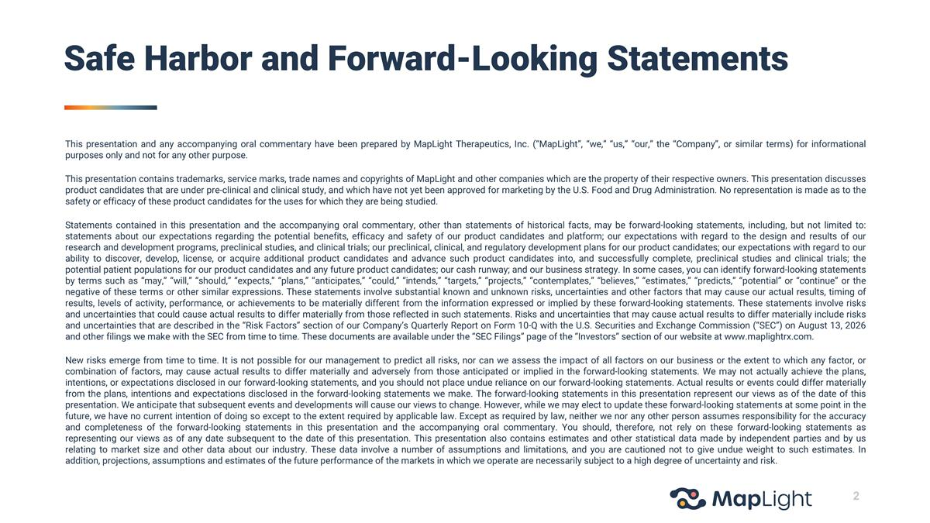
This presentation and any accompanying oral commentary have been prepared by MapLight Therapeutics, Inc. (“MapLight”, “we,” “us,” “our,” the “Company”, or similar terms) for informational purposes only and not for any other purpose. This presentation contains trademarks, service marks, trade names and copyrights of MapLight and other companies which are the property of their respective owners. This presentation discusses product candidates that are under pre-clinical and clinical study, and which have not yet been approved for marketing by the U.S. Food and Drug Administration. No representation is made as to the safety or efficacy of these product candidates for the uses for which they are being studied. Statements contained in this presentation and the accompanying oral commentary, other than statements of historical facts, may be forward-looking statements, including, but not limited to: statements about our expectations regarding the potential benefits, efficacy and safety of our product candidates and platform; our expectations with regard to the design and results of our research and development programs, preclinical studies, and clinical trials; our preclinical, clinical, and regulatory development plans for our product candidates; our expectations with regard to our ability to discover, develop, license, or acquire additional product candidates and advance such product candidates into, and successfully complete, preclinical studies and clinical trials; the potential patient populations for our product candidates and any future product candidates; our cash runway; and our business strategy. In some cases, you can identify forward-looking statements by terms such as “may,” “will,” “should,” “expects,” “plans,” “anticipates,” “could,” “intends,” “targets,” “projects,” “contemplates,” “believes,” “estimates,” “predicts,” “potential” or “continue” or the negative of these terms or other similar expressions. These statements involve substantial known and unknown risks, uncertainties and other factors that may cause our actual results, timing of results, levels of activity, performance, or achievements to be materially different from the information expressed or implied by these forward-looking statements. These statements involve risks and uncertainties that could cause actual results to differ materially from those reflected in such statements. Risks and uncertainties that may cause actual results to differ materially include risks and uncertainties that are described in the “Risk Factors” section of our Company’s Quarterly Report on Form 10-Q with the U.S. Securities and Exchange Commission (“SEC”) on August 13, 2026 and other filings we make with the SEC from time to time. These documents are available under the “SEC Filings” page of the “Investors” section of our website at www.maplightrx.com. New risks emerge from time to time. It is not possible for our management to predict all risks, nor can we assess the impact of all factors on our business or the extent to which any factor, or combination of factors, may cause actual results to differ materially and adversely from those anticipated or implied in the forward-looking statements. We may not actually achieve the plans, intentions, or expectations disclosed in our forward-looking statements, and you should not place undue reliance on our forward-looking statements. Actual results or events could differ materially from the plans, intentions and expectations disclosed in the forward-looking statements we make. The forward-looking statements in this presentation represent our views as of the date of this presentation. We anticipate that subsequent events and developments will cause our views to change. However, while we may elect to update these forward-looking statements at some point in the future, we have no current intention of doing so except to the extent required by applicable law. Except as required by law, neither we nor any other person assumes responsibility for the accuracy and completeness of the forward-looking statements in this presentation and the accompanying oral commentary. You should, therefore, not rely on these forward-looking statements as representing our views as of any date subsequent to the date of this presentation. This presentation also contains estimates and other statistical data made by independent parties and by us relating to market size and other data about our industry. These data involve a number of assumptions and limitations, and you are cautioned not to give undue weight to such estimates. In addition, projections, assumptions and estimates of the future performance of the markets in which we operate are necessarily subject to a high degree of uncertainty and risk. Safe Harbor and Forward-Looking Statements

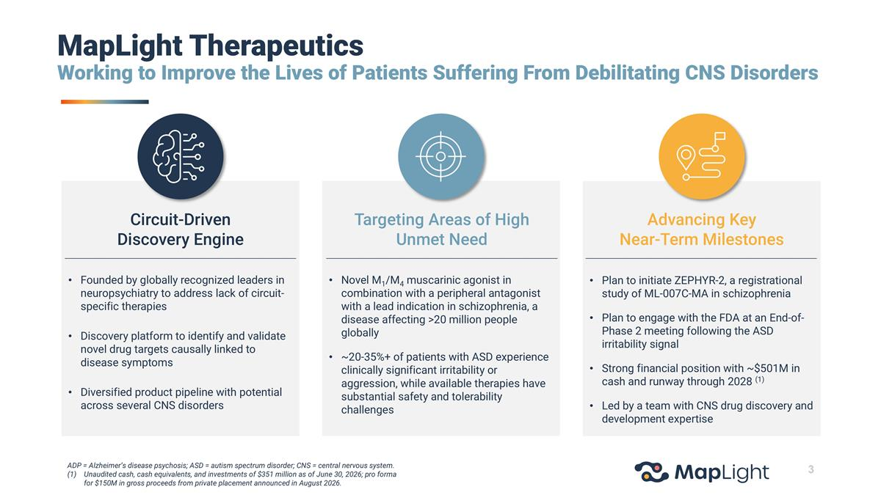
MapLight Therapeutics Working to Improve the Lives of Patients Suffering From Debilitating CNS Disorders Novel M1/M4 muscarinic agonist in combination with a peripheral antagonist with a lead indication in schizophrenia, a disease affecting >20 million people globally ~20-35%+ of patients with ASD experience clinically significant irritability or aggression, while available therapies have substantial safety and tolerability challenges Targeting Areas of High Unmet Need Founded by globally recognized leaders in neuropsychiatry to address lack of circuit-specific therapies Discovery platform to identify and validate novel drug targets causally linked to disease symptoms Diversified product pipeline with potential across several CNS disorders Circuit-Driven Discovery Engine Plan to initiate ZEPHYR-2, a registrational study of ML-007C-MA in schizophrenia Plan to engage with the FDA at an End-of-Phase 2 meeting following the ASD irritability signal Strong financial position with ~$501M in cash and runway through 2028 (1) Led by a team with CNS drug discovery and development expertise Advancing Key Near-Term Milestones ADP = Alzheimer’s disease psychosis; ASD = autism spectrum disorder; CNS = central nervous system. Unaudited cash, cash equivalents, and investments of $351 million as of June 30, 2026; pro forma for $150M in gross proceeds from private placement announced in August 2026.

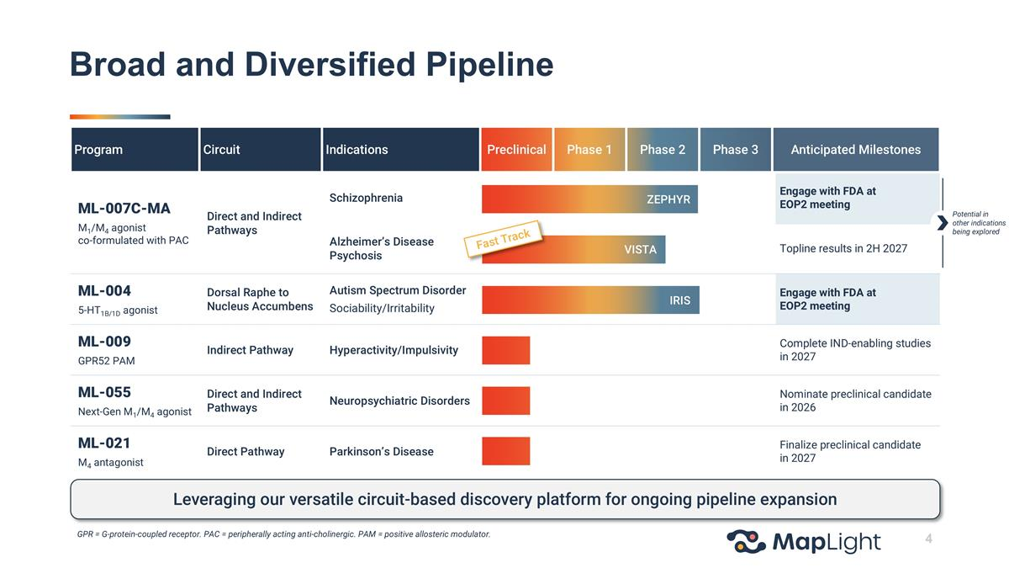
Program Circuit Indications Preclinical Phase 1 Phase 2 Phase 3 Anticipated Milestones ML-007C-MA M1/M4 agonist co-formulated with PAC Direct and Indirect Pathways Schizophrenia Engage with FDA at EOP2 meeting Alzheimer’s Disease Psychosis Topline results in 2H 2027 ML-004 5-HT1B/1D agonist Dorsal Raphe to Nucleus Accumbens Autism Spectrum Disorder Sociability/Irritability Engage with FDA at EOP2 meeting ML-009 GPR52 PAM Indirect Pathway Hyperactivity/Impulsivity Complete IND-enabling studies in 2027 ML-055 Next-Gen M1/M4 agonist Direct and Indirect Pathways Neuropsychiatric Disorders Nominate preclinical candidate in 2026 ML-021 M4 antagonist Direct Pathway Parkinson’s Disease Finalize preclinical candidate in 2027 Potential in other indications being explored ZEPHYR VISTA IRIS Fast Track Leveraging our versatile circuit-based discovery platform for ongoing pipeline expansion Broad and Diversified Pipeline GPR = G-protein-coupled receptor. PAC = peripherally acting anti-cholinergic. PAM = positive allosteric modulator.


ML-007C-MA Lead Asset in Development for Schizophrenia and ADP

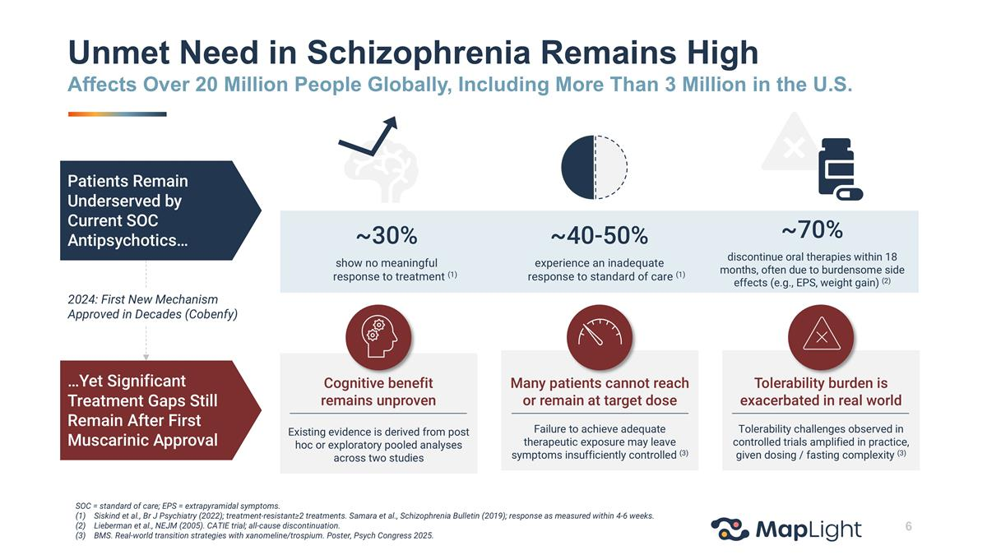
Existing evidence is derived from post hoc or exploratory pooled analyses across two studies Cognitive benefit remains unproven ~30% show no meaningful response to treatment (1) ~40-50% experience an inadequate response to standard of care (1) ~70% discontinue oral therapies within 18 months, often due to burdensome side effects (e.g., EPS, weight gain) (2) Patients Remain Underserved by Current SOC Antipsychotics… 2024: First New Mechanism Approved in Decades (Cobenfy) …Yet Significant Treatment Gaps Still Remain After First Muscarinic Approval Failure to achieve adequate therapeutic exposure may leave symptoms insufficiently controlled (3) Many patients cannot reach or remain at target dose Tolerability challenges observed in controlled trials amplified in practice, given dosing / fasting complexity (3) Tolerability burden is exacerbated in real world Unmet Need in Schizophrenia Remains High Affects Over 20 Million People Globally, Including More Than 3 Million in the U.S. SOC = standard of care; EPS = extrapyramidal symptoms. Siskind et al., Br J Psychiatry (2022); treatment-resistant≥2 treatments. Samara et al., Schizophrenia Bulletin (2019); response as measured within 4-6 weeks. Lieberman et al., NEJM (2005). CATIE trial; all-cause discontinuation. BMS. Real-world transition strategies with xanomeline/trospium. Poster, Psych Congress 2025.

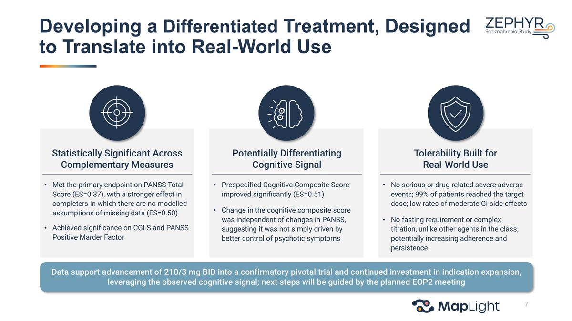
Met the primary endpoint on PANSS Total Score (ES=0.37), with a stronger effect in completers in which there are no modelled assumptions of missing data (ES=0.50) Achieved significance on CGI-S and PANSS Positive Marder Factor Statistically Significant Across Complementary Measures Prespecified Cognitive Composite Score improved significantly (ES=0.51) Change in the cognitive composite score was independent of changes in PANSS, suggesting it was not simply driven by better control of psychotic symptoms Potentially Differentiating Cognitive Signal No serious or drug-related severe adverse events; 99% of patients reached the target dose; low rates of moderate GI side-effects No fasting requirement or complex titration, unlike other agents in the class, potentially increasing adherence and persistence Tolerability Built for Real-World Use Data support advancement of 210/3 mg BID into a confirmatory pivotal trial and continued investment in indication expansion, leveraging the observed cognitive signal; next steps will be guided by the planned EOP2 meeting Developing a Differentiated Treatment, Designed to Translate into Real-World Use

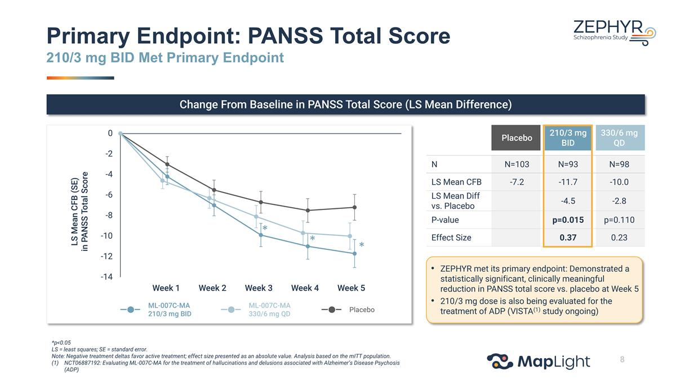
LS Mean CFB (SE) in PANSS Total Score Primary Endpoint: PANSS Total Score 210/3 mg BID Met Primary Endpoint Change From Baseline in PANSS Total Score (LS Mean Difference) *p<0.05 LS = least squares; SE = standard error. Note: Negative treatment deltas favor active treatment; effect size presented as an absolute value. Analysis based on the mITT population. NCT06887192: Evaluating ML-007C-MA for the treatment of hallucinations and delusions associated with Alzheimer’s Disease Psychosis (ADP) ML-007C-MA 210/3 mg BID Placebo ML-007C-MA 330/6 mg QD Placebo 210/3 mg BID 330/6 mg QD N N=103 N=93 N=98 LS Mean CFB -7.2 -11.7 -10.0 LS Mean Diff vs. Placebo -4.5 -2.8 P-value p=0.015 p=0.110 Effect Size 0.37 0.23 * * * Week 1 Week 2 Week 3 Week 4 Week 5 ZEPHYR met its primary endpoint: Demonstrated a statistically significant, clinically meaningful reduction in PANSS total score vs. placebo at Week 5 210/3 mg dose is also being evaluated for the treatment of ADP (VISTA(1) study ongoing)

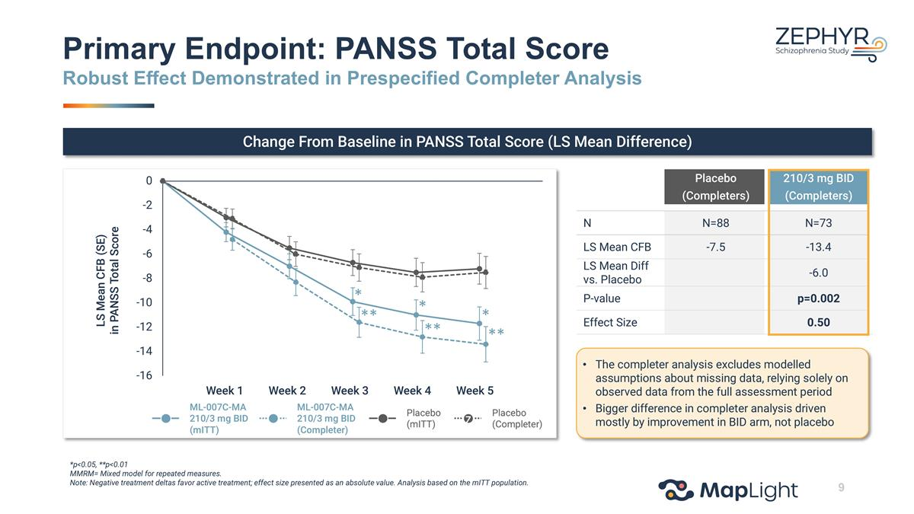
Week 1 Week 2 Week 3 Week 4 Week 5 Primary Endpoint: PANSS Total Score Robust Effect Demonstrated in Prespecified Completer Analysis Change From Baseline in PANSS Total Score (LS Mean Difference) LS Mean CFB (SE) in PANSS Total Score *p<0.05, **p<0.01 MMRM= Mixed model for repeated measures. Note: Negative treatment deltas favor active treatment; effect size presented as an absolute value. Analysis based on the mITT population. ML-007C-MA 210/3 mg BID (mITT) Placebo (Completer) ML-007C-MA 210/3 mg BID (Completer) Placebo (mITT) z ** ** ** * * * Placebo (Completers) 210/3 mg BID (Completers) N N=88 N=73 LS Mean CFB -7.5 -13.4 LS Mean Diff vs. Placebo -6.0 P-value p=0.002 Effect Size 0.50 The completer analysis excludes modelled assumptions about missing data, relying solely on observed data from the full assessment period Bigger difference in completer analysis driven mostly by improvement in BID arm, not placebo

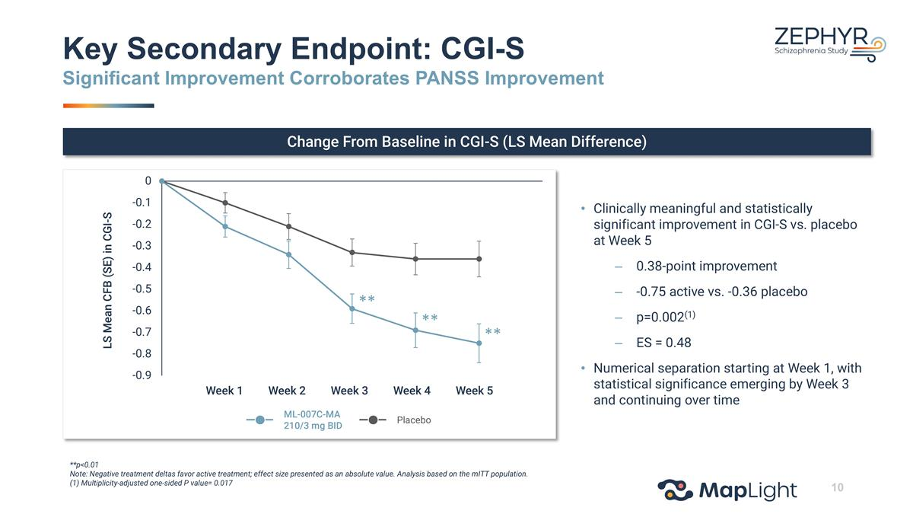
Key Secondary Endpoint: CGI-S Significant Improvement Corroborates PANSS Improvement Change From Baseline in CGI-S (LS Mean Difference) LS Mean CFB (SE) in CGI-S Clinically meaningful and statistically significant improvement in CGI-S vs. placebo at Week 5 0.38-point improvement -0.75 active vs. -0.36 placebo p=0.002(1) ES = 0.48 Numerical separation starting at Week 1, with statistical significance emerging by Week 3 and continuing over time **p<0.01 Note: Negative treatment deltas favor active treatment; effect size presented as an absolute value. Analysis based on the mITT population. (1) Multiplicity-adjusted one-sided P value= 0.017 ML-007C-MA 210/3 mg BID Placebo ** ** ** Week 1 Week 2 Week 3 Week 4 Week 5

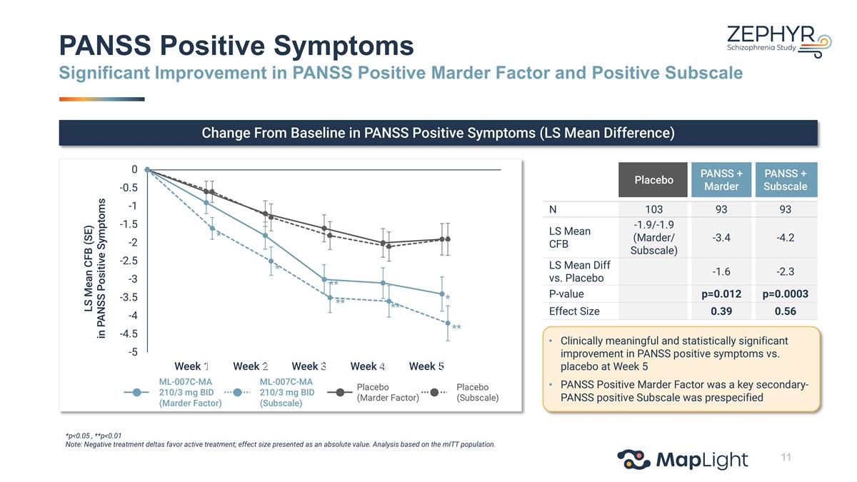
Change From Baseline in PANSS Positive Symptoms (LS Mean Difference) *p<0.05 , **p<0.01 Note: Negative treatment deltas favor active treatment; effect size presented as an absolute value. Analysis based on the mITT population. PANSS Positive Symptoms Significant Improvement in PANSS Positive Marder Factor and Positive Subscale Placebo PANSS + Marder PANSS + Subscale N 103 93 93 LS Mean CFB -1.9/-1.9 (Marder/ Subscale) -3.4 -4.2 LS Mean Diff vs. Placebo -1.6 -2.3 P-value p=0.012 p=0.0003 Effect Size 0.39 0.56 Week 1 Week 2 Week 3 Week 4 Week 5 ML-007C-MA 210/3 mg BID (Marder Factor) Placebo (Subscale) ML-007C-MA 210/3 mg BID (Subscale) Placebo (Marder Factor) LS Mean CFB (SE) in PANSS Positive Symptoms ** ** ** * * * ** Clinically meaningful and statistically significant improvement in PANSS positive symptoms vs. placebo at Week 5 PANSS Positive Marder Factor was a key secondary- PANSS positive Subscale was prespecified

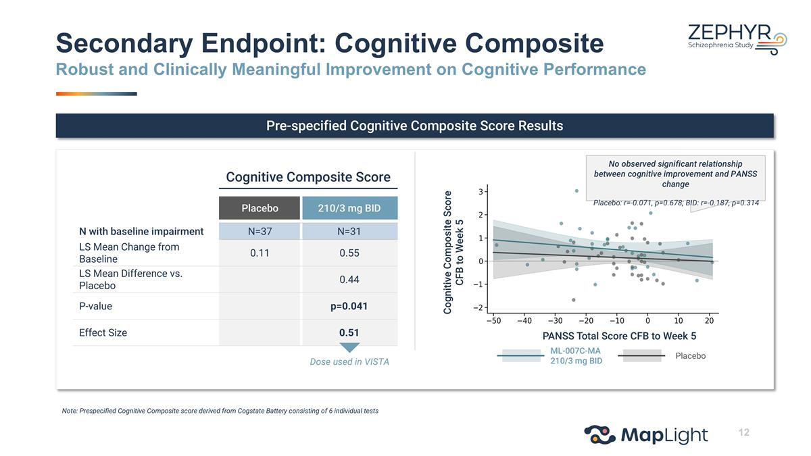
Pre-specified Cognitive Composite Score Results Cognitive Composite Score CFB to Week 5 PANSS Total Score CFB to Week 5 Cognitive Composite Score Placebo 210/3 mg BID N with baseline impairment N=37 N=31 LS Mean Change from Baseline 0.11 0.55 LS Mean Difference vs. Placebo 0.44 P-value p=0.041 Effect Size 0.51 Dose used in VISTA ML-007C-MA 210/3 mg BID Placebo Note: Prespecified Cognitive Composite score derived from Cogstate Battery consisting of 6 individual tests Secondary Endpoint: Cognitive Composite Robust and Clinically Meaningful Improvement on Cognitive Performance No observed significant relationship between cognitive improvement and PANSS change Placebo: r=-0.071, p=0.678; BID: r=-0.187, p=0.314

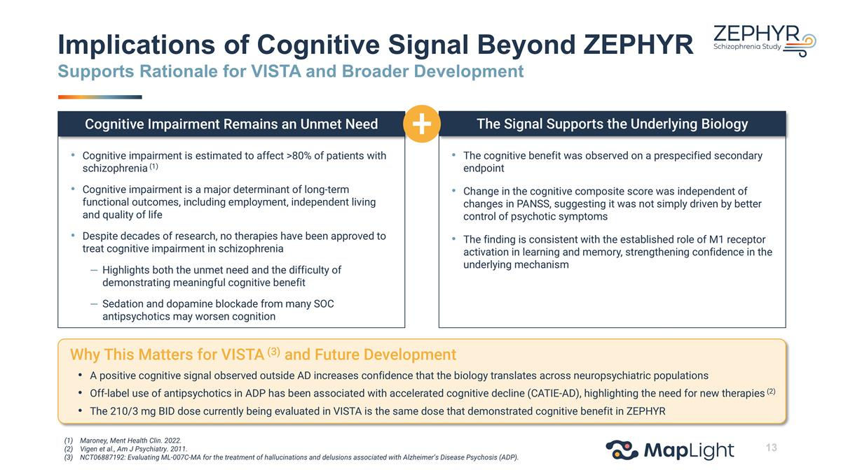
Implications of Cognitive Signal Beyond ZEPHYR Supports Rationale for VISTA and Broader Development Cognitive impairment is estimated to affect >80% of patients with schizophrenia (1) Cognitive impairment is a major determinant of long-term functional outcomes, including employment, independent living and quality of life Despite decades of research, no therapies have been approved to treat cognitive impairment in schizophrenia Highlights both the unmet need and the difficulty of demonstrating meaningful cognitive benefit Sedation and dopamine blockade from many SOC antipsychotics may worsen cognition Cognitive Impairment Remains an Unmet Need The Signal Supports the Underlying Biology The cognitive benefit was observed on a prespecified secondary endpoint Change in the cognitive composite score was independent of changes in PANSS, suggesting it was not simply driven by better control of psychotic symptoms The finding is consistent with the established role of M1 receptor activation in learning and memory, strengthening confidence in the underlying mechanism Why This Matters for VISTA (3) and Future Development A positive cognitive signal observed outside AD increases confidence that the biology translates across neuropsychiatric populations Off-label use of antipsychotics in ADP has been associated with accelerated cognitive decline (CATIE-AD), highlighting the need for new therapies (2) The 210/3 mg BID dose currently being evaluated in VISTA is the same dose that demonstrated cognitive benefit in ZEPHYR Maroney, Ment Health Clin. 2022. Vigen et al., Am J Psychiatry. 2011. NCT06887192: Evaluating ML-007C-MA for the treatment of hallucinations and delusions associated with Alzheimer’s Disease Psychosis (ADP).

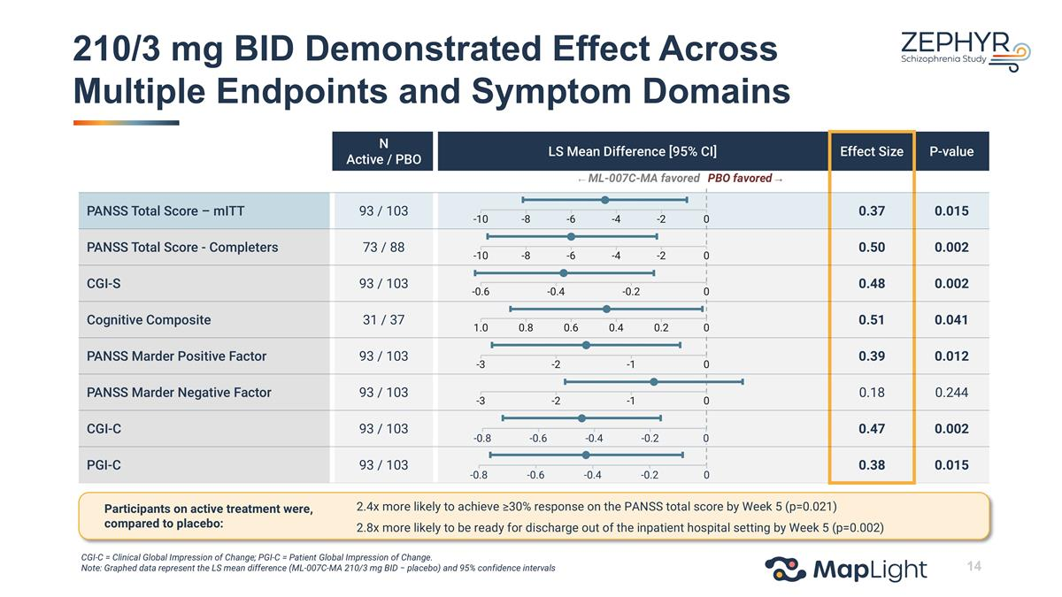
210/3 mg BID Demonstrated Effect Across Multiple Endpoints and Symptom Domains N Active / PBO LS Mean Difference [95% CI] Effect Size P-value PANSS Total Score – mITT 93 / 103 0.37 0.015 PANSS Total Score - Completers 73 / 88 0.50 0.002 CGI-S 93 / 103 0.48 0.002 Cognitive Composite 31 / 37 0.51 0.041 PANSS Marder Positive Factor 93 / 103 0.39 0.012 PANSS Marder Negative Factor 93 / 103 0.18 0.244 CGI-C 93 / 103 0.47 0.002 PGI-C 93 / 103 0.38 0.015 -0.6 -0.4 -0.2 0 1.0 0.8 0.6 0.4 0.2 0 -3 -2 -1 0 -3 -2 -1 0 ← ML-007C-MA favored PBO favored → -10 -8 -6 -4 -2 0 -10 -8 -6 -4 -2 0 CGI-C = Clinical Global Impression of Change; PGI-C = Patient Global Impression of Change. Note: Graphed data represent the LS mean difference (ML-007C-MA 210/3 mg BID − placebo) and 95% confidence intervals -0.8 -0.6 -0.4 -0.2 0 -0.8 -0.6 -0.4 -0.2 0 Participants on active treatment were, compared to placebo: 2.4x more likely to achieve ≥30% response on the PANSS total score by Week 5 (p=0.021) 2.8x more likely to be ready for discharge out of the inpatient hospital setting by Week 5 (p=0.002)

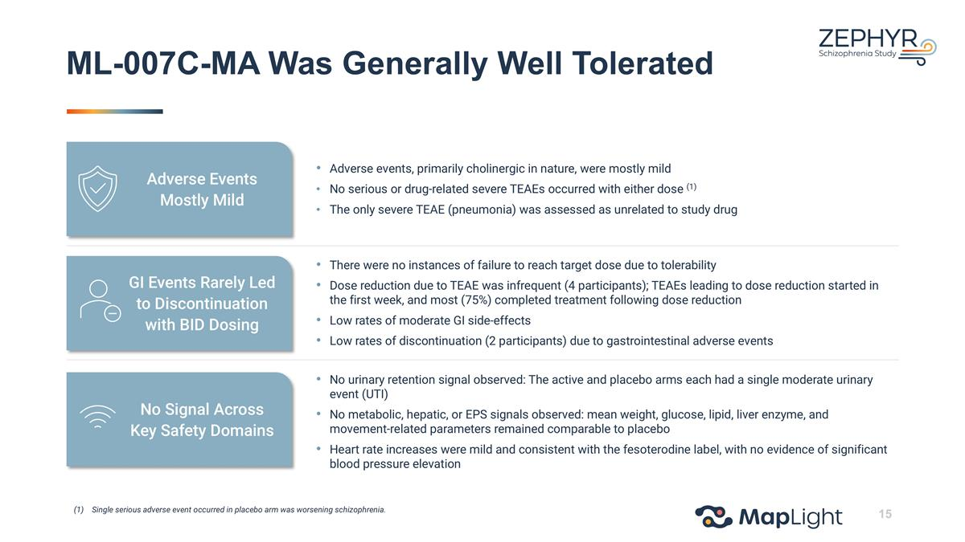
ML-007C-MA Was Generally Well Tolerated Single serious adverse event occurred in placebo arm was worsening schizophrenia. Adverse events, primarily cholinergic in nature, were mostly mild No serious or drug-related severe TEAEs occurred with either dose (1) The only severe TEAE (pneumonia) was assessed as unrelated to study drug There were no instances of failure to reach target dose due to tolerability Dose reduction due to TEAE was infrequent (4 participants); TEAEs leading to dose reduction started in the first week, and most (75%) completed treatment following dose reduction Low rates of moderate GI side-effects Low rates of discontinuation (2 participants) due to gastrointestinal adverse events No urinary retention signal observed: The active and placebo arms each had a single moderate urinary event (UTI) No metabolic, hepatic, or EPS signals observed: mean weight, glucose, lipid, liver enzyme, and movement-related parameters remained comparable to placebo Heart rate increases were mild and consistent with the fesoterodine label, with no evidence of significant blood pressure elevation Adverse Events Mostly Mild GI Events Rarely Led to Discontinuation with BID Dosing No Signal Across Key Safety Domains

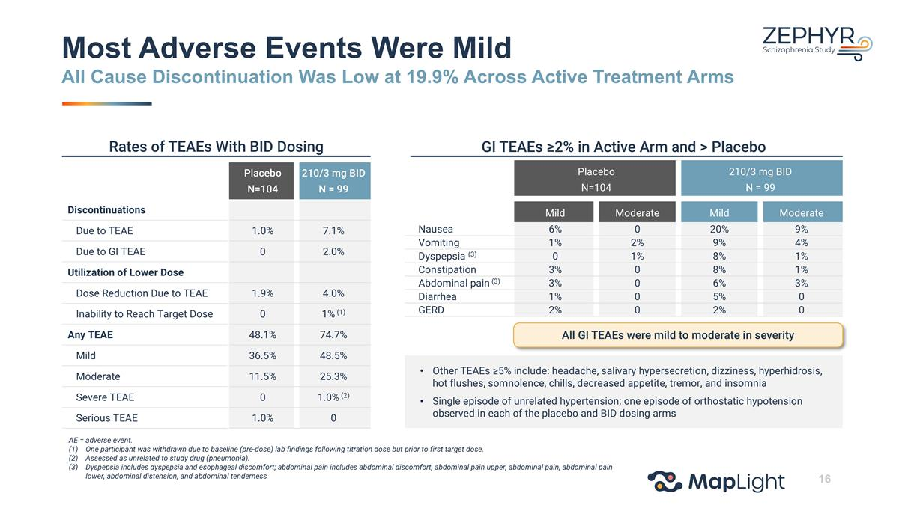
Placebo N=104 210/3 mg BID N = 99 Mild Moderate Mild Moderate Nausea 6% 0 20% 9% Vomiting 1% 2% 9% 4% Dyspepsia (3) 0 1% 8% 1% Constipation 3% 0 8% 1% Abdominal pain (3) 3% 0 6% 3% Diarrhea 1% 0 5% 0 GERD 2% 0 2% 0 Rates of TEAEs With BID Dosing GI TEAEs ≥2% in Active Arm and > Placebo Most Adverse Events Were Mild All Cause Discontinuation Was Low at 19.9% Across Active Treatment Arms All GI TEAEs were mild to moderate in severity AE = adverse event. One participant was withdrawn due to baseline (pre-dose) lab findings following titration dose but prior to first target dose. Assessed as unrelated to study drug (pneumonia). Dyspepsia includes dyspepsia and esophageal discomfort; abdominal pain includes abdominal discomfort, abdominal pain upper, abdominal pain, abdominal pain lower, abdominal distension, and abdominal tenderness Other TEAEs ≥5% include: headache, salivary hypersecretion, dizziness, hyperhidrosis, hot flushes, somnolence, chills, decreased appetite, tremor, and insomnia Single episode of unrelated hypertension; one episode of orthostatic hypotension observed in each of the placebo and BID dosing arms Placebo N=104 210/3 mg BID N = 99 Discontinuations Due to TEAE 1.0% 7.1% Due to GI TEAE 0 2.0% Utilization of Lower Dose Dose Reduction Due to TEAE 1.9% 4.0% Inability to Reach Target Dose 0 1% (1) Any TEAE 48.1% 74.7% Mild 36.5% 48.5% Moderate 11.5% 25.3% Severe TEAE 0 1.0% (2) Serious TEAE 1.0% 0

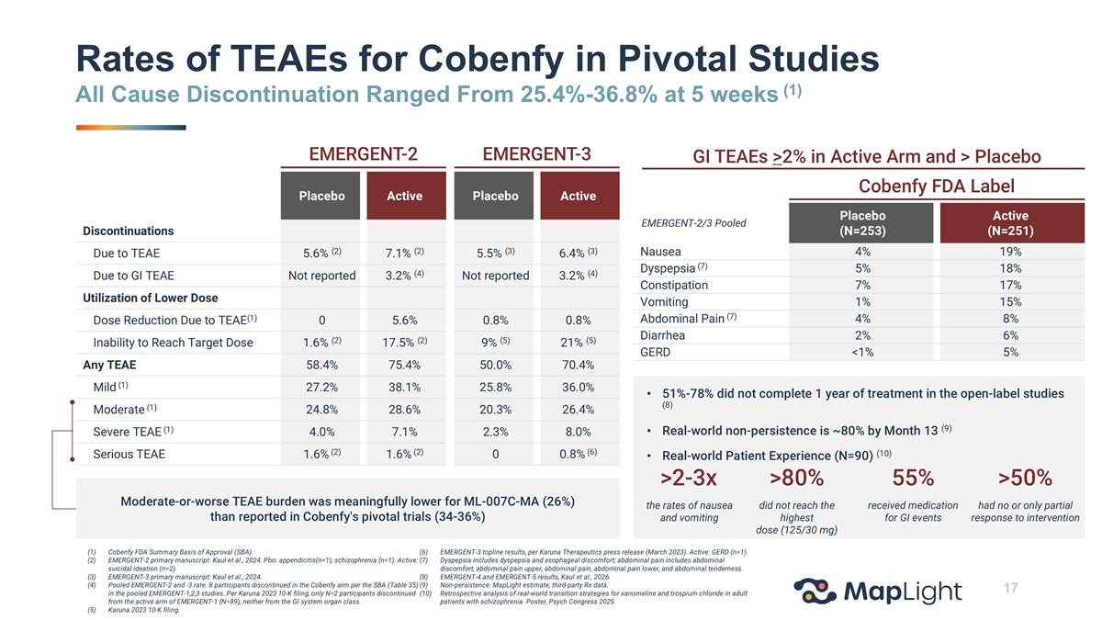
EMERGENT-2 EMERGENT-3 Placebo Active Placebo Active Discontinuations Due to TEAE 5.6% (2) 7.1% (2) 5.5% (3) 6.4% (3) Due to GI TEAE Not reported 3.2% (4) Not reported 3.2% (4) Utilization of Lower Dose Dose Reduction Due to TEAE(1) 0 5.6% 0.8% 0.8% Inability to Reach Target Dose 1.6% (2) 17.5% (2) 9% (5) 21% (5) Any TEAE 58.4% 75.4% 50.0% 70.4% Mild (1) 27.2% 38.1% 25.8% 36.0% Moderate (1) 24.8% 28.6% 20.3% 26.4% Severe TEAE (1) 4.0% 7.1% 2.3% 8.0% Serious TEAE 1.6% (2) 1.6% (2) 0 0.8% (6) Rates of TEAEs for Cobenfy in Pivotal Studies All Cause Discontinuation Ranged From 25.4%-36.8% at 5 weeks (1) Moderate-or-worse TEAE burden was meaningfully lower for ML-007C-MA (26%) than reported in Cobenfy's pivotal trials (34-36%) Cobenfy FDA Label EMERGENT-2/3 Pooled Placebo (N=253) Active (N=251) Nausea 4% 19% Dyspepsia (7) 5% 18% Constipation 7% 17% Vomiting 1% 15% Abdominal Pain (7) 4% 8% Diarrhea 2% 6% GERD <1% 5% GI TEAEs >2% in Active Arm and > Placebo 51%-78% did not complete 1 year of treatment in the open-label studies (8) Real-world non-persistence is ~80% by Month 13 (9) Real-world Patient Experience (N=90) (10) >2-3x >80% 55% the rates of nausea and vomiting did not reach the highest dose (125/30 mg) received medication for GI events >50% had no or only partial response to intervention Cobenfy FDA Summary Basis of Approval (SBA). EMERGENT-2 primary manuscript: Kaul et al., 2024. Pbo: appendicitis(n=1), schizophrenia (n=1). Active: suicidal ideation (n=2). EMERGENT-3 primary manuscript: Kaul et al., 2024. Pooled EMERGENT-2 and -3 rate. 8 participants discontinued in the Cobenfy arm per the SBA (Table 35) in the pooled EMERGENT-1,2,3 studies. Per Karuna 2023 10-K filing, only N=2 participants discontinued from the active arm of EMERGENT-1 (N=89), neither from the GI system organ class. Karuna 2023 10-K filing. EMERGENT-3 topline results, per Karuna Therapeutics press release (March 2023). Active: GERD (n=1). Dyspepsia includes dyspepsia and esophageal discomfort; abdominal pain includes abdominal discomfort, abdominal pain upper, abdominal pain, abdominal pain lower, and abdominal tenderness. EMERGENT-4 and EMERGENT-5 results, Kaul et al., 2026. Non-persistence: MapLight estimate, third-party Rx data. Retrospective analysis of real-world transition strategies for xanomeline and trospium chloride in adult patients with schizophrenia. Poster, Psych Congress 2025.

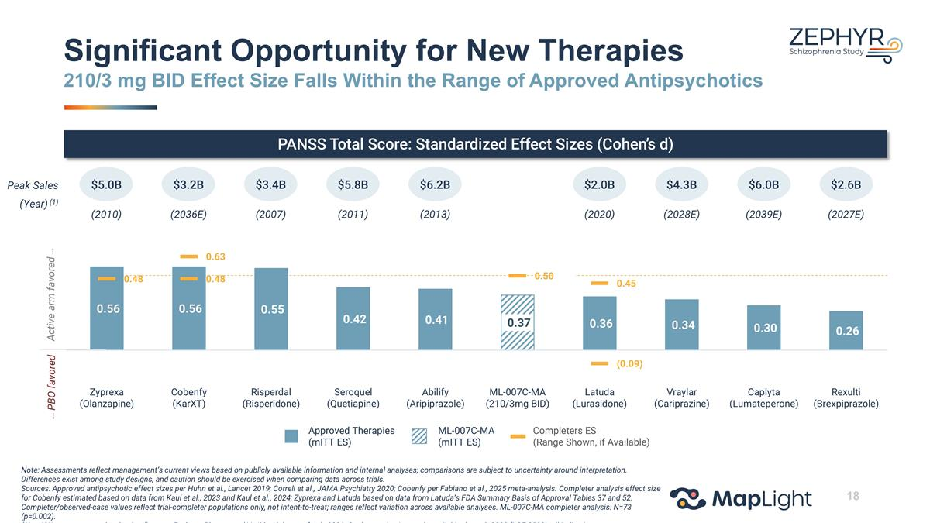
PANSS Total Score: Standardized Effect Sizes (Cohen’s d) Peak Sales (Year) (1) $5.0B $3.2B $3.4B $5.8B $6.2B $2.0B $4.3B $6.0B $2.6B (2010) (2036E) (2007) (2011) (2013) (2020) (2028E) (2039E) (2027E) Significant Opportunity for New Therapies 210/3 mg BID Effect Size Falls Within the Range of Approved Antipsychotics Approved Therapies (mITT ES) Completers ES (Range Shown, if Available) ML-007C-MA (mITT ES) Active arm favored → ← PBO favored Note: Assessments reflect management’s current views based on publicly available information and internal analyses; comparisons are subject to uncertainty around interpretation. Differences exist among study designs, and caution should be exercised when comparing data across trials. Sources: Approved antipsychotic effect sizes per Huhn et al., Lancet 2019; Correll et al., JAMA Psychiatry 2020; Cobenfy per Fabiano et al., 2025 meta-analysis. Completer analysis effect size for Cobenfy estimated based on data from Kaul et al., 2023 and Kaul et al., 2024; Zyprexa and Latuda based on data from Latuda’s FDA Summary Basis of Approval Tables 37 and 52. Completer/observed-case values reflect trial-completer populations only, not intent-to-treat; ranges reflect variation across available analyses. ML-007C-MA completer analysis: N=73 (p=0.002). WW consensus peak sales (oral) as per Evaluate Pharma and Visible Alpha as of July 2026; Caplyta projections only available through 2030 (LOE 2039); all indications.

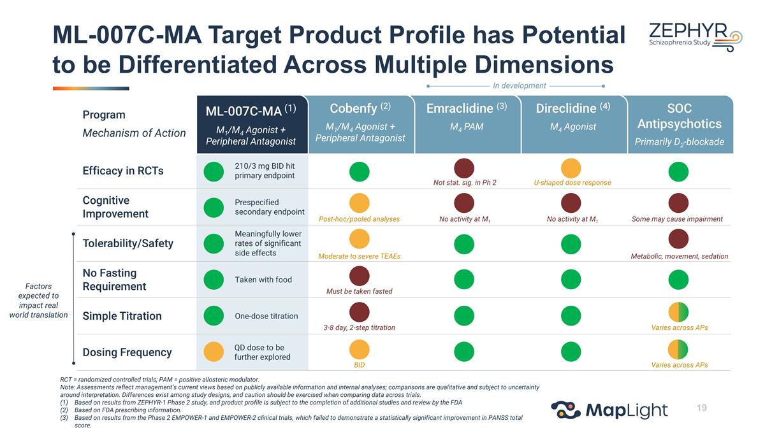
Program Mechanism of Action Efficacy in RCTs 210/3 mg BID hit primary endpoint Cognitive Improvement Prespecified secondary endpoint Tolerability/Safety Meaningfully lower rates of significant side effects No Fasting Requirement Taken with food Simple Titration One-dose titration Dosing Frequency QD dose to be further explored ML-007C-MA Target Product Profile has Potential to be Differentiated Across Multiple Dimensions RCT = randomized controlled trials; PAM = positive allosteric modulator. Note: Assessments reflect management’s current views based on publicly available information and internal analyses; comparisons are qualitative and subject to uncertainty around interpretation. Differences exist among study designs, and caution should be exercised when comparing data across trials. Based on results from ZEPHYR-1 Phase 2 study, and product profile is subject to the completion of additional studies and review by the FDA Based on FDA prescribing information. Based on results from the Phase 2 EMPOWER-1 and EMPOWER-2 clinical trials, which failed to demonstrate a statistically significant improvement in PANSS total score. Based on results from the Phase 2 clinical trial, which showed statistically significant improvement only at the lowest dose of the four active drug arms evaluated. No activity at M1 No activity at M1 Some may cause impairment Factors expected to impact real world translation SOC Antipsychotics Primarily D2-blockade Direclidine (4) M4 Agonist Emraclidine (3) M4 PAM Cobenfy (2) M1/M4 Agonist + Peripheral Antagonist ML-007C-MA (1) M1/M4 Agonist + Peripheral Antagonist In development U-shaped dose response Post-hoc/pooled analyses Moderate to severe TEAEs Must be taken fasted 3-8 day, 2-step titration BID Not stat. sig. in Ph 2 Metabolic, movement, sedation Varies across APs Varies across APs

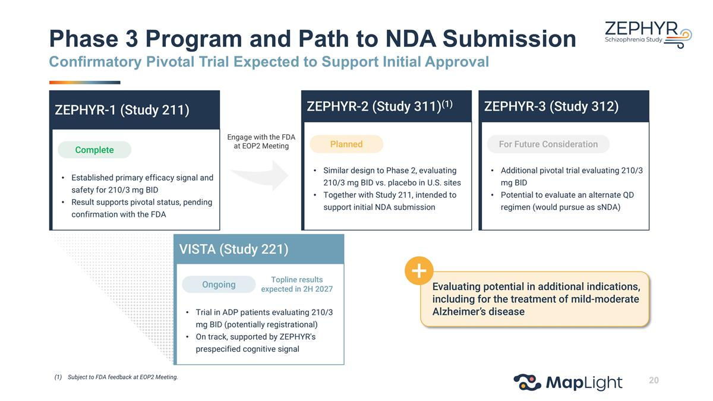
Phase 3 Program and Path to NDA Submission Confirmatory Pivotal Trial Expected to Support Initial Approval Trial in ADP patients evaluating 210/3 mg BID (potentially registrational) On track, supported by ZEPHYR's prespecified cognitive signal Ongoing VISTA (Study 221) Topline results expected in 2H 2027 Evaluating potential in additional indications, including for the treatment of mild-moderate Alzheimer’s disease Engage with the FDA at EOP2 Meeting Established primary efficacy signal and safety for 210/3 mg BID Result supports pivotal status, pending confirmation with the FDA Complete ZEPHYR-1 (Study 211) Similar design to Phase 2, evaluating 210/3 mg BID vs. placebo in U.S. sites Together with Study 211, intended to support initial NDA submission Planned ZEPHYR-2 (Study 311)(1) Additional pivotal trial evaluating 210/3 mg BID Potential to evaluate an alternate QD regimen (would pursue as sNDA) For Future Consideration ZEPHYR-3 (Study 312) Subject to FDA feedback at EOP2 Meeting.

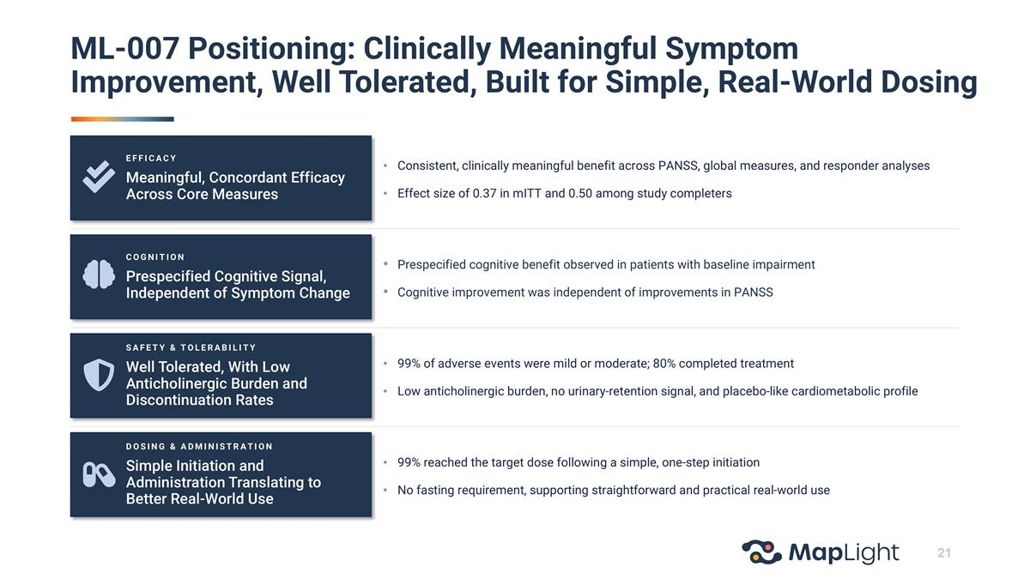
ML-007 Positioning: Clinically Meaningful Symptom Improvement, Well Tolerated, Built for Simple, Real-World Dosing Consistent, clinically meaningful benefit across PANSS, global measures, and responder analyses Effect size of 0.37 in mITT and 0.50 among study completers Prespecified cognitive benefit observed in patients with baseline impairment Cognitive improvement was independent of improvements in PANSS 99% of adverse events were mild or moderate; 80% completed treatment Low anticholinergic burden, no urinary-retention signal, and placebo-like cardiometabolic profile 99% reached the target dose following a simple, one-step initiation No fasting requirement, supporting straightforward and practical real-world use EFFICACY Meaningful, Concordant Efficacy Across Core Measures COGNITION Prespecified Cognitive Signal, Independent of Symptom Change SAFETY & TOLERABILITY Well Tolerated, With Low Anticholinergic Burden and Discontinuation Rates DOSING & ADMINISTRATION Simple Initiation and Administration Translating to Better Real-World Use


ML-004 5-HT1B/1D Agonist in Development for Autism Spectrum Disorder (ASD)

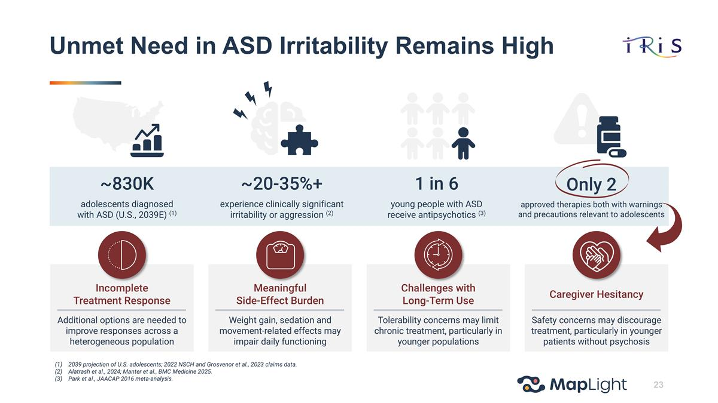
Unmet Need in ASD Irritability Remains High ~830K adolescents diagnosed with ASD (U.S., 2039E) (1) ~20-35%+ experience clinically significant irritability or aggression (2) 1 in 6 young people with ASD receive antipsychotics (3) Only 2 approved therapies both with warnings and precautions relevant to adolescents Additional options are needed to improve responses across a heterogeneous population Incomplete Treatment Response Weight gain, sedation and movement-related effects may impair daily functioning Meaningful Side-Effect Burden Tolerability concerns may limit chronic treatment, particularly in younger populations Challenges with Long-Term Use Safety concerns may discourage treatment, particularly in younger patients without psychosis Caregiver Hesitancy 2039 projection of U.S. adolescents; 2022 NSCH and Grosvenor et al., 2023 claims data. Alatrash et al., 2024; Manter et al., BMC Medicine 2025. Park et al., JAACAP 2016 meta-analysis.

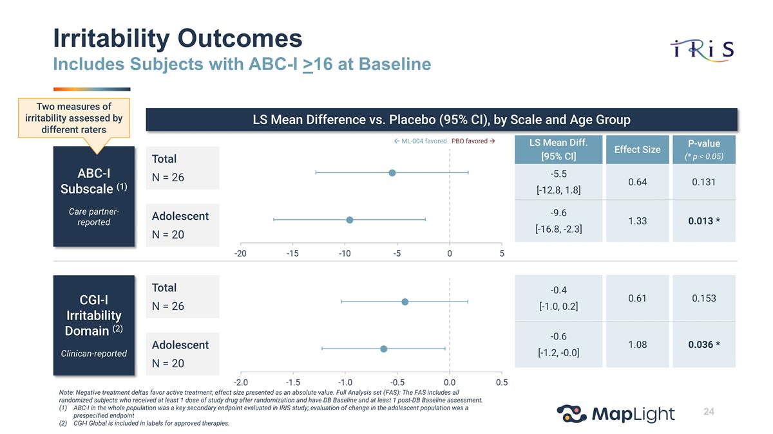
Irritability Outcomes Includes Subjects with ABC-I >16 at Baseline ABC-I Subscale (1) Care partner-reported CGI-I Irritability Domain (2) Clinican-reported Two measures of irritability assessed by different raters LS Mean Difference vs. Placebo (95% CI), by Scale and Age Group Total N = 26 Adolescent N = 20 Total N = 26 Adolescent N = 20 LS Mean Diff. [95% CI] Effect Size P-value (* p < 0.05) -5.5 [-12.8, 1.8] 0.64 0.131 -9.6 [-16.8, -2.3] 1.33 0.013 * -0.4 [-1.0, 0.2] 0.61 0.153 -0.6 [-1.2, -0.0] 1.08 0.036 * ß ML-004 favored PBO favored à Note: Negative treatment deltas favor active treatment; effect size presented as an absolute value. Full Analysis set (FAS): The FAS includes all randomized subjects who received at least 1 dose of study drug after randomization and have DB Baseline and at least 1 post-DB Baseline assessment. ABC-I in the whole population was a key secondary endpoint evaluated in IRIS study; evaluation of change in the adolescent population was a prespecified endpoint CGI-I Global is included in labels for approved therapies.

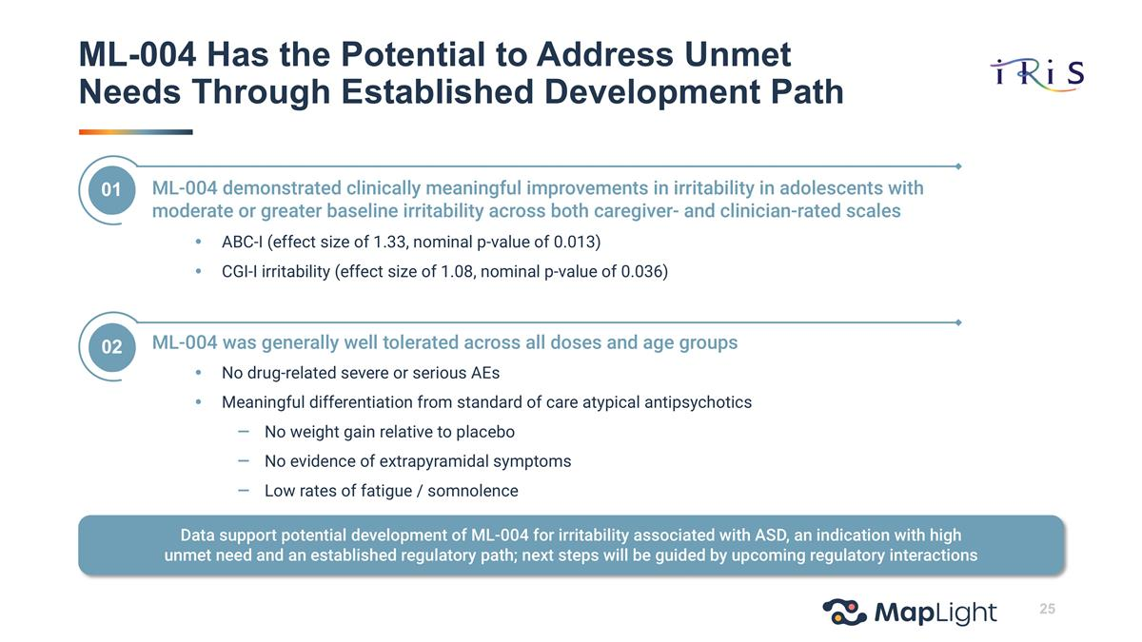
ML-004 Has the Potential to Address Unmet Needs Through Established Development Path ML-004 demonstrated clinically meaningful improvements in irritability in adolescents with moderate or greater baseline irritability across both caregiver- and clinician-rated scales ABC-I (effect size of 1.33, nominal p-value of 0.013) CGI-I irritability (effect size of 1.08, nominal p-value of 0.036) 01 ML-004 was generally well tolerated across all doses and age groups No drug-related severe or serious AEs Meaningful differentiation from standard of care atypical antipsychotics No weight gain relative to placebo No evidence of extrapyramidal symptoms Low rates of fatigue / somnolence 02 Data support potential development of ML-004 for irritability associated with ASD, an indication with high unmet need and an established regulatory path; next steps will be guided by upcoming regulatory interactions


Appendix

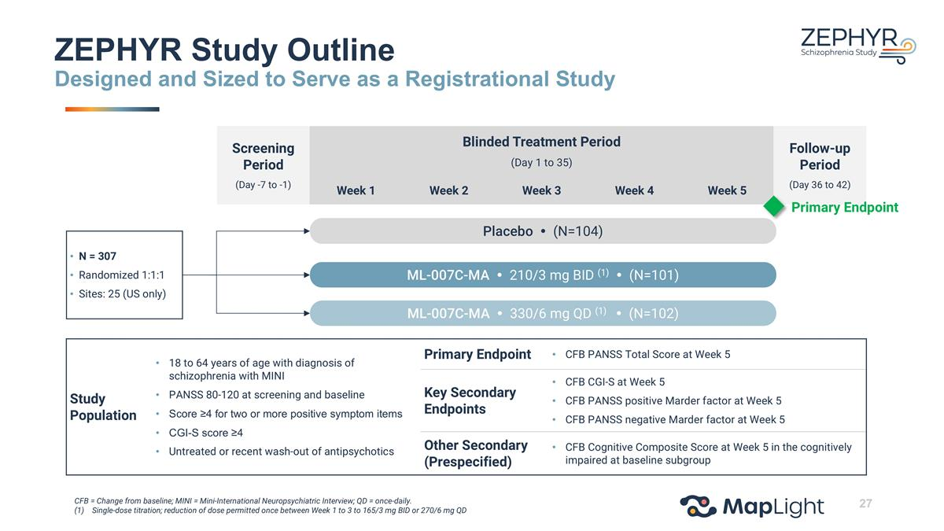
Screening Period (Day -7 to -1) Blinded Treatment Period (Day 1 to 35) Follow-up Period (Day 36 to 42) Week 1 Week 2 Week 3 Week 4 Week 5 N = 307 Randomized 1:1:1 Sites: 25 (US only) Placebo  (N=104) ML-007C-MA  330/6 mg QD (1)  (N=102) ML-007C-MA  210/3 mg BID (1)  (N=101) Primary Endpoint Study Population 18 to 64 years of age with diagnosis of schizophrenia with MINI PANSS 80-120 at screening and baseline Score ≥4 for two or more positive symptom items CGI-S score ≥4 Untreated or recent wash-out of antipsychotics Primary Endpoint CFB PANSS Total Score at Week 5 Key Secondary Endpoints CFB CGI-S at Week 5 CFB PANSS positive Marder factor at Week 5 CFB PANSS negative Marder factor at Week 5 Other Secondary (Prespecified) CFB Cognitive Composite Score at Week 5 in the cognitively impaired at baseline subgroup ZEPHYR Study Outline Designed and Sized to Serve as a Registrational Study CFB = Change from baseline; MINI = Mini-International Neuropsychiatric Interview; QD = once-daily. Single-dose titration; reduction of dose permitted once between Week 1 to 3 to 165/3 mg BID or 270/6 mg QD

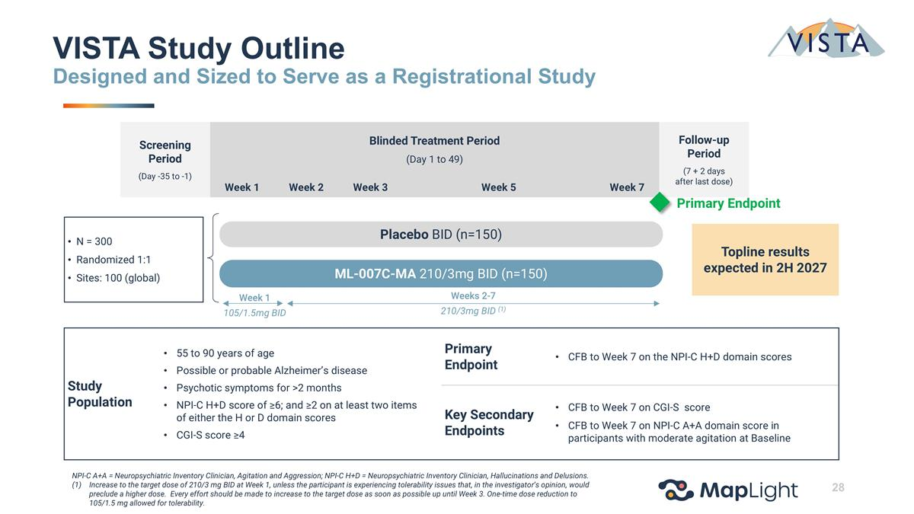
Screening Period (Day -35 to -1) Blinded Treatment Period (Day 1 to 49) Follow-up Period (7 + 2 days after last dose) Week 1 Week 2 Week 3 Week 5 Week 7 ML-007C-MA 210/3mg BID (n=150) Primary Endpoint Week 1 105/1.5mg BID Weeks 2-7 210/3mg BID (1) Placebo BID (n=150) N = 300 Randomized 1:1 Sites: 100 (global) Topline results expected in 2H 2027 VISTA Study Outline Designed and Sized to Serve as a Registrational Study NPI-C A+A = Neuropsychiatric Inventory Clinician, Agitation and Aggression; NPI-C H+D = Neuropsychiatric Inventory Clinician, Hallucinations and Delusions. Increase to the target dose of 210/3 mg BID at Week 1, unless the participant is experiencing tolerability issues that, in the investigator’s opinion, would preclude a higher dose. Every effort should be made to increase to the target dose as soon as possible up until Week 3. One-time dose reduction to 105/1.5 mg allowed for tolerability. Study Population 55 to 90 years of age Possible or probable Alzheimer’s disease Psychotic symptoms for >2 months NPI-C H+D score of ≥6; and ≥2 on at least two items of either the H or D domain scores CGI-S score ≥4 Primary Endpoint CFB to Week 7 on the NPI-C H+D domain scores Key Secondary Endpoints CFB to Week 7 on CGI-S score CFB to Week 7 on NPI-C A+A domain score in participants with moderate agitation at Baseline

